

The “Barefoot” Herbalist, M.H 108 (the “first” Barefoot Herbalist Website on the internet)

https://barefootherbalistmh.com/wp-content/uploads/General-Disclaimer.pdf

This type of website is best viewed on a computer screen, due to a large volume of pdf pages / books. Due to the fact most people use cell phones, the pictures will be centered and single, because that is what cell phones do when looking at websites with lots of pictures. This will make the pages very long.

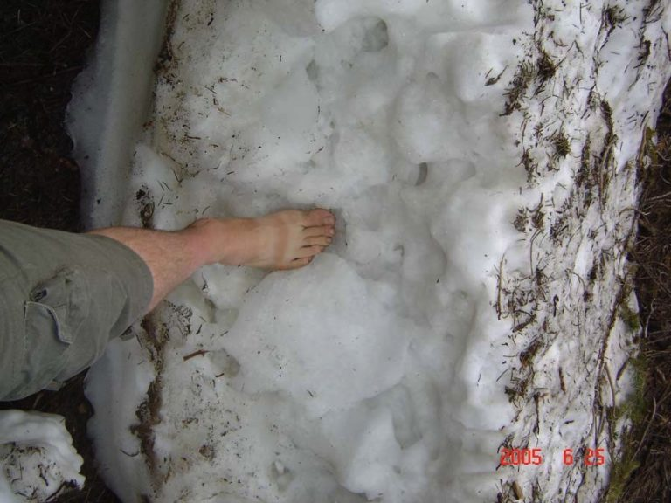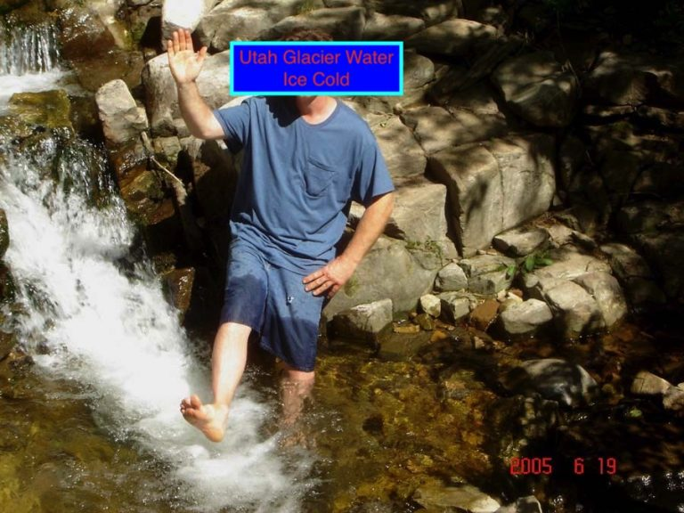

Glacier Ice Glacier Run off

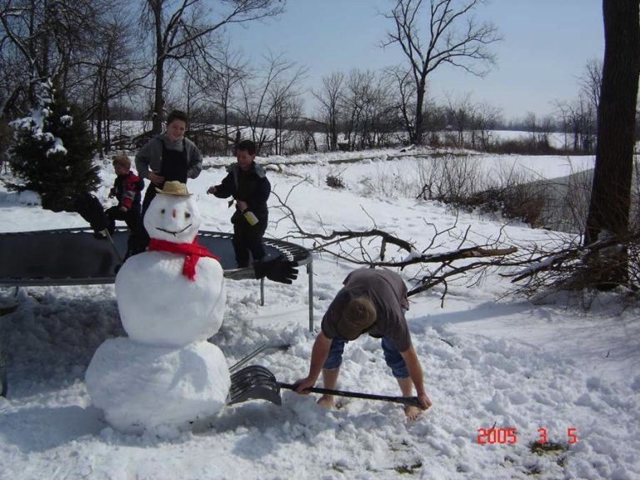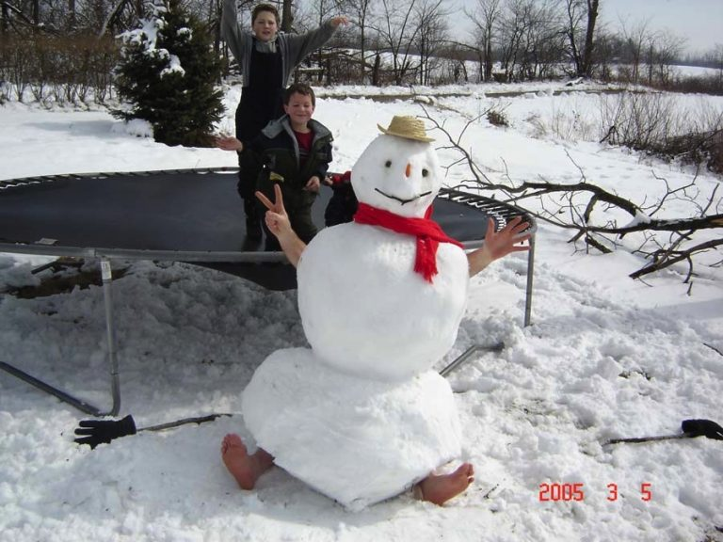

Trampoline is great exercise year around
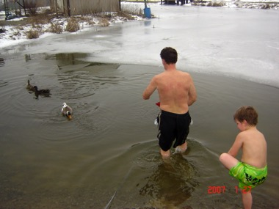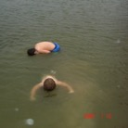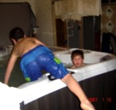

Feeding the ducks, Kids seeing you can hold their face in the ice water the longest, Learning at a young age how to use 103-degree water, so they can then swim in ice water.

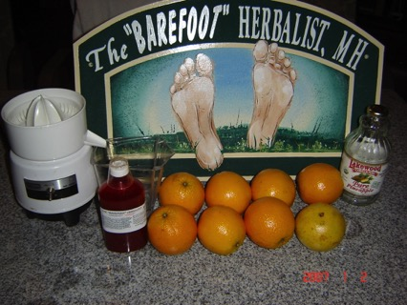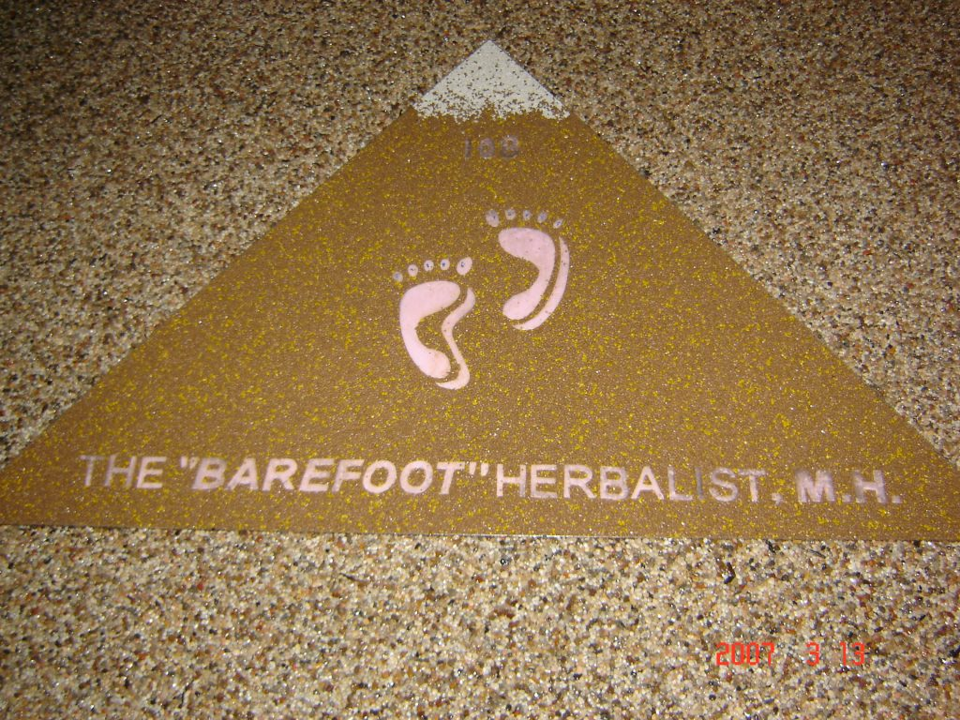

The 8 Orange Cure – All. The Pyramids are not what schoolbooks say they are; much of what we were trained to believe is a false education by “false” design. Children understand Nature easier, because they have less to de-educate them selves of. De-Education is the path to learning truths.

Welcome to the School of “Self-Applied” Prevention

This website is about 20 years old and approx. every 5 years I have had to make it over from scratch due to the hosting software changes etc. Each time I rebuild; it changes allot, Jan 2020 I had to start over from scratch and starting Sunday April 4th I am starting over from scratch hopefully for the last time. It will take a lot of time to recreate the past years as I build new pages. Hopefully not only will this become the last time I have to start all over, this will also be the largest and best the school has ever been, it will take “years” to build this website back to all its glory, with thousands of pages of files, news letters and great old books. M.H.



Today April 4th 2021 (Easter) in America, we had 20-degree weather just 2 days ago. Today the creek is still very cold and we were installing a field tile through a piece of swampy ground–for the fun of it, I will give a few pictures to remember the day this website was set – free to be rebuilt.
The ice – cold creek we were draining the swamp into had a ‘rare’ treat; eels. There were schools of eels laying eggs in there icy cold / shallow water. 50 years ago when I was playing in a larger creek, I found large schools of large eels, called lamprey eels that swim up rivers into small creeks to lay their eggs. I have never seen those eels ever again and today, I have never seen these type of adult “miniature’ eels. So I consider finding fresh water eels a very ‘rare’ discovery.

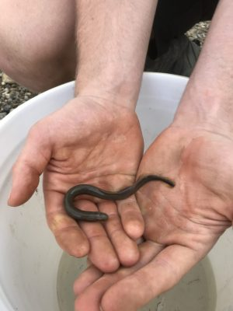
Miniature Adult Eel Video

https://barefootherbalistmh.com/wp-content/uploads/IMG_5540.mov

Eels Swimming

https://barefootherbalistmh.com/wp-content/uploads/IMG_5531-1.mov

These Eels are laying eggs in ice – cold water! I find that amazing! I have played in creeks my entire life and this is the first time I have ever seen this specie. This creeks dry 1/2 the year and flows flows into river called The Little Darby, which flows eventually to the Ohio River and down to the Gulf of Mexico.
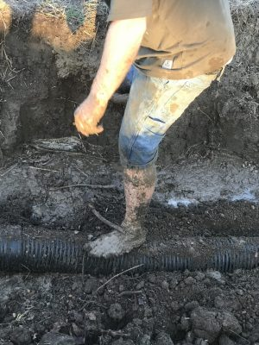
Installing a drain through a swamp into a creek that is not as deep as the swamp can be a muddy mess. Walking / working in deep mud makes boots weigh heavy with mud and also want to slide off into the mud as you bring your leg up out of the mud. For these reasons, I prefer to be barefoot, especially if there is water to wash the mud off. In this case the mud was about 2 feet deep. My feet are not bothered by the cold water / mud and I am able to dig with a shovel barefoot. I am fairly sure, not too many people, especially my age that can work in deep / cold mud or go barefoot in very cold water and not many can dig dirt with a shovel while barefoot.

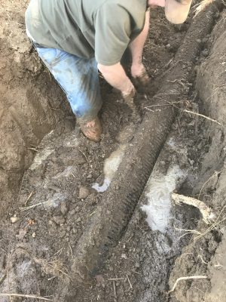
Our feet are a cleansing organs and designed to be in direct with the earth and should be comfortable at 40 degrees cooler temp than our blood stream is. Our feet should be very tuff. Shoes do more damage than most people have any idea of.



Today felt warm due to heavy chem – trail jets none stop spraying the atmosphere for the past few days. With out the chem- trail jets, the temperature was 20 degrees just 48 hours earlier; today it was 70 degrees. With heavy massive world – wide spraying, they can raise the temperature as much as 50 degrees above normal. I have watched “My Skies” for 30+ years and long ago made a book and 2 – hour video education showing how they have controlled and create global warming by design since 1949 and have mastered weather control. The advanced education covers many subjects that affect Longevity. They are now predicting 80 degrees for April 7th and just 1 week ago it was 20 degrees. The power of a fleet of military jets has the ability to drag weather around the world and they have from day 1–created what the Fake News calls Global Warming. With out these jets, April 7th would be in the 20’s and not 80 degrees. Understanding your environment is essential to our survival.

Today’s weather control pictures above my house:



Ariel Spraying started in 1949 to date
I have Watched My Skies daily for 20+ years
Years ago my first book and 2 hour video educates about the air we breathe

Every day of life is an Education, we learn as we adapt and it will always be survival of the “fittest. This entire website will cover the subject of longevity. Our longevity depends on how aware we are of all the bad that wants our lives shortened. Most people have no clue they were born on a battlefield of germ and chemical warfare. Fewer realize how bad parasites and poisons truly are.

April 13, 2021

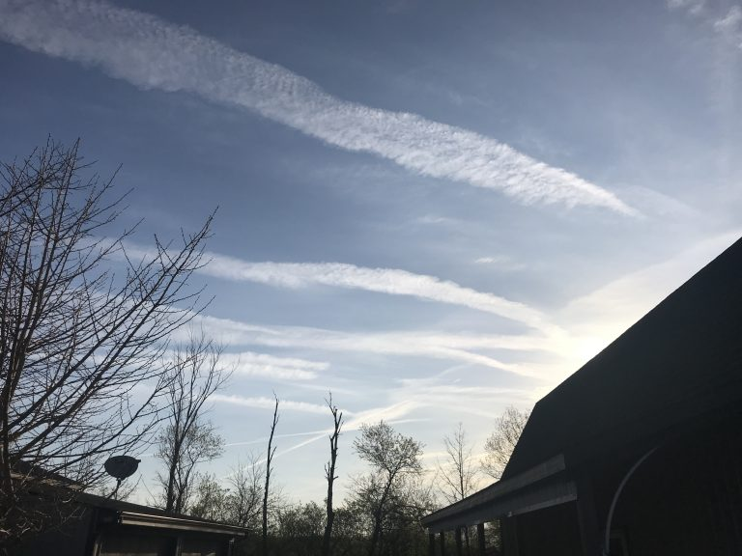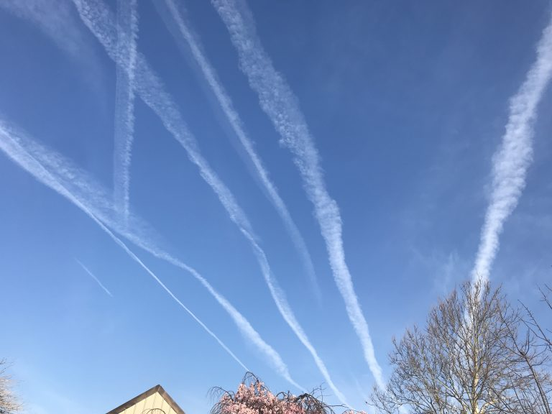
For a full week they have non stop sprayed in an effort to make it warm, they are now predicting cooler than normal weather for the next week. “IF” they had not filled with skies with these heat-trapping chemicals, I am sure instead of having 70 degree weather, it would be in the 20’s. This chemical / weather spraying started in 1949 to warm the earth affects the health and longevity of “all” life on earth. The fall-out is tremendous.
April brings Dandelions, a famous herb / food back in the days pre grocery stores. When pioneers were living on meats all winter and suffering by spring, the first real foods, such as Dandelions were a welcome food. The first fresh flowers can be eaten raw or cooked. The leaves can be eaten and the roots made into tea, tincture, powder, etc. and a great cleansing herb. Some old order Amish believed that if you pulled up the roots and let them dry and just shake the dirt off the roots and do not wash the dirt off and make tea, that the tea is very anti-cancer. Sadly because Dandelion is very common, herbal authors avoid it because it is easy to obtain in common yards and not a product they can promote for commercial sources that pay them to write herb books.

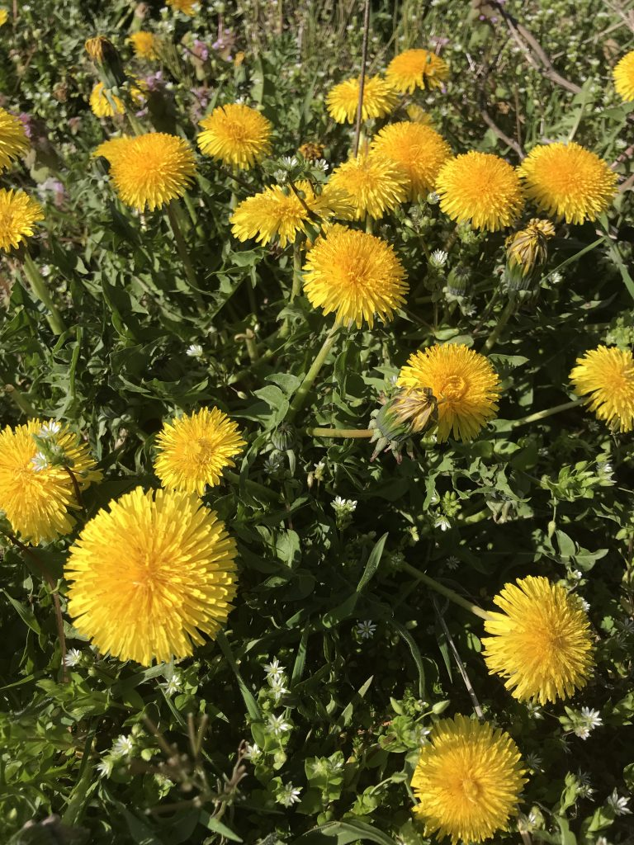
ff 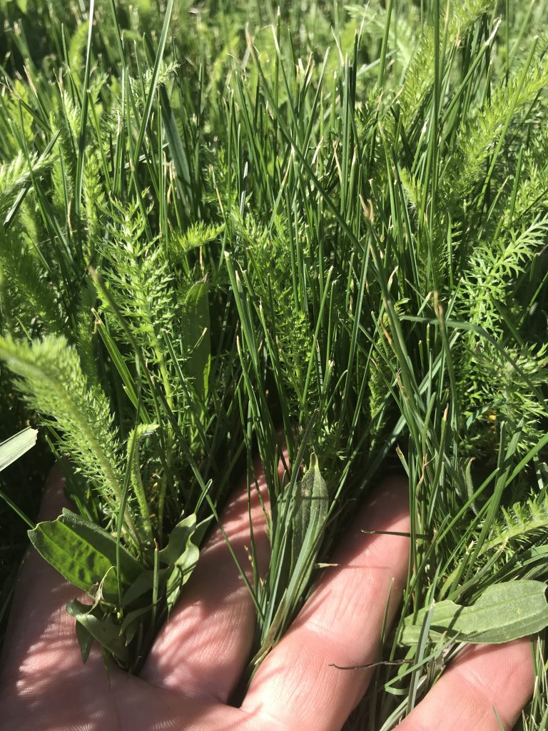

Yarrow is very easy to find and the young shoots appear in April. David Christopher, son of the late Dr. John R. Christopher grew up in the herbal world and I asked him what his favorite of all herbs was and he told me Yarrow. Yarrow is a fantastic herb to increase circulation and can her used in the bathtub water or all methods of herbal forms.

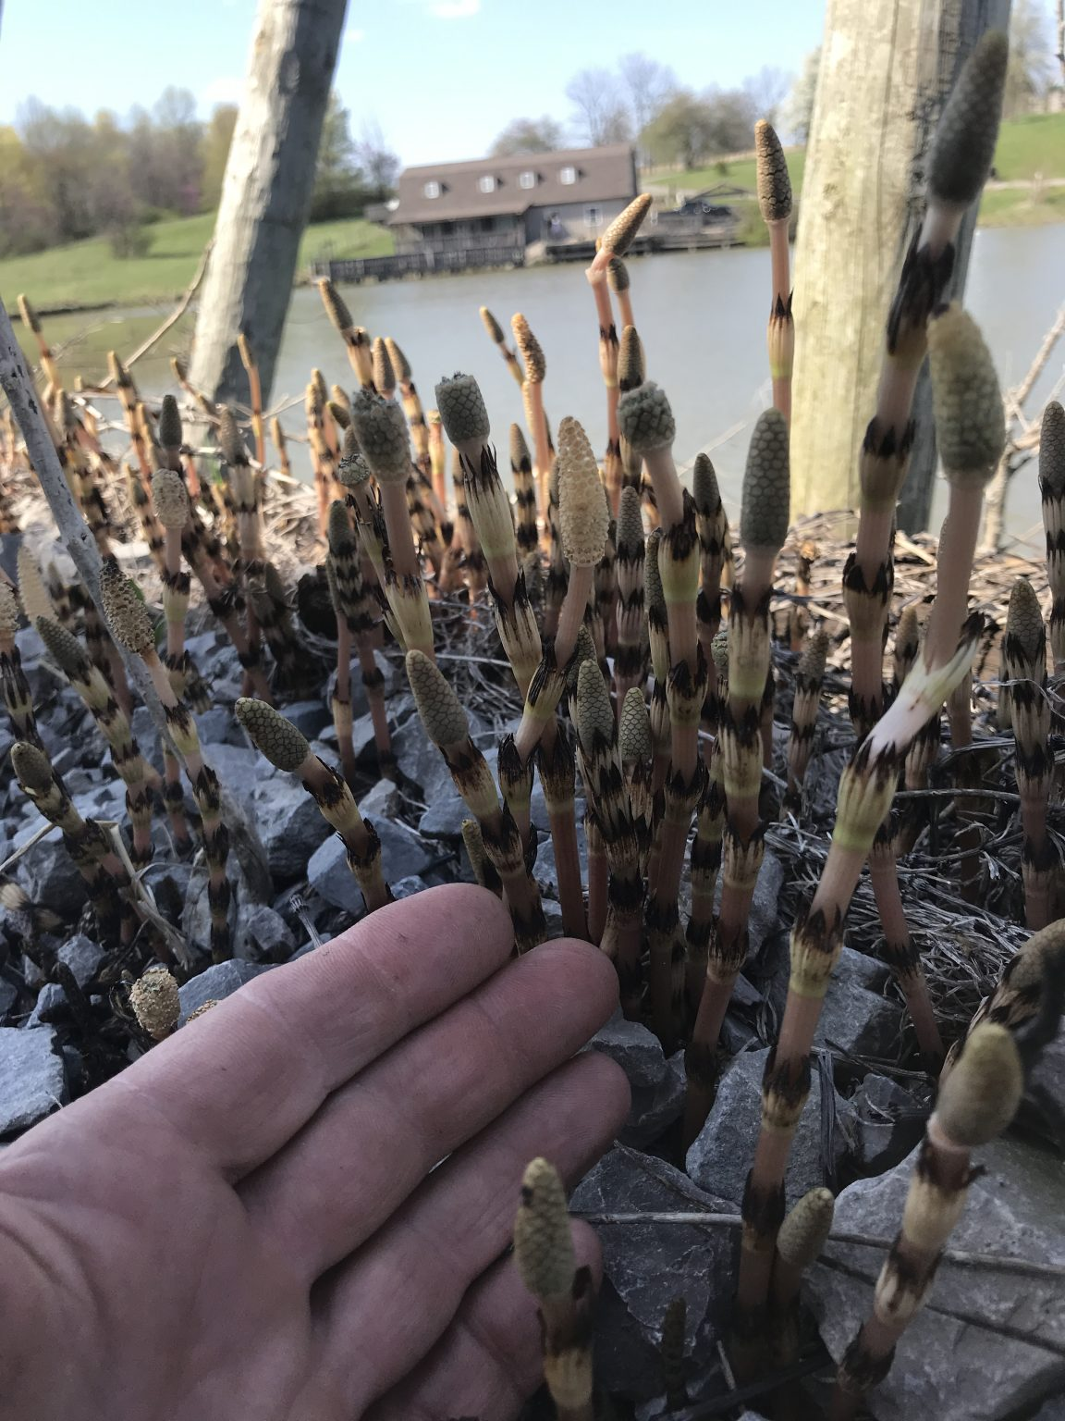
Horsetail / Shave Grass grows in sandy / gravel, damp / wet soil. It grows wild all around my property and it one of the top beneficial herbs in the herbal world. Science suggest this is an ancient plant, it surely is very “unique’. These are the early spring “Males”. They appear quickly, release endless ‘spores” that cover the ground and then they all die fast. Instantly the females rise out of the ground and collect the spores in their leaves. The Male Plants live underground approx. 350 days a year. I have never seen these in herbal books, while the female plants are very famous, very beneficial to human health. My property has them everywhere.

xxx 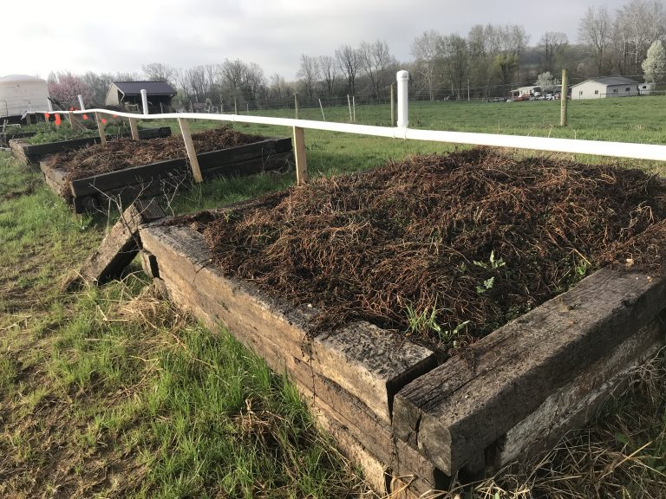 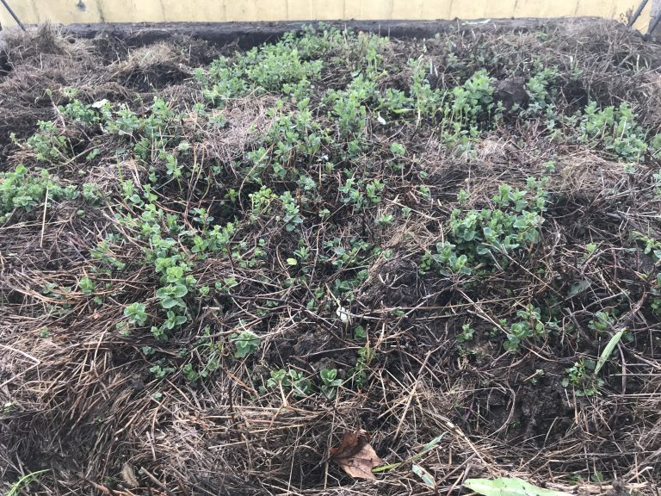

I have a lot of Peppermint; the plants above ground die off in the snow and leave dead leaves as a natural insulation. Today I pulled off the dead plants and you can see the new growth appearing.

April 15th

Mullein loves rocky / poor soil. It lives two years and has flowers / seeds the second summer. This plant will stay green through out the winter, unless it stays extremely cold for a long period. Mullein as an herb has many uses, in pre modern times, it was a natural toilet paper type herb, people smoked it for congestion and is one of the top lung congestion herbs I used for making what i call “Air Restore” Tincture.

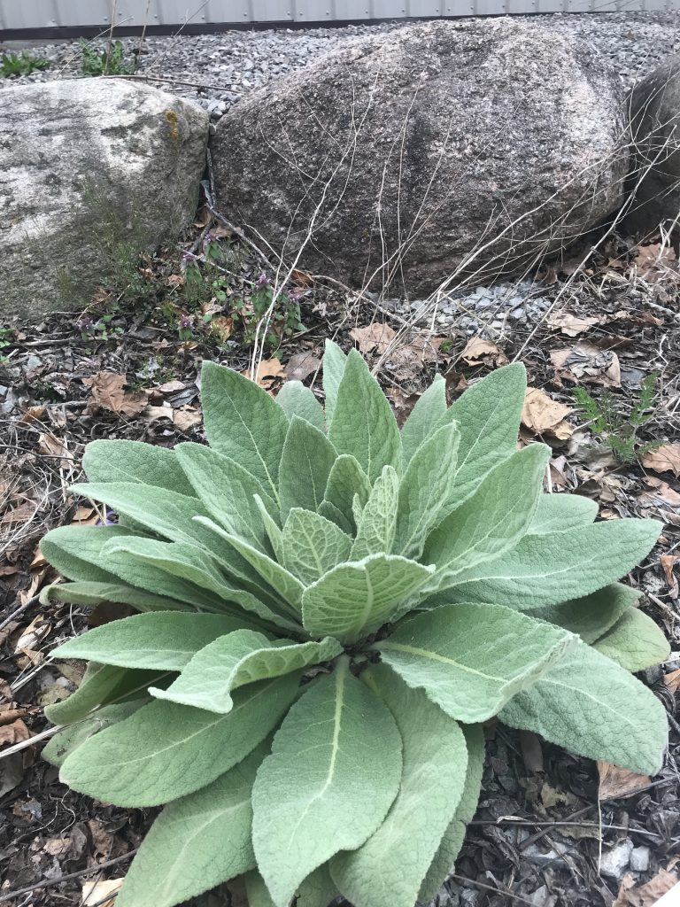

April 20th

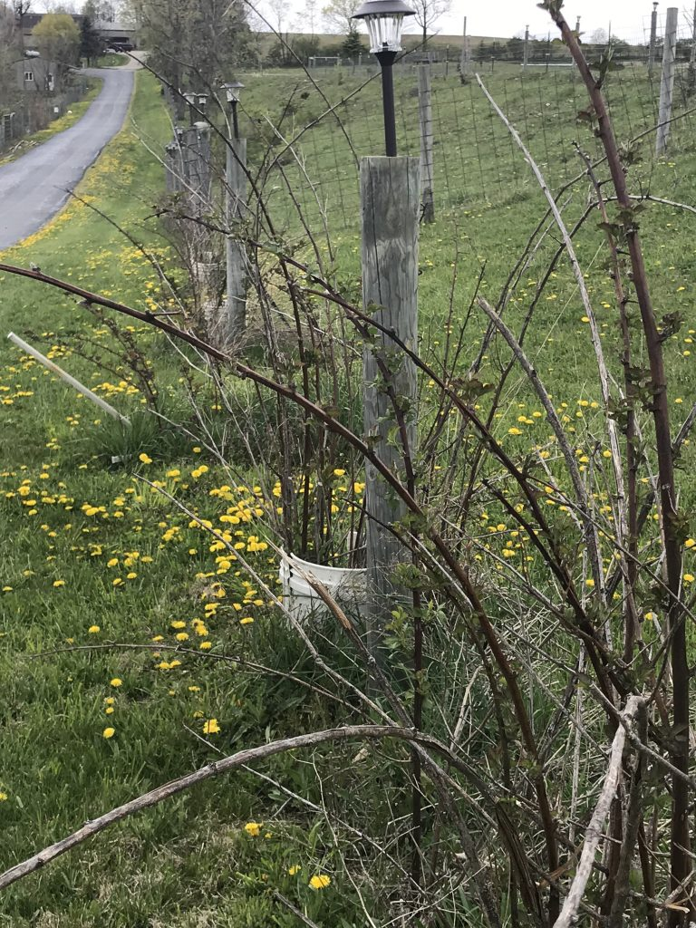

Black Berries have been highly modified to be thorn less and can have super large fruit. Black Berries in general are only sweet when very ripe. Some plants can have as much as 20 pounds of fruit per season. The Wild / Natural plants can tolerate normal weather, while the hybrids can be plagued with worms and can 100% freeze out. People prefer the much sweeter Raspberries and the birds do also. In recent years the Black Berry has gotten a reputation as anti cancer herb. The Black / Purple fruits of the vine and tree can be high in natural Potassium. Potassium helps balance / reduce salt and can result in less disease.

The Internet supply endless information, which is all opinions and often used to scare people away from Self-Applied health and herbs that have allot of health history. When you want the best herbal information, use the Internet as a reference, but if you want truthful history, read the books written by the herbal doctors that made those herbs famous.

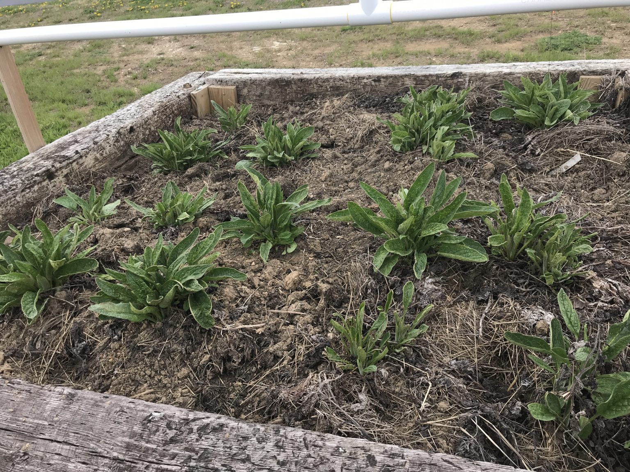

c
Comfrey Plants are amazing and also known as Bone Knit. The best mineral / calcium rich herb that is the secret to the success of the Bone / Flesh & Cartilage formulas. Not native to America, but does very well once started. Goat farmers are known to keep comfrey plants where their goats can eat freely as a sickness prevention herb. Organic Gardeners grow comfrey as a fertilizer source, due to the fast growing plants with very deep roots cane be cut multiple times per summer and spread on the garden soil to increase organic mineral content. The leaves are very strong first thing in the spring and suggested to use them for fertilizer and collect the second growth; otherwise commercially it is the roots that are famous. Once dried herbs loose some of their potency and since Herbal Comfrey is always sold dry, there is never a problem with its use—BUT since Dr. John R. Christopher made several herbs extremely famous, the ‘world” did all they could to discredit the best of the best herbs, of which comfrey is a truly prized herb that i would never want to be with out.

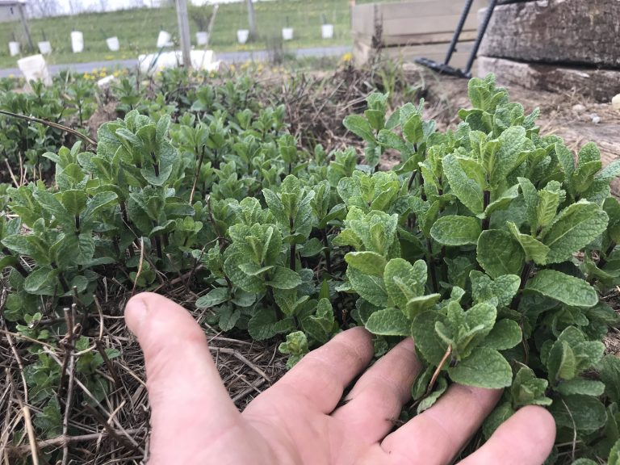
Spearmint makes an herbal tea that state exactly like double spearmint gum, mixed with a little peppermint makes for near perfect ice tea. There is one mint that is suppose to be similar to Spearmint, but better yet, last fall I was able to obtain a sample of roots of that extremely rare mint and that is my experiment for a 2021 summer tea.

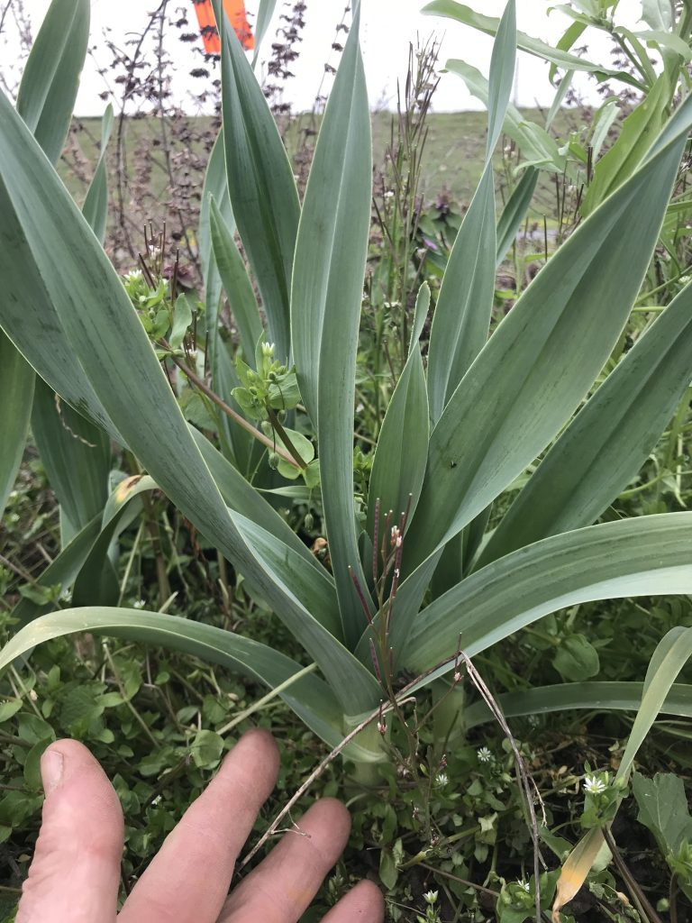
Garlic is one of the oldest / historical herbs with endless uses. One of the most “unique” books ever written about cancer treatment in Japan, used garlic in ways you would not believe. That book and many more have been part of the School of “Self-Applied” Prevention for a very long time. You would have to read the book to even begin to believe it and he has many pictures to prove his methods. I have been raising Elephant Garlic for 20+ years and the man that gave be a few plants had been raising it for 40+ years. it can be harvested each year or permitted to grow wild and live fine on its own. I have 20 year old plants that have never been harvested. The average gardener plants garlic each year.

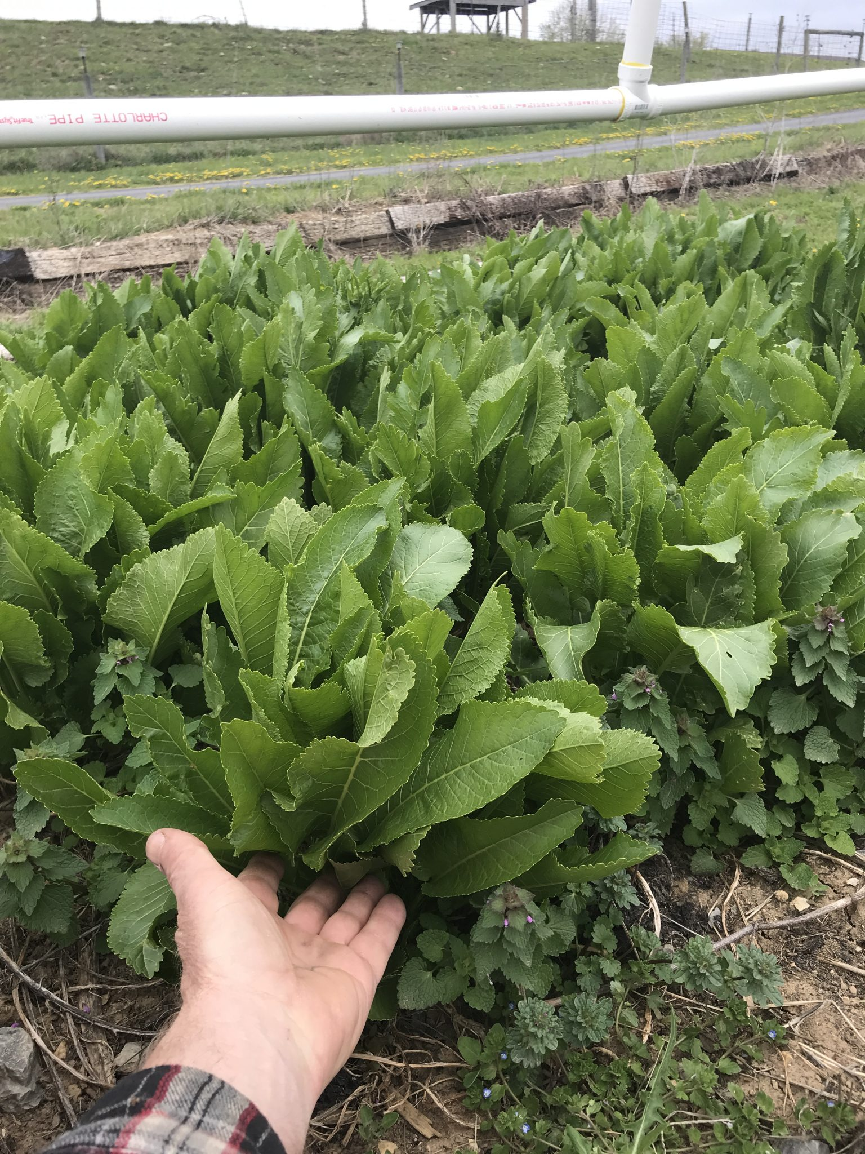
Horse Radish is another hardy herb that most every gardener use to raise, this is an amazing herb that can be used as a food source and an essential herb used in making the best all purpose healing formulas.

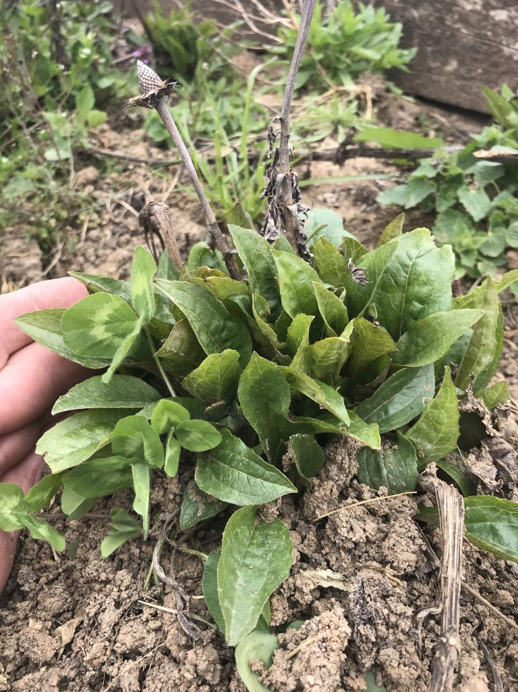
Echinacea is commonly used for its roots; I like the flowers as well. Often used for children’s immune building formulas and the old stories as a Snake Bite Elixir in the old days. One famous herbal doctor liked drinking a 2-ounce tincture bottle once every 3 months as an Immune Booster. There are several old herbal books that will teach everything they know about these great herbs, I personally do not trust much on the Internet about herbal use today. The best books were written pre 1950.

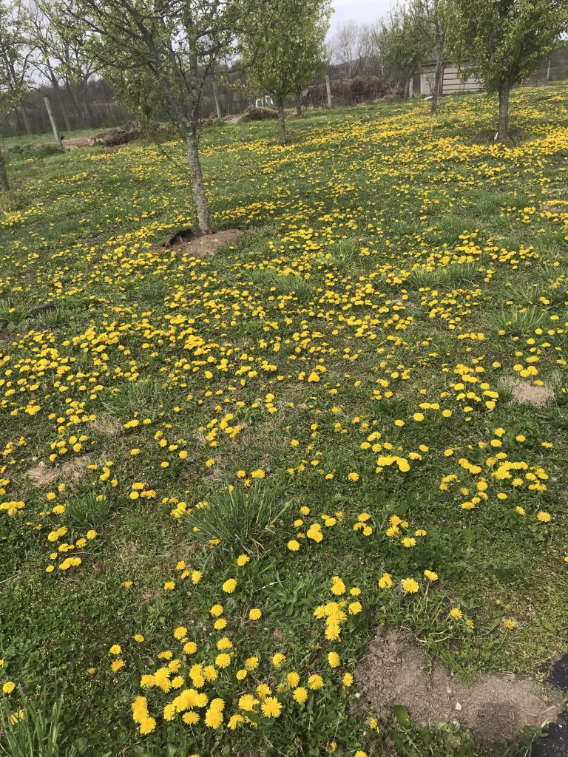
The Dandelions are up thick now, believe me, back in the old days that you lived wild and free, after a long cold winter of eating dry meat and sickly by spring, you would love to eat handfuls of this free food that aids in the cleaning of the blood stream. Just because an herb is abundant, does not make it worth less in human health—but all the authors pushing commercial herbs, almost always ignore some of there best herbs, may of which can easily be garden raised.

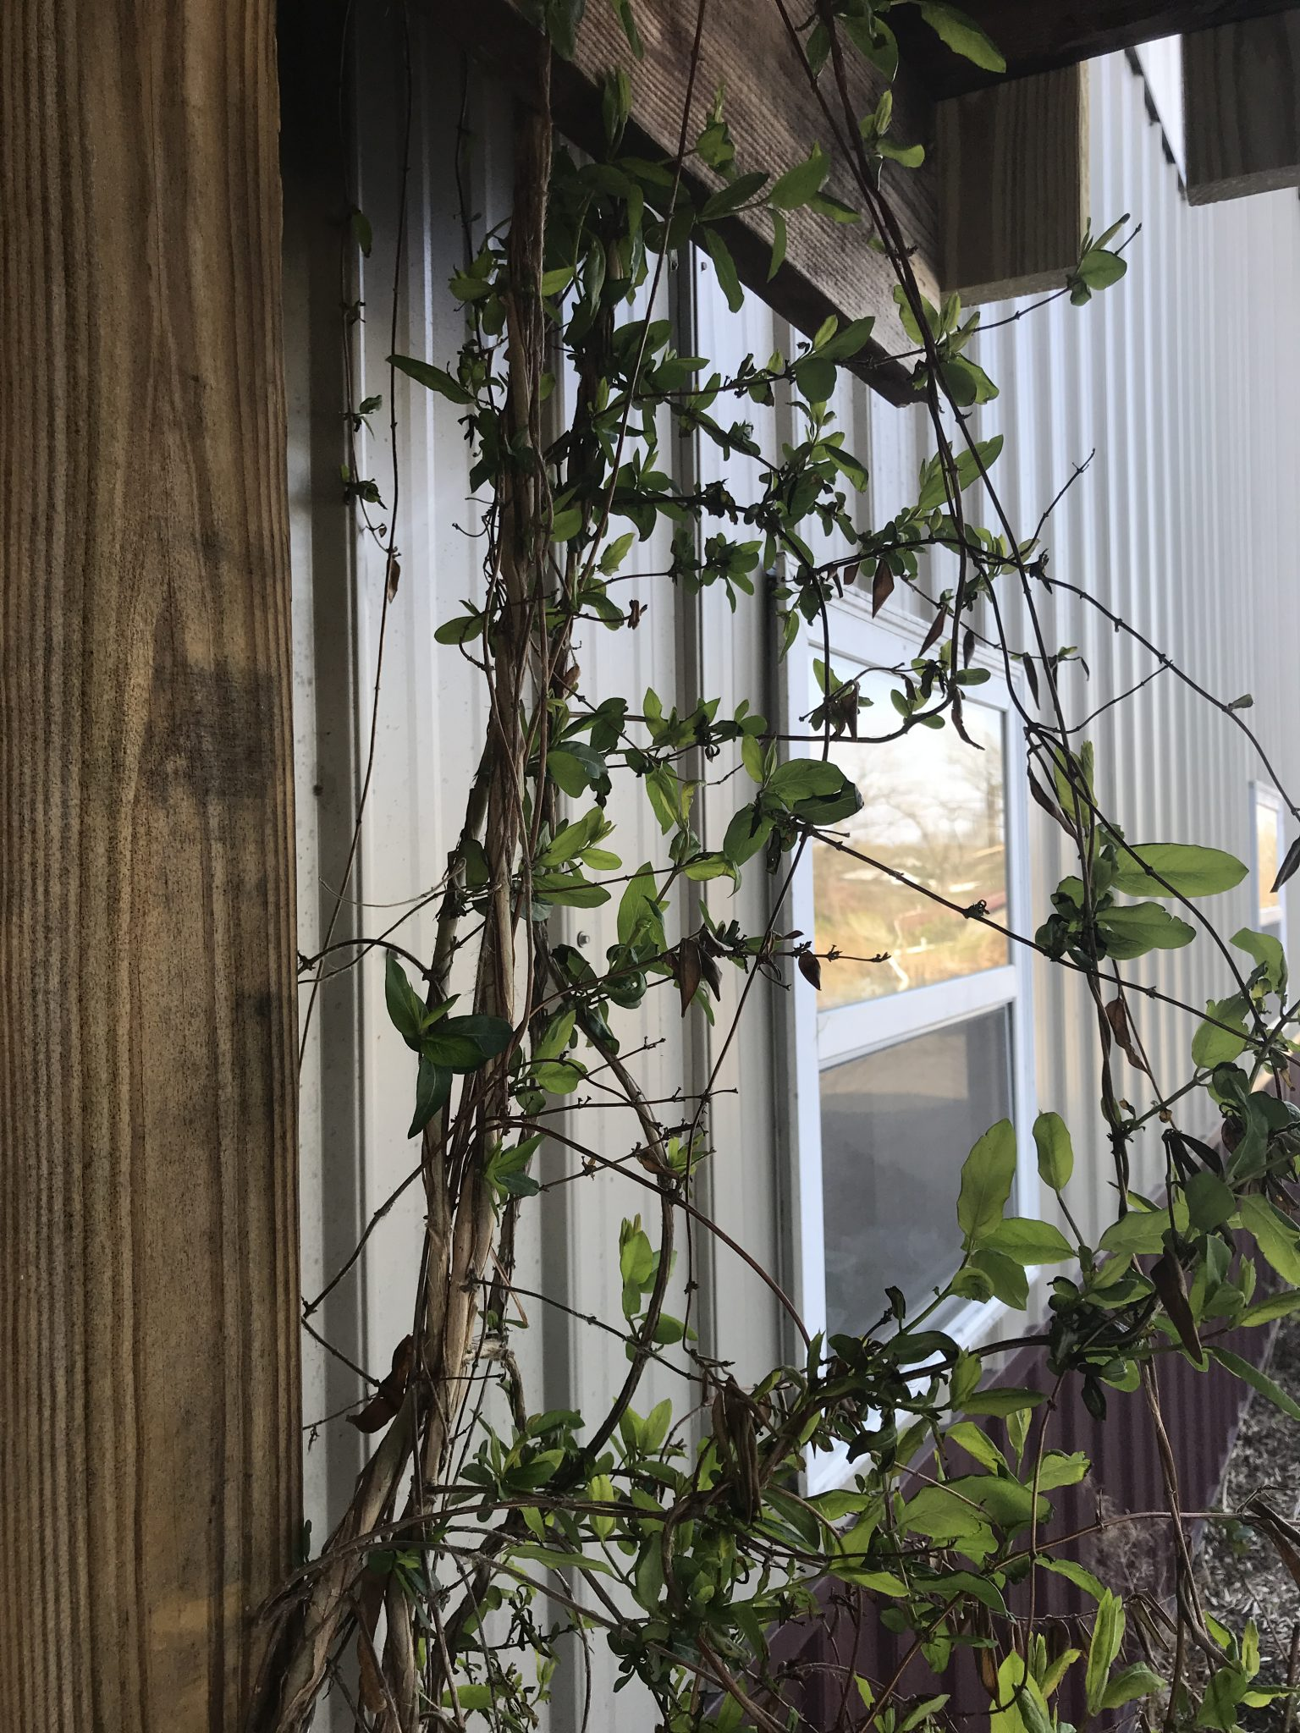
Honeysuckle use to be very common long ago, the is a plant taken from a plant that was nearly 100 years old. The real Honeysuckle is hard to obtain today, this flowering vine can be smelled from far away and one of the finest flowers you can ever smell. Every bee will come to harvest this flower. When I asked the largest producer of steam distilled essential oils on earth if they had any essential oils they believed was equal or better than Wild Oregano; they told 2 common plants, of which I have both with 50 feet of my house, of which Honeysuckle was 1 of the 2. I have many gallons of this essential oil because those that know the truth put this herb in the top 3 of all essential oils.

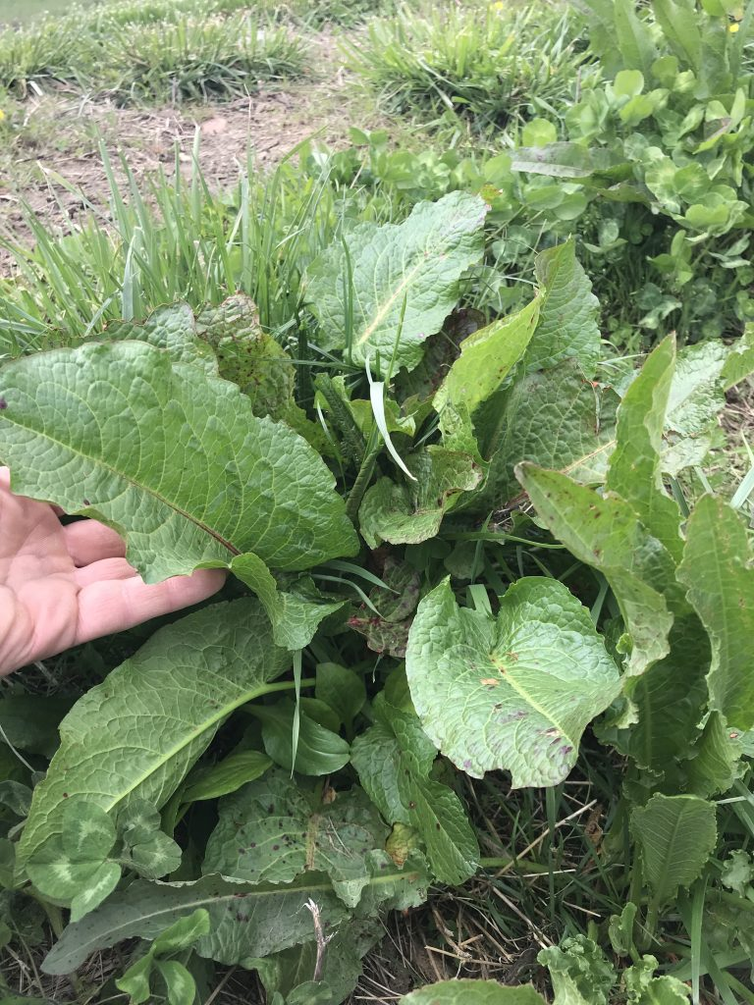
Yellow Dock grows all over my property, it loves water, known as the iron herb, this very common herb never gets the respect it deserves. The Iron Formula surely one of Dr. Christopher’s great formulas that have been long forgotten. one study showed that the only thing all mass murders had in common, was their imbalanced iron.

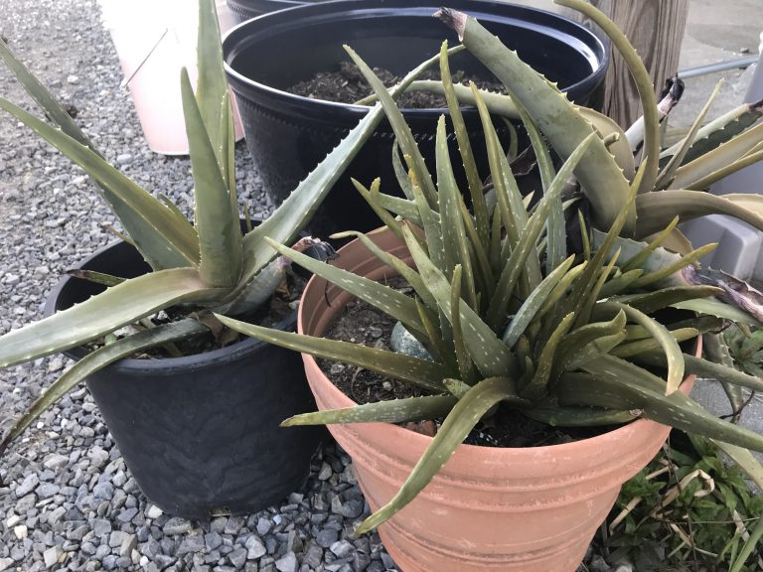
I have raised Aloe for 40 years, it has so many herbal / food uses. My mother gave me her green house my dad purchased 20+ years ago and these plants will find their new home in the fiberglass green house once I get its set up.

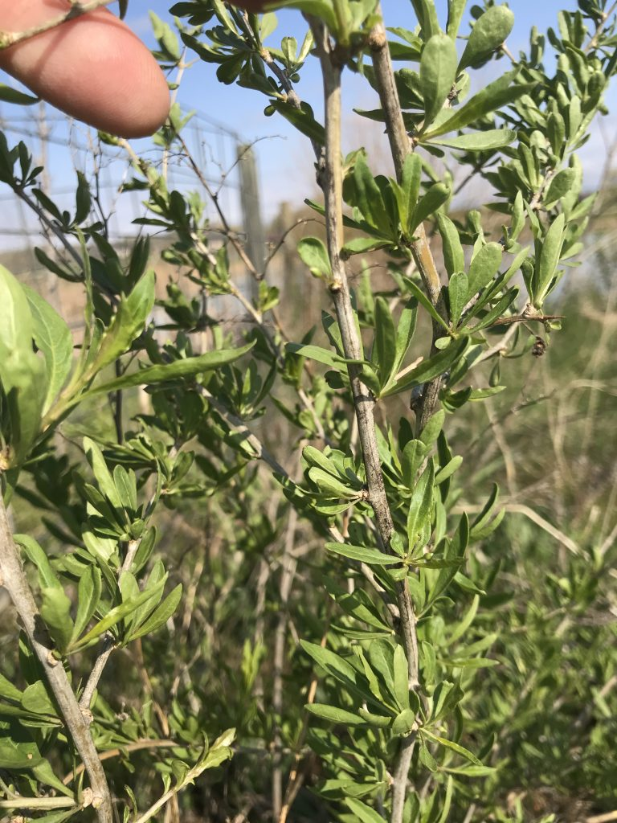
Goji Berry Bush

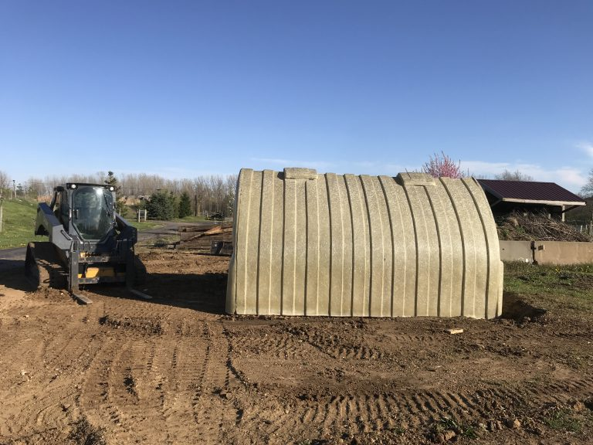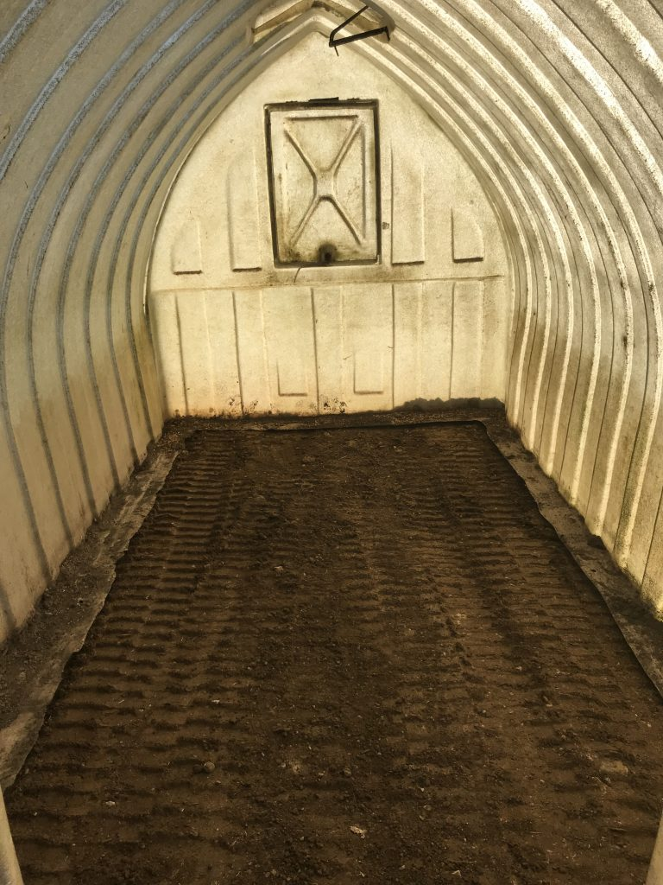

Even though this green house is 20+ years old, we were about to pick it up and put on a trailer and bring it home. This is a 100% FIBERGLASS greenhouse. Ideally it is set down in dirt 6 inches and will never rot and is very strong.

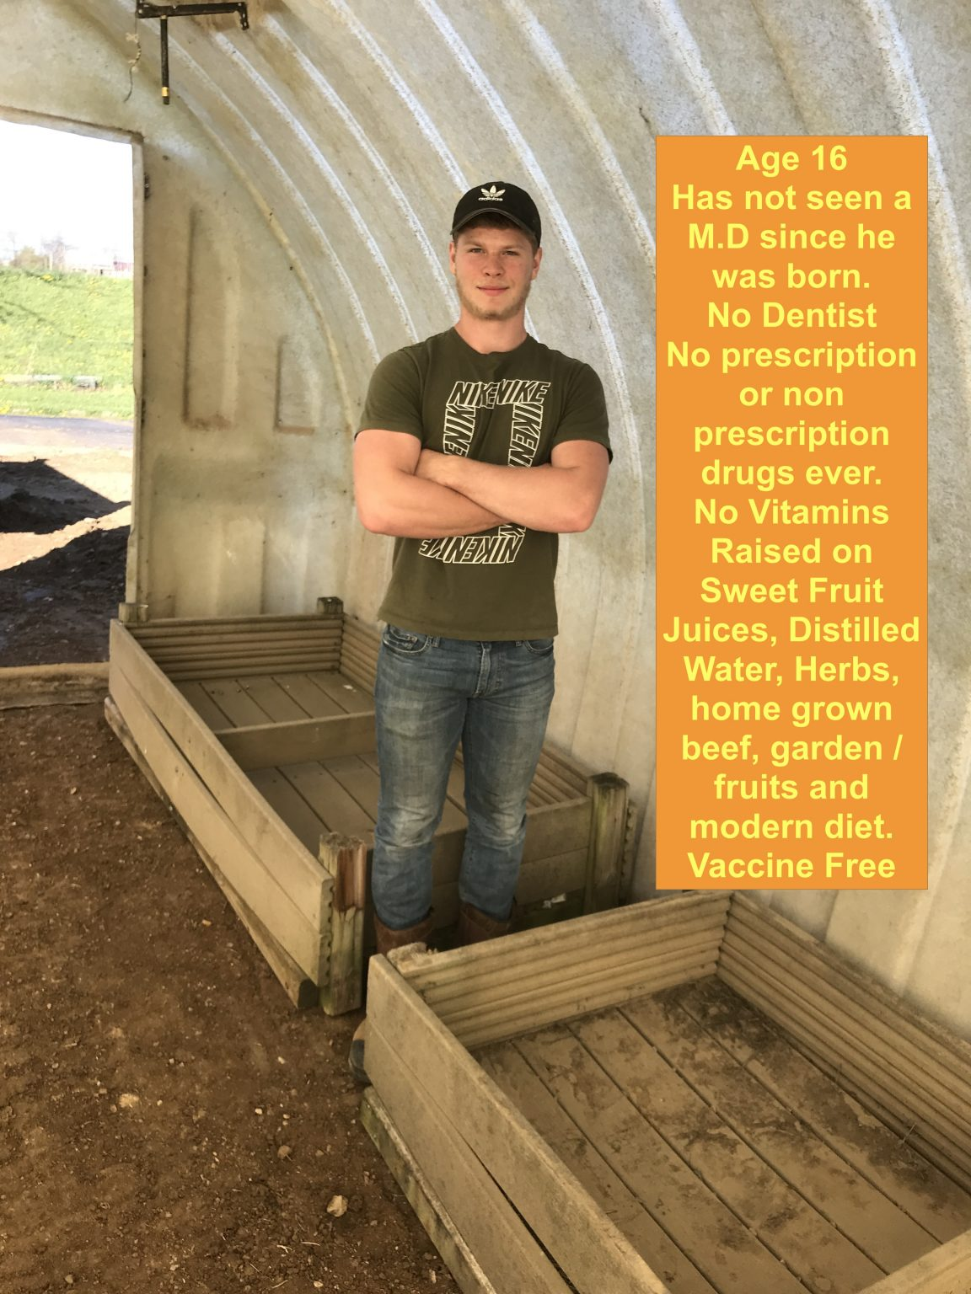

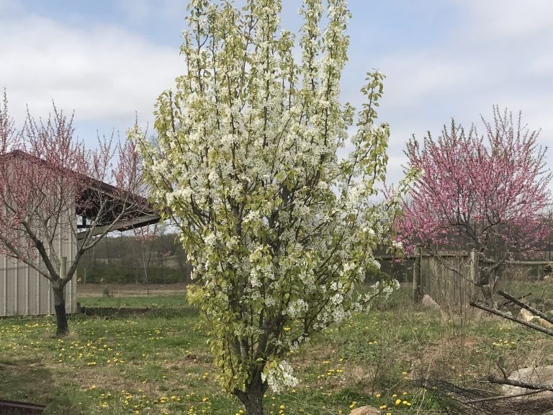

The pink flowering trees are Peach Trees and the white flowering tree is a Pear Tree. This April 20th, we are expecting snow all night and on and off snow for the next week. When i was a kid, there were apple orchards everywhere! Thanks to Chem Trail Military Global Warming, they raise the winter weather 30-50 degrees by filling the skies with aluminum and titanium dioxides to trap the heat and control all weather year around. This spraying not only poisons all life on earth, they create abnormally warm winters and then on the days they do not spray, the temperature can drop 30-50 degrees. We have had hot weather that always tricks the trees and plants to flower early and then when they allow a few days of natural weather, they kill the flowers every year and as a result all the apple orchards have been gone for 20+ years.
“If” they shut the chem trail jets down, we would still be experiencing winter weather in the 20’s and none of the plants shown above, would have green or be flowering. This spraying started in 1949 to date and they 100% create Global Warming in attempt to control an ice age period. By 1992 they added chemicals to affect the thyroid health of every mammal on earth, in an effort to reduce human populations worldwide. During the aerial atmospheric spraying, we have had air conditioning on, wearing tea shirts and boating / fishing. In the morning we will be shoveling snow. “IF” they would stop spraying us unwanted bugs, this planet would be ‘freezing”, The human body is loaded with these heavy metals and there are ways to remove some of it and will be just 1 of the many educations deeper into this website.

April 21st

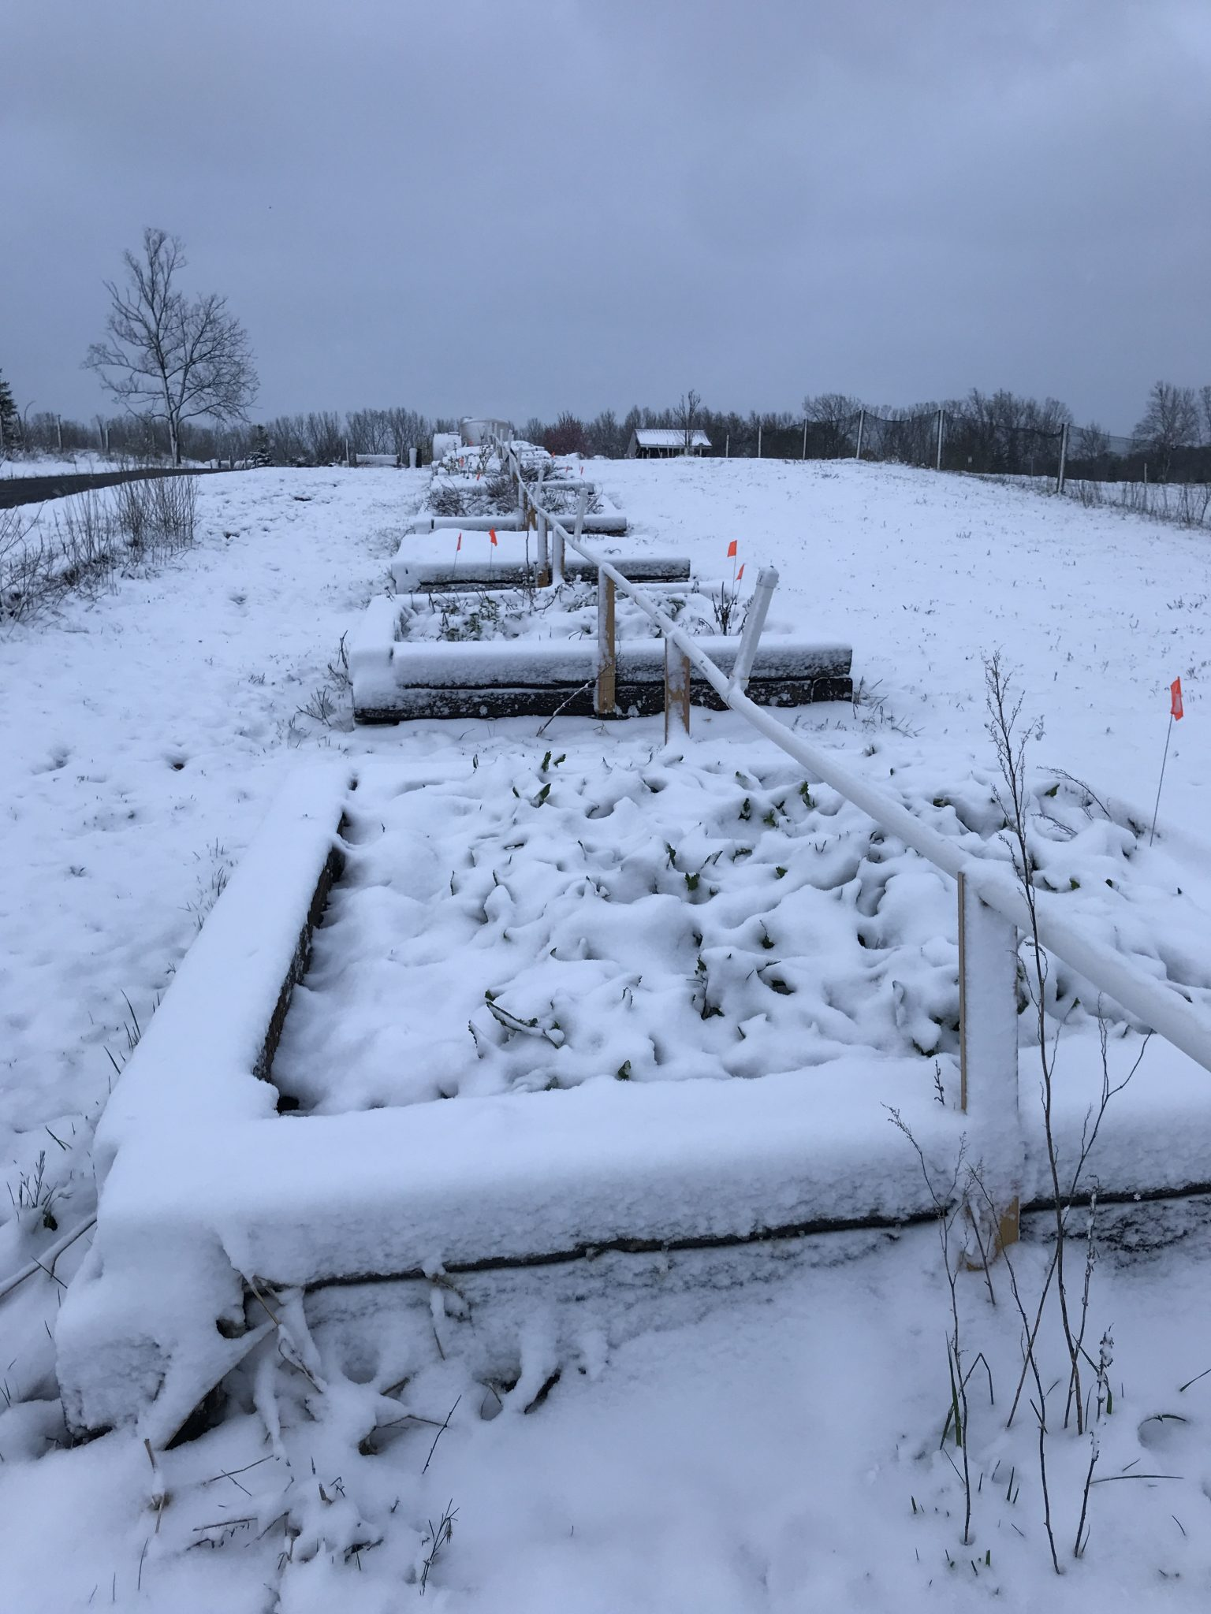

The lower box is the tall Horseradish shown in the picture 1 day earlier!

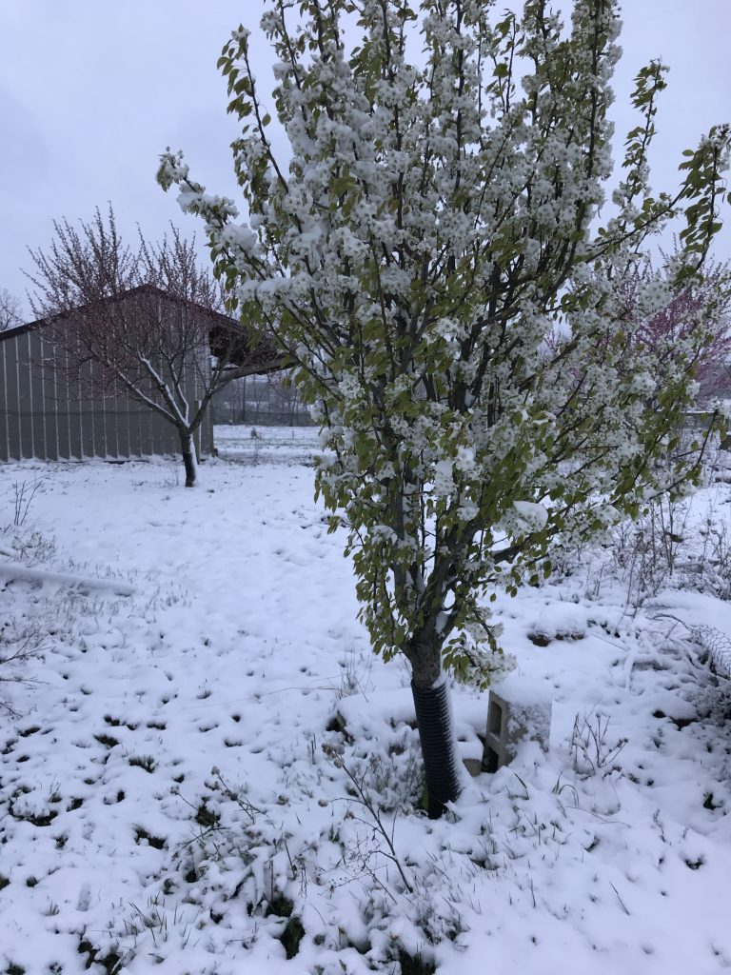
Pear, Apple & Peach Trees, year after year do not survive the weather manipulation. The hardwood trees have been prematurely dying for many years due to fungus that grows due to lack of enough sunshine, thanks to weather manipulation started in 1949.

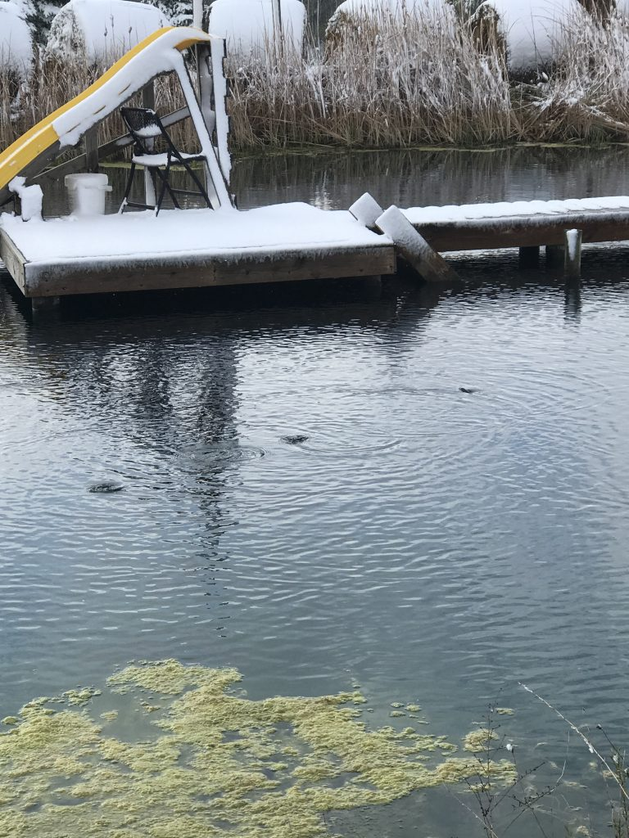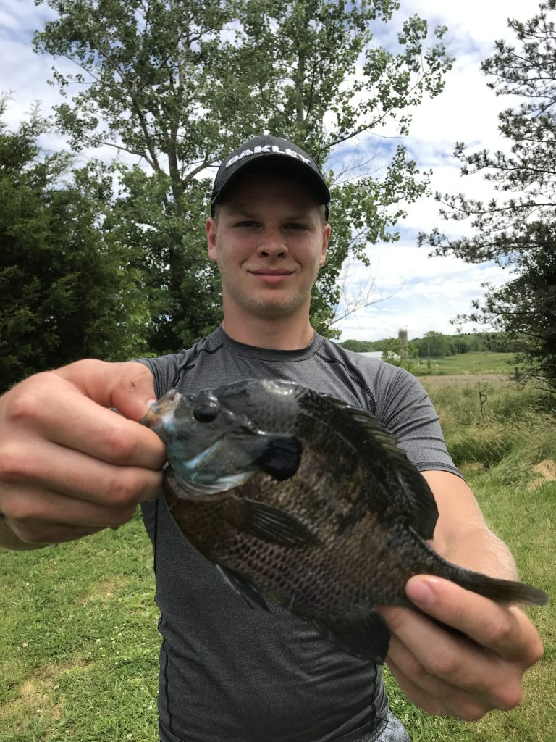
Bluegill fish eating floating food, in mid 20’s temperature.
The interesting thing is a breed of Bluegill Fish I obtained last Spring, these pan fish have babies all summer long, even when they them selves are just months old and less than 1/2 grown. I have never seen such a “Hardy” fish. More amazing is how they eat in cool / cold water. The normal bluegill and other species that will eat commercial fish feed, will not eat until warm weather. This bluegill has been eating for a few weeks and the 20-degree weather did not slow them down.
Bluegill fish are generally not a commercial “food” fish, they have millions of babies that become food for the larger fish, including their own species that eats the majority of the eggs and baby fish. Yet, the common bluegill, often known as a pan size fish, is one of the best tasting fresh water species found in the wild. I have built ponds for 40 years and have not eaten a pond fish for 30 years, but if I was to, the Bluegill would be one of the best. Commercially they want larger fish, such as catfish & perch that can be trained to eat commercial feed and certainly most salmon and trout sold today are all commercially farm raised. This particular bluegill, when fed, can grow to adult size in one year, this far North, which is surprising to me.

April 22

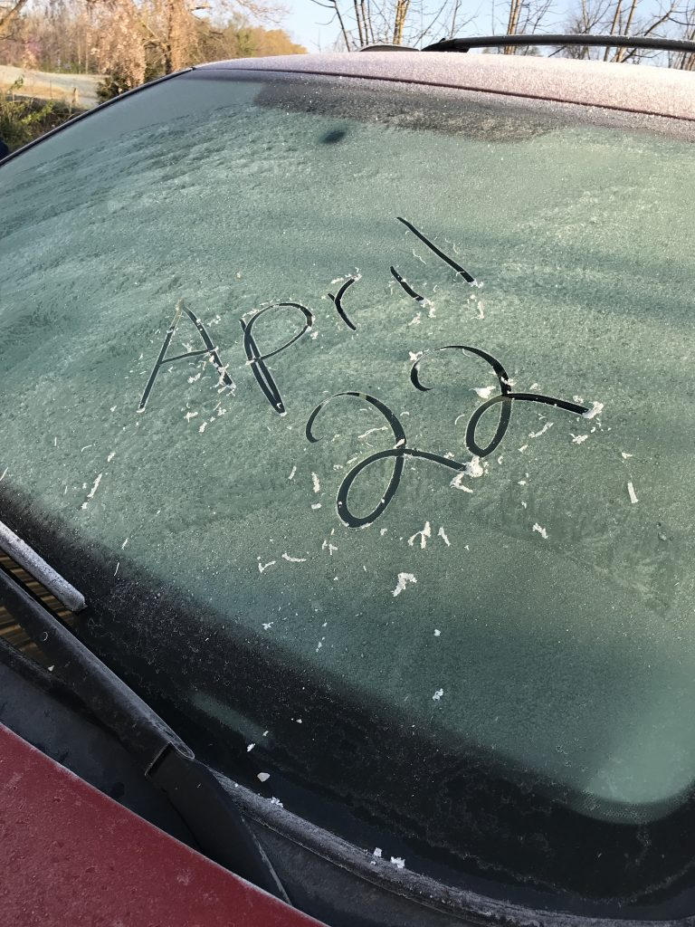
Snow, Sleet, Frost makes the fruit trees near impossible

April 24th

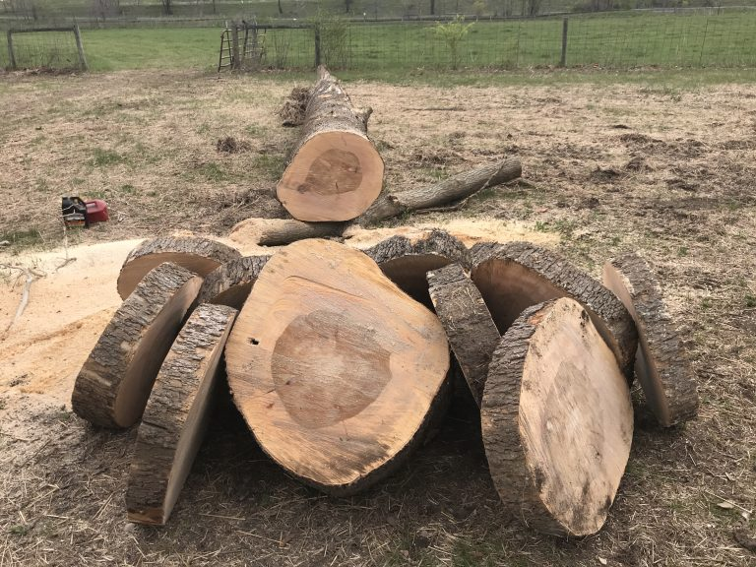

A large Popular tree about 100+ feet tall fell over into the field, these huge trees in the cotton wood family grow fast and heavy and commonly grow along creeks where they suck up water and become too heavy for the wet spring soil to support their weight. The cotton wood trees growing in the same area are up to 5 feet in diameter and over 100 feet tall and all leaning and one day will fall over. Huge cotton wood trees are almost impossible to cut and too heavy to move. The old timers and Amish still to this day will make slits in the huge cotton wood trees and back with black gun powder and explode the powder so the trees will split into pieces so they can be lifted up into a saw meal.
The wet / heavy trees are considered hard wood trees, but also the “softest” of the hardwoods and long ago they used them to make barn floors, hay wagon floors, bridges; anything that kept the wood from having contact with the dirt. if they are in a wet situation the wood will absorb water and then rot. The wood is considered worthless as a heat source. In current history, the cotton wood family trees are taking over as the good trees are failing to thrive, due to the chem trail jets blocking the sunlight, which increases the mold and there hardwood forest are dying. These wet growing popular / cotton wood trees seem to be mold resistant and will grow in wet soil. They are one of the few trees that can be covered by moving sand and the trees will continue you to grow even if only a few feet of the top of the trees are above the sand. they are extremely hardy trees considered as a worthless tree that is damaging once they fall across roads, because of their great size and weight. The cordon wood trees are twice as wider as the tree shown.
YET, being the softest of the hardwood trees and of great width, they are “perfect” as a target for ax / hatchet / knife throwing sport. I normally cut them up and make piles in the corners of the pond and allow them to become a natural mineral / fertilizer for the fish. The men of 200 years ago loved these huge trees to build their barns–back in the days with no tractors, no chain saws and men—were real men of great strength.

