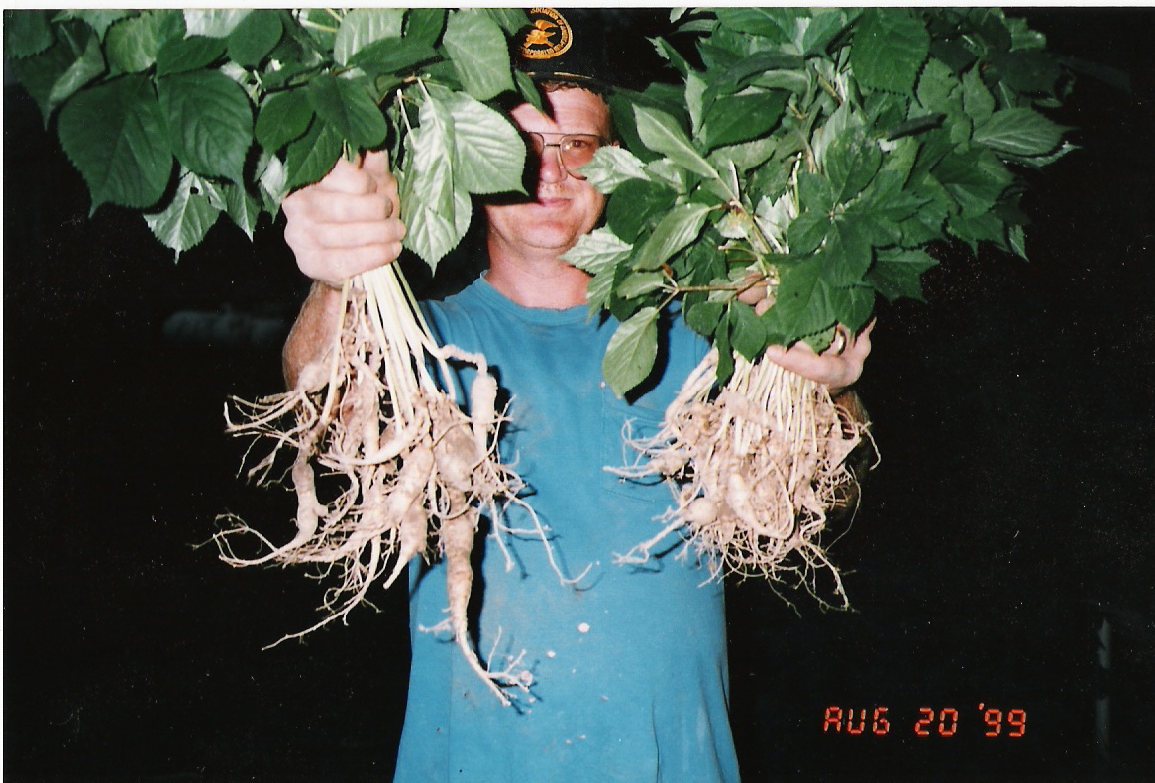

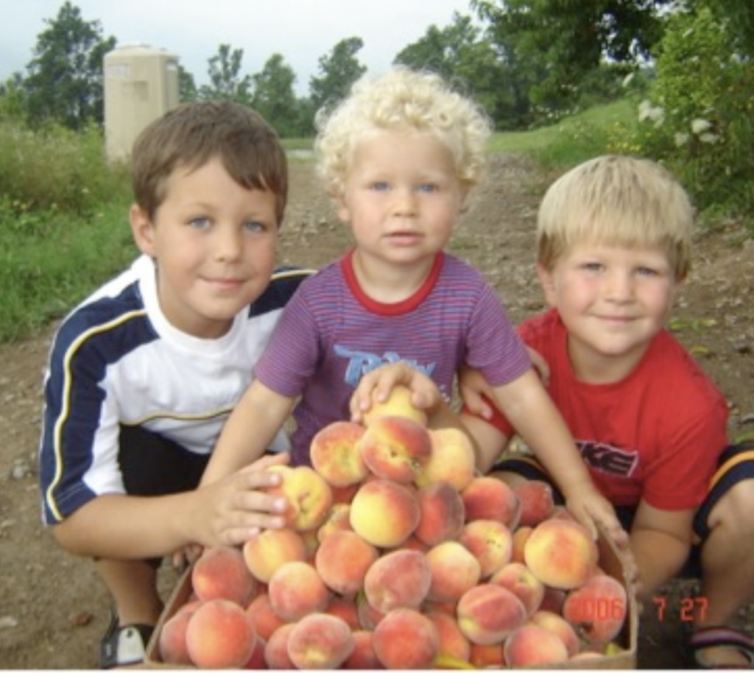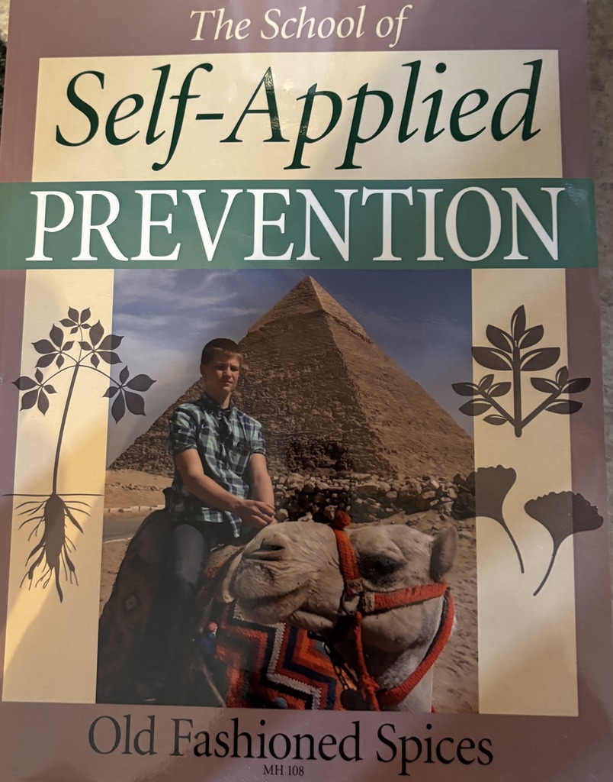

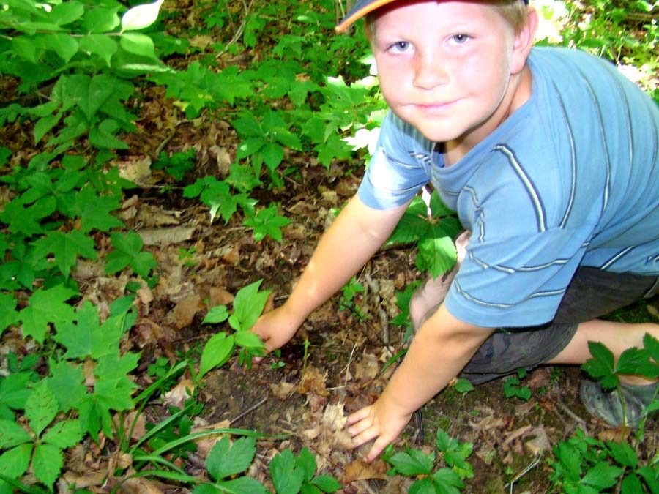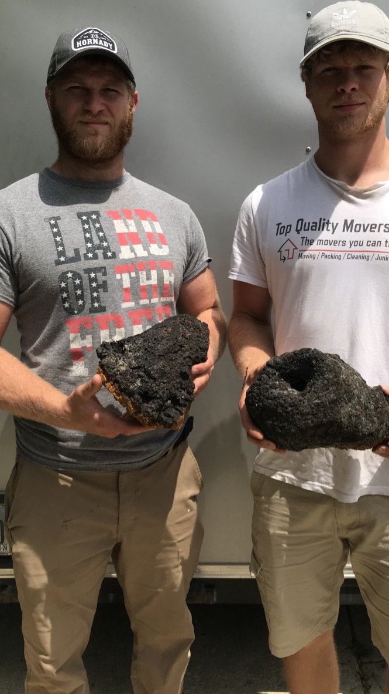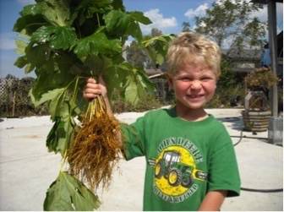

Old Fashioned Spices
LifeWave
Live Long ~ Live Well ~ Live Younger

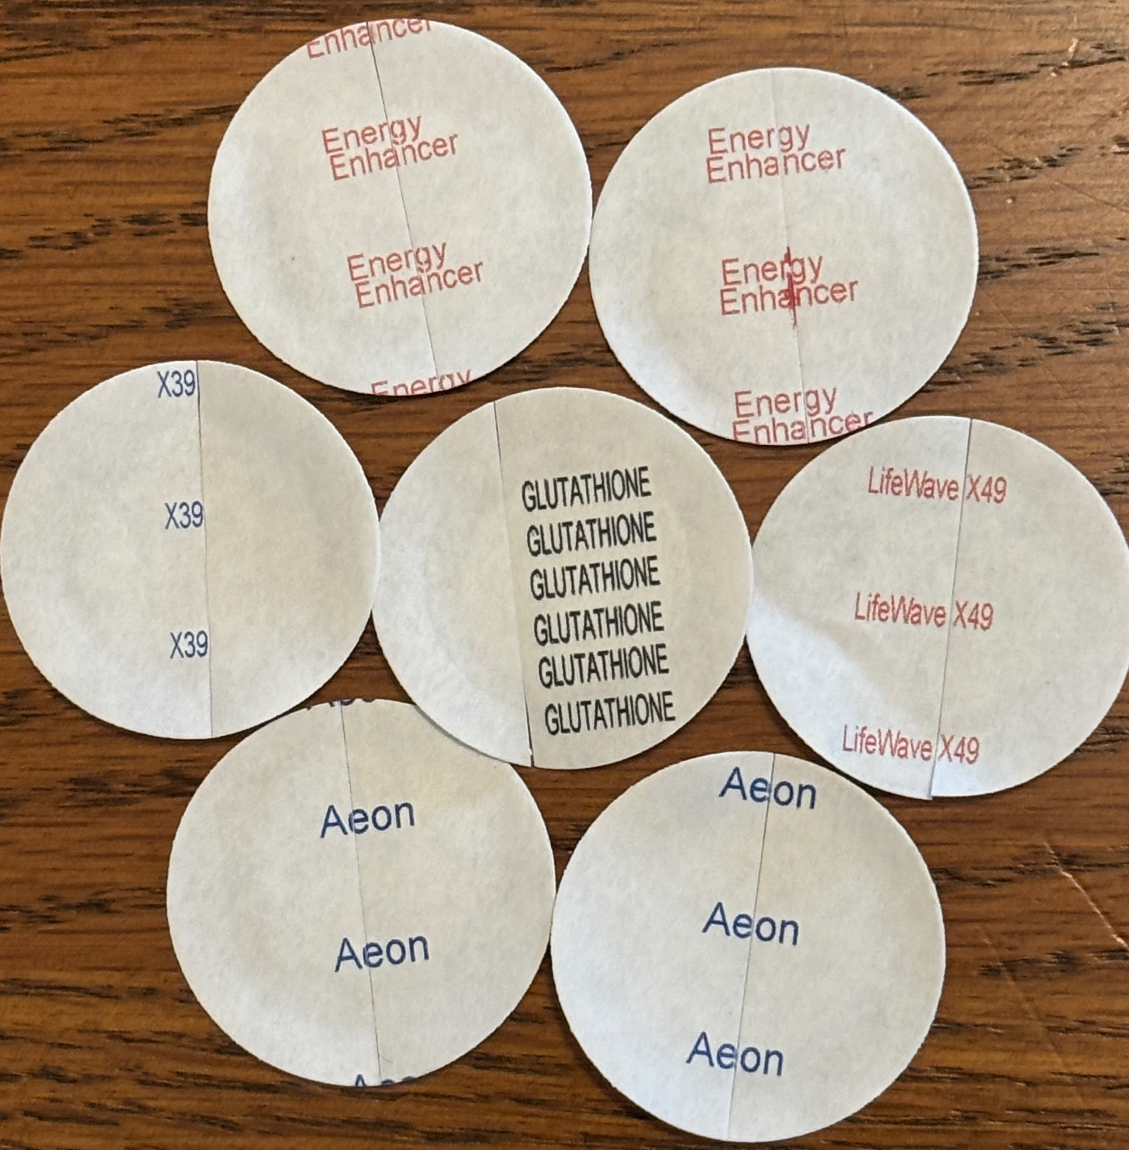
The author has made steam distilled water, studied herbs & old medical authors, made herbal products, not had a doctor other than a chiropractor since 1985. The children never saw a doctor after birth other than their chiropractor! Drug / Vitamin Free! I Grew up with no running water in the house, a hand well pump outside and an outhouse 100’ from the house. Went to town several x a year. Eventually milked 100 head of cows daily as a teen. I Never lived in a city. If you can see your neighbor, you live too close! I have had multiple broken bones and never went to a med doctor thanks to learning from people such as David Christopher & John Keim; that understood broken bones with herbs and chiropractic aid.

2026

All information subject to change!

My Opinions!

Nothing more implied!

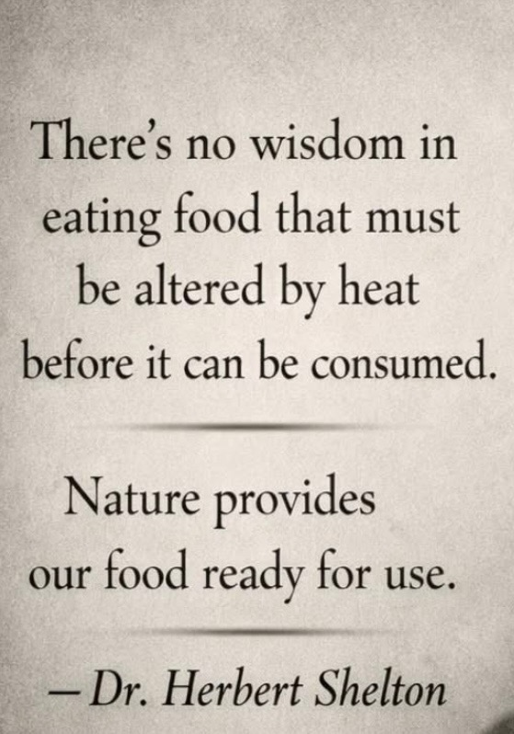

A 2-year-old “Knows”

Every toddler in the “wild” before electric, fire, tools; all adapted from mother’s milk to Nature’s Free sweet / yummy fresh ripe fruits of each color of the season. Honey is Nature’s Treat! All species eat “Free” Foods! Can only live where their foods grow free. Factory made foods that do not rot, is “stuff” that was never created for health. What accumulates, ends in death.
Prevention Starts before Conception! We are not Sick, We are poisoned! Deficiency Diet starts, the day of Conception! Parasites are a Result! Their Job? To return those that disobey; back to the soil! A Real Chiropractor is a must, to be drug free! Dirty Water #1 Cause of Premature Age / Death!

All Natural Ageing / Death is Advanced Scurvy!

Sweet / Yummy, Root Bark foods from Trees, Bushes & Vines have “organic” size minerals that are Anti-Scurvy! All none root bark plants have all the world’s pollution and rock minerals that clog the body & create scurvy! World War 1 never ended, never slowed down! All wrong foods clog the body, insures aging, loss of circulation, loss of health and starvation. Wrong foods feeds parasites! Lymes the last Great Plague! Males age 250, healthy as their 24 year old sons, studied 11 years, Oxford Med proved they ate 99% fruit / root vegetables and 1% meats. Published as The “Vitalist”, by1900 and later nicknamed Vitamin! The foundation of medical. By 1920 Dr Hay, MD / Jackson, MD cured all with Oranges & Corrective Diet! Dr. Morton Walker tested these males in recent years and proved they are lead / heavy metal free! He said that must be the reason they never die a natural death!

A None Deficient Diet enables Health / Longevity!

LifeWave believes in Reverse Aging!

The Body Physical 50% / The Body Electrical 50%

Super Babies

Healthy Children

Bone / Dental Health

Self-Applied “Prevention”

Clean Water

Parasites / Cleanses

Pets / Livestock

Burns / Broken Bones

Aging / Reverse Aging

Alkalinity / Acid

Digestion / Elimination / Poisons

(To explain all would take 1,000+ pages)
Prevention is far cheaper, far more rewarding and avoiding of pains and hardships. Sickness is “designed” to own the family farm. Old Med said it simple, if you do not eat it, you will not need us to help you remove it.

Warning: 100% of the content of this book is Opinions Only! These Opinions are subject to change as I learn! Every time I think I know it all, I discover I barely knew ½ of what I thought I knew. These are my opinions from reading / self-experiencing; many health books written from the 1600’s to date!

This info is not for anyone or for any diagnoses! It is written for fun and for self-experimenting adults only. Generalized Theories! I personally have never discovered anything new; most everything is the result of learning from books and teachers. Teachers can be “everything” Nature has to offer!

Nature never lies, never changes! My 1st herb teacher often said; ask any Gorilla your health questions, he cannot lie! Only humans can choose to lie or lack experience to know. All humans are all at a different level of dying and degree of constipation. All that do die naturally, will die of “advanced” scurvy! All suffer from imbalance, acidic diet and have trillions of parasites in them. Every breath of air is toxic, full of fungus and chemicals. All require daily antidotes! This is zero medical information; seek your white coats for that.

You will need a great Chiropractor and a dentist for correction of dental disasters. The “Best” MD cured all with diet by 1920’s!

God is Good, God is Always Good!
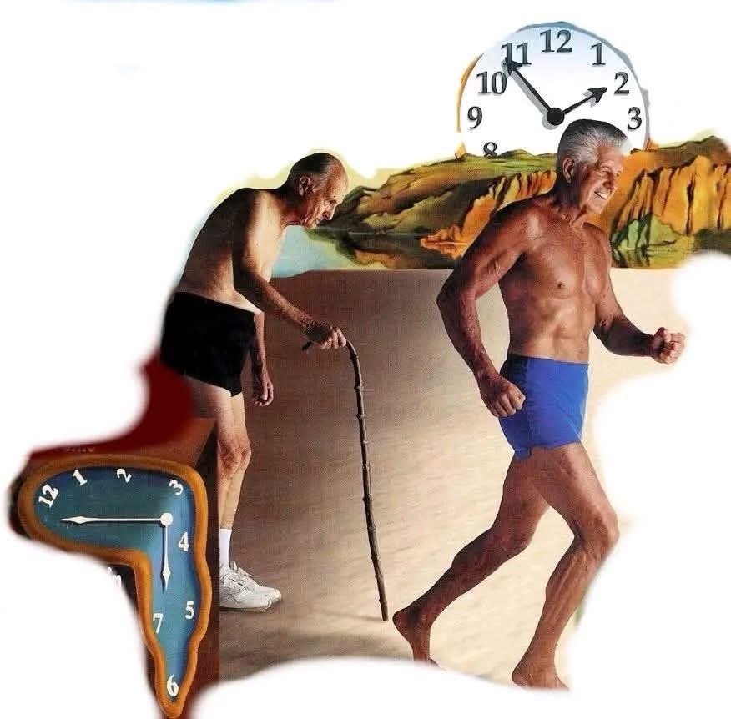
All premature death is a result of deficiency diet / light, loss of Circulation / Advanced Scurvy / Dirty Water / parasites / mold / fungus, predators & poisons! Our subconscious mind controls our heartbeat, breath, and functions and lies to us all the time! We are what we “think” we are and should be, making false education the enemy.
The Body Electric 50% of Health!
The nerves, brain, intelligence, love, desire / family!

The Body Physical 50% of health!
Bones / Flesh / Cartilage (BF&C), our mineral body!

The goal of this booklet is about reverse aging! Elimination of the bad; more of the good and antidotes for the unavoidable. Much of this information comes from pre 1950. The human body is no more what is put in the mouth; as is a tree made of dirt. If a tree were made of dirt, it would fall over from the hole beneath it. All life on earth is a result of Sun Light and the Sun’s “Perfect” combination of Minerals. We and all are what we breathe, what we absorb, what we make from the sun. The earth & air is all “electric” from the sun. “All” is North / South / East / West “Magnetic” Electrical Energy!

Old Med believed humans do not eat to digest and assimilate what they put in their mouth; they believed they are trying to absorb the “Light” (radiation)” from what they ate! When the Stomach & Liver are both “empty” they are blood cleansing organs! Everything that enters the body, effects the pH and mineral “balance” and the blood rapidly wants rid of it and return balance. The blood seeks to be 7.35 pH always!

The Body Electric 50%
The Body Electric is our nerves, our brain, our cells, our solar plexus - our Light! We are Electrical / Light Beings!
While growing; our Light / Electric should be “perfect” & strong! All electric deficiencies will cause health issues same as all diet deficiencies! These deficiencies start after conception! Plentiful Sunlight, fresh air on all skin and grounded to the earth always; is how Nature intended! Not wrong foods, clothes or houses! For every “sin” against Nature, the body pays a price with less health. The human eyes need experience in darkness! Never ever wear sunglasses ever!
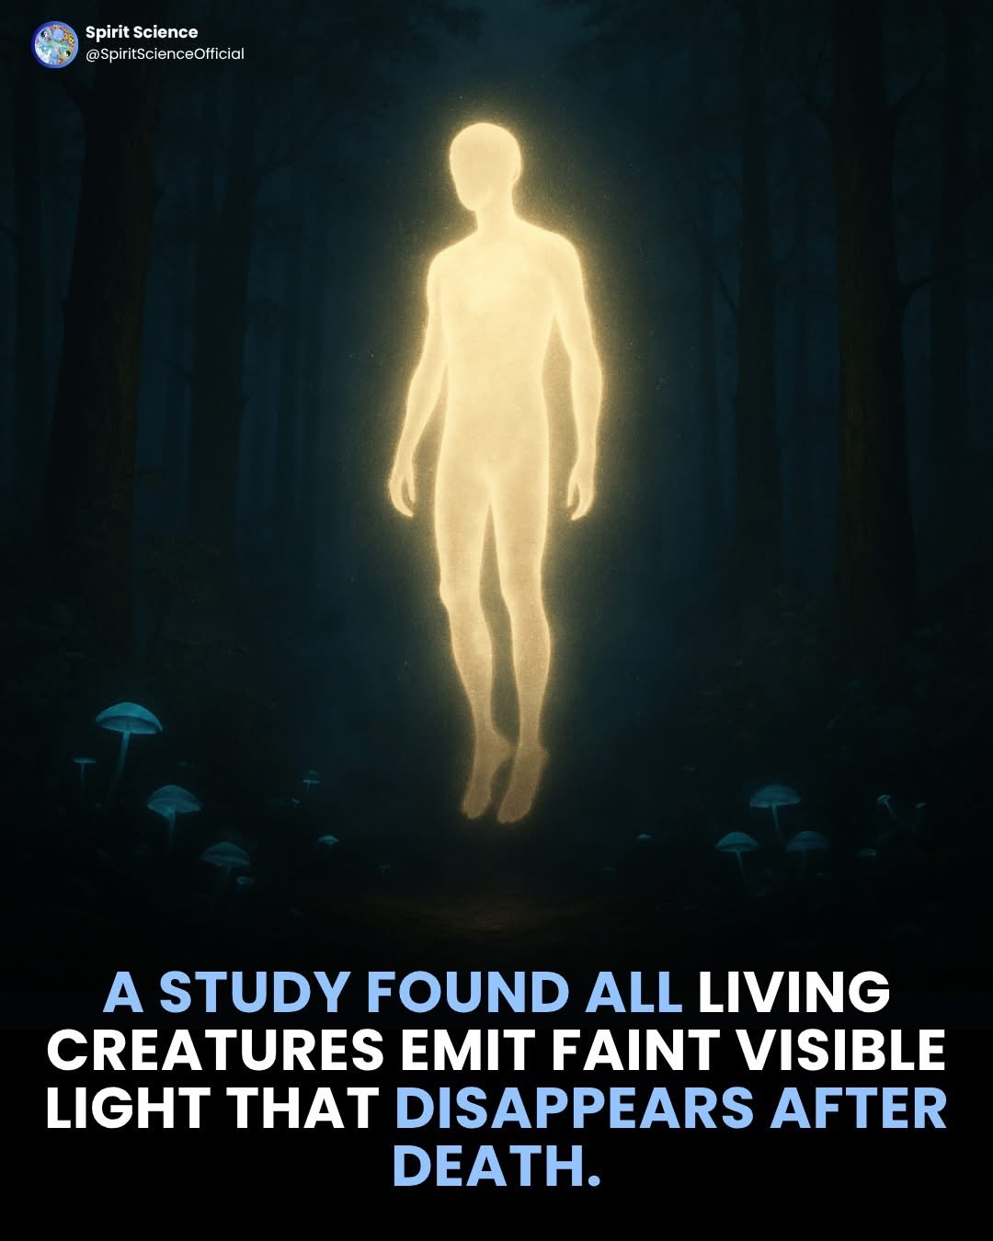

The Body electric is affected by every foreign object inside the body and designed to always be grounded to the bare dirt! Nature never lies or looses! Life is very much like a battery! Human history suggest, by age 25 we are full-grown and then we start to “age” by way of less “electric”. All the great scientist / doctors “all” have 1 thing in common, they died young, most die less than 100 years. Self-Poisoned and most of all; from “false” education, they followed their false “prophets” their eyes and ears and went the route of their family and neighbors. The subconscious brain determines your health, strength, weight, life and death based on your beliefs. False worldly education / fears is always the #1 enemy.

The Human Battery by 1950 was proven to be 100+ hormone producing glands under the skin! Creating ”all” that is required from sunlight and our air supplies the oxygen and water! The none stop Sunburst supplies earth with endless (manna) minerals, as do volcanoes and winds. Med by 1950 believed humans were created to never eat or drink and the sun & air provided all. True functional humans live on sun / air and hormones control the functions of the body. When humans started loosing their hormone producing glands, they are hungry!

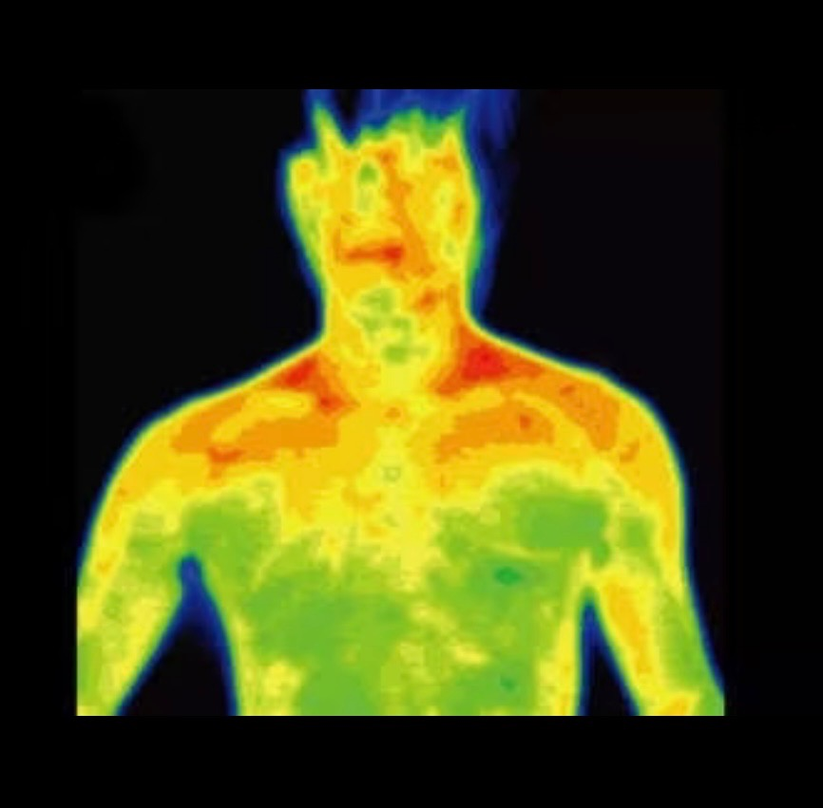
All mammals “glow”, we literally “loose” Light! Our fingertips and lips glow the most! We have at least 108 spots called acupuncture locations where we loose light. These spots can be tested and located on anyone easily with a simple device. These “spots” connect to our body electric! Our cells create .07 volts of electric!

The Body Electric has been explored by medical since electricity was made. By 1960’s real medical has been frequency / light medicine! Endless devices, lights, methods, hospitals etc. The most human friendly was created 22+ years ago by David Schmidt, and created The LifeWave Company and I personally believe that is the “Best” company / product / methods in the world that is human “friendly” & economical. His goal is helping everyone & “believes” in the possibility of reverse aging! Most of his products have proved real and some I put in the “miracle” category. Lifewave products / methods take time to learn and best to have someone you can call anytime (Brenda) and ideal is having at least 1 book. There are many books on line.

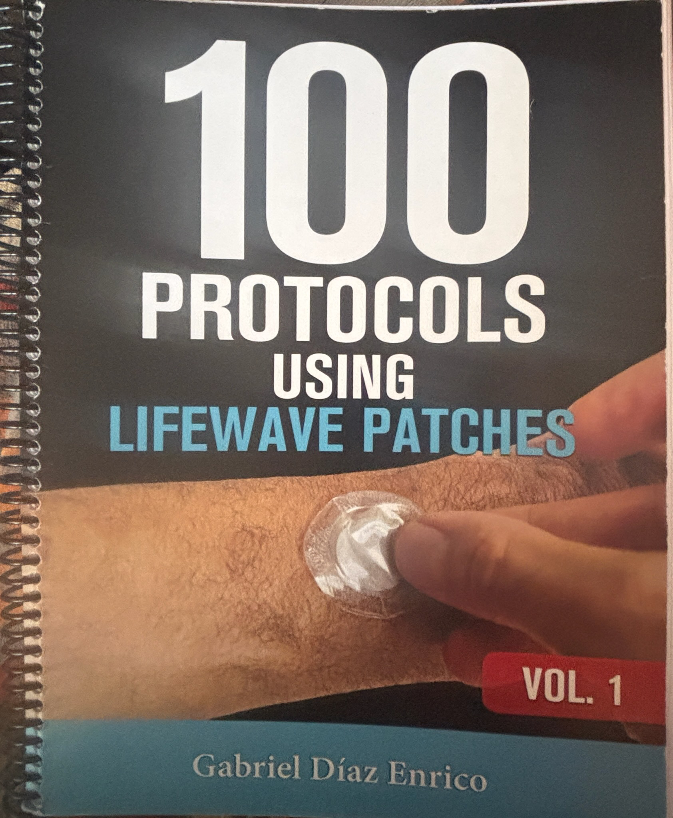
We have this book printed to heavy paper for the American Amish and this book is the key to that success! Having a physical book is fast and easy and a “must” in my opinion for those wishing to explore the entire LifeWave Experience! I highly suggest anyone using Lifewave to have this book and understand people experience LifeWave over years of time! It is daily for Life!
I have read and explored human health since 1985 and not had a dr since 1985 and believe LifeWave covers all the needs of The Body Electric that products are capable of! Otherwise humans are designed to live in the Sun, every day, all day with no clothes. Longevity starts with the Sun!
I use: LifeWave X-39, X-49, Glutathione, Aeon, Energizer Patches Daily. Nighttime I use Silent Night. For those that have pains, nothing compares to IceWave with Aeon.

Most Important is The Alavida Patch for nighttime for the health of the Pineal Gland!
For a better understanding of LifeWave Products, please

call / text Brenda @ 937-210-2332, e-mail:

countrybaskets@earthlink.net. Visit

www.Lifewave.com/BrendaBerry and for lots of info:

www.barefootherbalistmh.com

X20 Water 2 glasses daily with your X-39 & X-49 is

Miraculous!

LifeWave X20 Water is based on Infusing Light, frequencies based on The Tree of Life and Hydrogen.

I highly suggest you only use your own Steam Distilled Water in this machine and never drink water unless you have steam distilled it 1st.

I drink 14-28 oz. of X20 water every morning! The inventor says always wear your X-39 patch every day, with this water! I highly suggest this, I have seen near miracle results with their 1st glass of water when elderly / sickly people have done this. The results after 30 days, I put this in the “Miracle” Class of products. X-39 with X20 and You GO! MH108

LifeWave, you can endlessly watch videos and read on line, watch / Listen to zoom calls from the inventor and large groups or better yet, just call Brenda, she loves to help those that are willing to ask. She and sometimes her friends will even do seminars. The rest of this little booklet will be about all the subjects people do not like- Diet, Habits, Parasites, Poisons:

Why we all prematurely die!
The Body Physical 50%
The Body Physical is a huge, never ending subject because people most often; until all else fails and then attempts to undo a lifetime of “wrong”. Truly an ounce of prevention is worth more than a pound of cure! That apple a day would have kept the dr away for a very long time! Sadly Nature
never lies, never looses and every human succumbs to the laws of Nature!
1880-1901 Oxford medical studied males age 250 that never die a natural death. Published as The Vitalist! Dr. Morton Walker tested them and discovered they are lead / heavy metal free. He believed that explained their health. Their diet was 99% fruit / root vegetables and 1% meats. They lived at a high altitude. They are still studied today!



The females died by age 150’s due to having too many babies to close together, 3 years apart is the minimum; those that break that rule have ill babies for the fact their baby can be no healthier than the mother. The mother gives of her health for each baby. Generally those that fight natural fade away by their 7th generation. She needs 3 years recovery between babies!

Fact: Humans were created to live where it never becomes colder than 65 degrees! If a coconut tree cannot survive, then the climate is not ideal for humans. Nature rewards for obeying and Nature provides loss of circulation for disobedience. Humans respond as an invasive specie due to the fact all other species on earth obey and only eat what God provides freely.

It is a simple fact, baby is created by mother’s blood and then once breathing air, phase 2 is mother’s milk. Mother’s milk will have all her poisons and her parasites that her body wants rid of and her blood dumps into her milk to be expelled from her body. Her milk becomes part of her monthly period. No mother can change that fact of Nature. Milk is blood minus the red blood cells!

- There are multiple human plagues, the oldest dating back to the beginning, in that humans cannot keep or make what is called Vitamin C. Every newborn baby suffers from this plague. Mother’s milk supplies none and her milk cannot be better than her own health.

Dr. Howard Hay, MD america’s greatest and 1st alkaline dr learned how to cure “all” with orange juice & corrective diet. He explained babies are not “perfect” because at birth, they all are Diet Delinquent! This brings up the 1st subject Super Babies! Not a subject you will find elsewhere. A Super Baby is conceived by a mother that has no diet delinquencies- More Simple than one would think! She will naturally have less parasites and the wise, will want to de-worm prior to pregnancy.

This baby will be born “stronger’ than normal babies and “if” the diet is not delinquent, this baby will “develop” normally by age 1 and the smartest group of people on earth, told me these will be Super Babies! Dr. Cass Ingram wrote that these babies will be born healthier, stronger and prettier than other kids their age in school. Our kids were some of the strongest in their school sports, wise and their children better yet, so I agree with their theories. I took what they wrote / said and did it my way. This entire booklet is My Way based on many authors, books, people and experiences. I make my own conclusions and everything is subject to “change”!

The following are handmade, somewhat exotic herbal use!
Unique to say the least!

The Super Baby
100’s of books have been written exploring all the whys and how’s, everything can be done “Better”; for the Super Baby subject, the following has to do for the most important human on earth- the 1st granddaughter! So it had to be the absolute best.
The 9 months in the womb is simplistic! Drug free, Poison free as possible! No deficiencies! The New Born Baby! Day 1, we all noticed incredible hand strength, eyesight and awareness. Every farmer understands Parasites & usable Minerals! The same applies for Super Babies!



The well prepared parents: to - be read / ask and are prepared and not easy victims. The “Best” Chiropractor adjusts the mother monthly and then weekly the last month and is well experienced with pregnancy. For a true super baby, drug free & natural as possible is essential. Mother’s health is priority and mother’s milk the only true food. Avoiding all the “traps” saves mother and baby’s health. You do not want to fail in education and learning from others, because for many, the 1st baby is sacrificed due to fears and failure to understand that you are in charge and drs work for you. You take charge of your family.

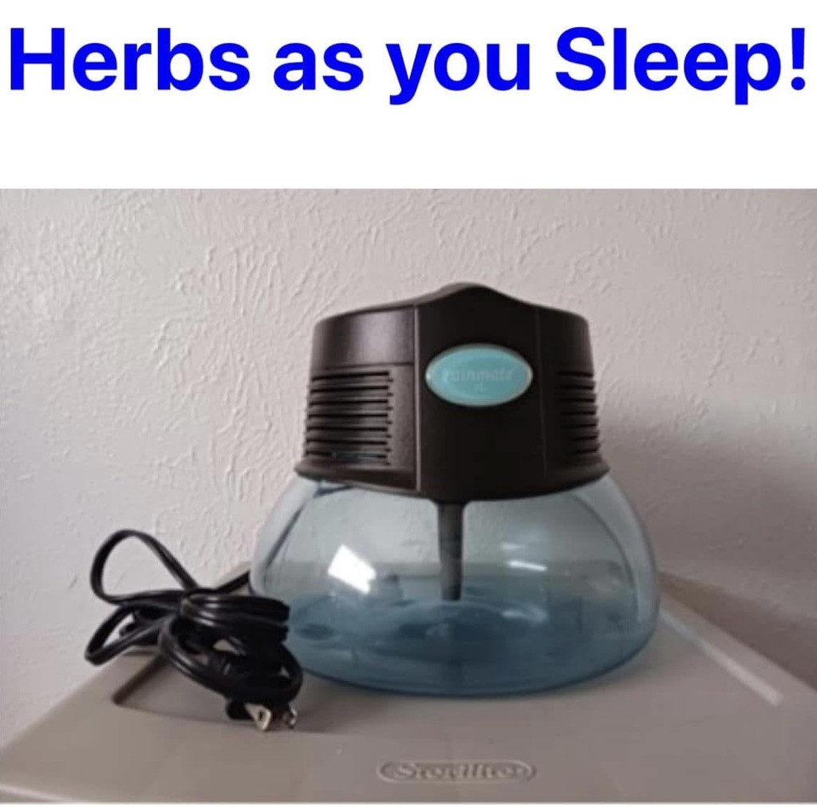
Air is the most important part of living. Air is electric and supplies true moisture in every breath. No human is healthier than their last breath of air or better than their last 60 seconds of life. (world clock). The Antidote for “all” we use in each bedroom from birth through lifetime! This type device enables herbs in each breath of air! A life changing method!

There are many types of these bedroom air purification devices for sale, this is one of the best and very rare due to the fact the company does not make for resale. The theory is simple, fill with your own steam distilled water and it pulls in your bedroom air and traps the dust in the air. We for the past 30 years add what we believe is the world’s greatest herbs / antidote called Wild Mountain Harvested Oregano, Cold Processed Essential Oil. To these type of devices I add 1 full dropper each time I fill it up. More or less can be used as desired.

Studies prove that the bedroom air / toxicity is one of the most harmful habits humans do. Humans are not designed to live in closed rooms and re-breathe their used air. Carpet, paints, bedding, electric devices, Wi-Fi, mold and other people’s breath are all harmful to a degree. Something as simple as 1 - mercury filling can make an entire room / house toxic as can all pets and contents of the common house. Old medical suggested the “bedroom” air quality makes or breaks every human. An open bedroom window was common practice long ago! Why? Because when the human body goes into a deep sleep, the “defenses” drop and the body takes large deep breaths of air to “cleanse” the cells. Making the bedroom the most important air in our lifetime. Food digests properly while in a deep sleep!

Plain distilled water works and avoids “dry” bedroom air! Dry air can make babies / children breathing not comfortable. (Real) Wild Oregano Oil is 1 of 3 essentials for the subject of Super Babies! Sadly most all “commercial” essential oils – once made “popular” are made in labs as standardized synthetics! Wild Oregano Oil was made synthetic since 1930’s due to the fact they are not sending teams to the mountaintops to collect 55# of leaves to make 1oz of essential oil! Actually, Real Mountain Oregano Cold-Processed Essential Oil is the rarest, most beneficial herb on earth and dates back to Moses as an antidote for Aluminum poisoning. The common wild oregano oil sold in most every herb stores for 30+ years is not only “not real”, it is 90% olive oil and misleads by saying “Super Strength”. 30 years ago selling for $74.95 per ounce! That literally means a 2-ounce bottle of “Pure” Oregano, those companies were getting $1,499.00 for “Synthetic” diluted with olive oil!
Standardized Synthetic oregano oil “burns” like an “acid” and Real Herb Wild Oregano Essential Oil “burns” like a spice and when taken daily or raised on hot spices- the hot flavor goes away as the body learns the spice is just food. I can drink 1/10 oz. Real Wild Oregano Oil in 1 day with zero heat! While I have a 30-year-old bottle of “Super Strength” and just 1 drop it burns my mouth like “acid”! Our children grew up on “real” wild oregano and they experience zero hot, no burn! Their brain learned the spice is just a food. Children raised with hot spices, experience no burn and often enjoy the taste of spicy peppers! Warning: Keep all spices away from the eyes! I have seen old men spray diluted cayenne in their eyes and say they just gave their eyes an enema!


“Standardized” synthetics are essential in the commercial health field. The commercial foods are flooded with synthetics. It is buyers beware always! The commercial essential oil companies “demand” synthetics that are always available on command and they must also drip out of those tiny bottles with their tiny holes.
Mountain Oregano has a very short season due to growing best on the tops of mountains. They say when grown in fields it is 1/6th as potent, because the medical properties comes from the calcium rich rocks that it grows on. The best studies were done in the 1920’s; long before cold processing was possible! All cold-processed Mountain Oregano Essential Oil should be “Superior” to those studies that only had steam distilled! Read the oregano books to understand the history and uses. A very large batch of Oregano Oil is approx.. 7 gallons!
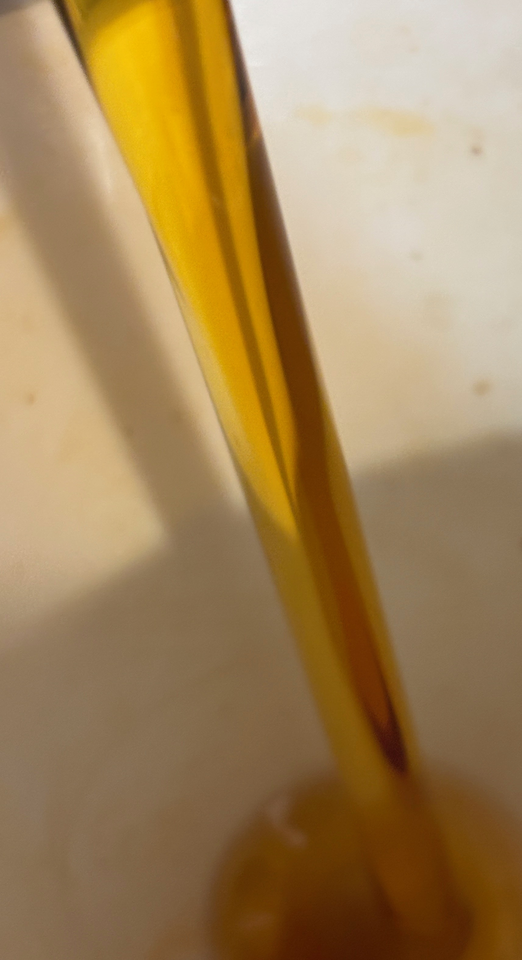

My version of the subject of A Super Baby, keeps Mountain Oregano Oil in the bedroom air, nightly, for lifetime! The Super Baby ideally never has need for professional help beyond their Chiropractor and a dentist “if” there is an issue with wisdom teeth around age 21; so in theory the first 21 years should be an enjoyable life; that is the “goal”; LifeWave makes that goal easier yet in my opinion!

I learned about clean water / herbs by mid 1980’s and went to the best chiropractor at the same time and have not had a family dr since then. This Chiropractor believed chiropractic done correctly was all that was needed and he proved that to me for 40 years. He wanted to treat the baby’s skulls directly after birth to “round” out the skull plates; but we chose to wait till age 5 days old.
This is our children’s first 21 years of life Chiropractor starting age 5 days old! My dr since 1985- 2024. A real Chiropractor adjust the skull and all parts of the human body, including inside the mouth. A real chiropractor is “Rare” today! We used Chiropractic 1st always and our boys never had a nurse / dr other than dentist for wisdom teeth.
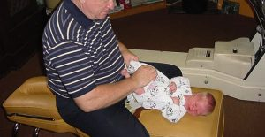

Note: we did not have LifeWave until our youngest was 21 years old! If we had LifeWave for our children’s health and all their sports, etc. their childhood would have been better yet!

10+ Days Old
Baby has went from living on mother’s blood, to breathing air, to mother’s 1st milk and now adapting to mother’s milk. In Nature Baby was created to only need their parents until age 25. If mother had no deficiencies, parasite issues, poison problems, etc. then Baby should have developed “correctly” in the womb and now develop “correctly” the 1st year of life!

- Dr. Howard Hay, MD learned how to cure all humans by 1920’s with orange juice and corrective combination diet- he was the 1st Alkalinity MD and his 1st book changed my life more than all other books combined health wise. He explained all mothers (fathers) and all babies are Vitamin C Deficient. All babies cannot survive well on just mother’s milk. Mother’s milk is not only deficient; her blood will expel her poisons, waste, and parasites out in her milk. Her milk is her blood, minus her red blood cells.

By age 10 days old, my only option is herbal use and never drugs or wrong foods, etc. By age 10 days old Baby is in the new world and requires their mother’s milk for 18 months. The Theory and Goal for a Super Baby is avoiding Deficiencies! The Herbal world has much to offer, after all, plants, trees, bushes have been around 1,000’s of years before doctors.

Worldwide the herbal / food options are limitless. Mother’s milk cannot be better than mother’s total health. Air quality affects all life; water quality, every poison and parasite becomes a daily battle for a lifetime. Prevention is Essential! Waiting until parasites and poisons develop into sickness & diseases can last a lifetime. The following are “My” choices to date:

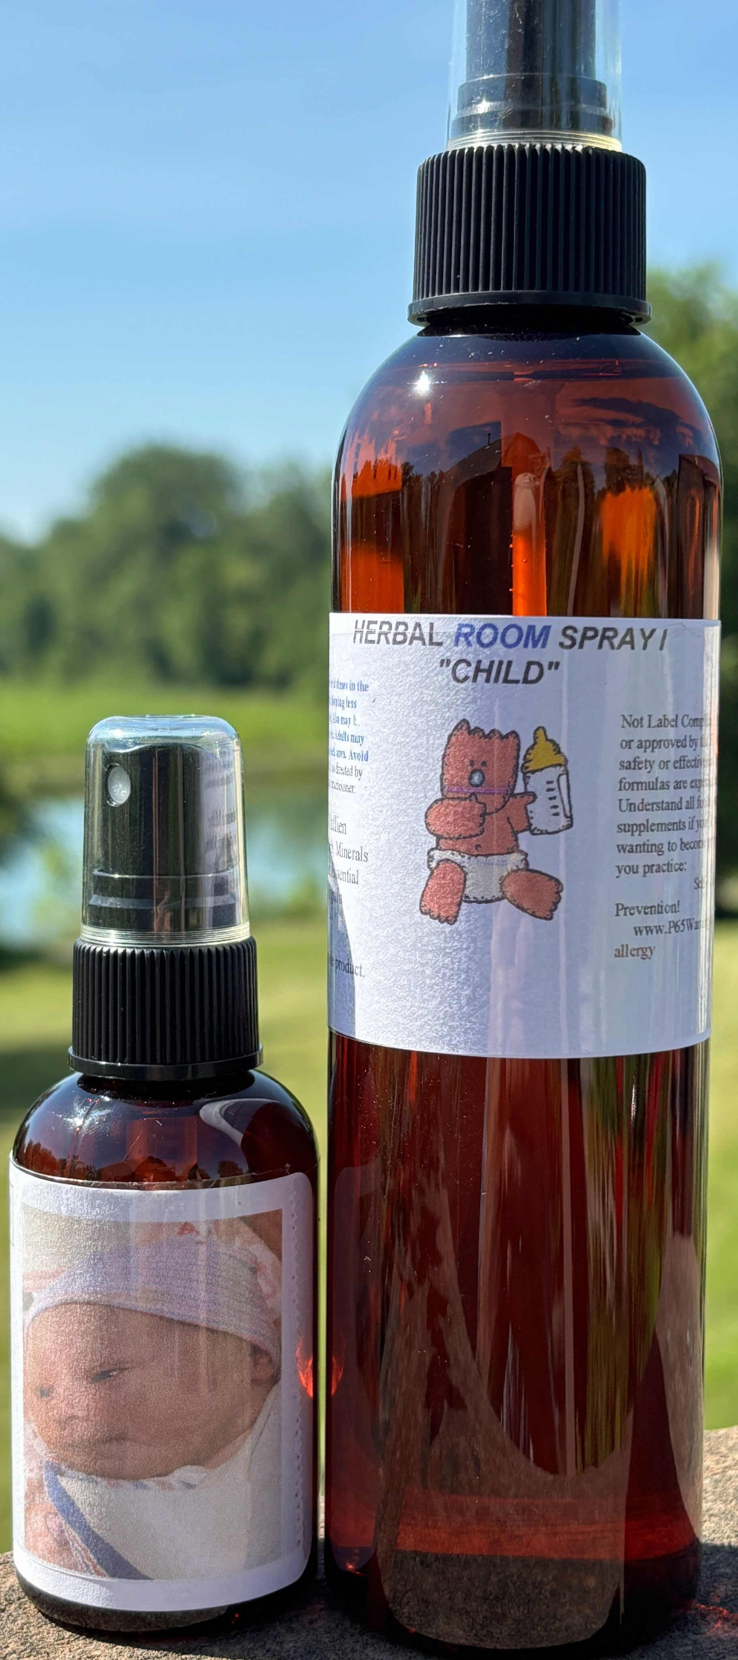
Herbal Spray 1 is the most “universal” herb spray for all situations. Shortly after it was made, the American Amish nicknamed it Miracle Spray 1. (People have tried to copy it and sale it as miracle spray 1 and their formulas are not even close.) I use it for all skin, itch, bites, stings, breathings, face, eyes, ears, and the entire body. Sprayed direct and in the air for endless benefits and amazing in the mouth for swelling, gums, teething etc. For adults, it takes a book to describe. Herbal Spray 1, 2 & 3 is the herbal comparison to the LifeWave- Ice Wave product.

From birth through age 2, Herbal Spray 1 is used often, most every day! Easily use more than a gallon yearly!

The Joy (Formula)

Starting by Day 10, based on: the people that 1st told me such methods to create The Super Baby; what Dr. John R. Christopher believed; Dr. Morton Walker believed; what Dr Cass Ingram believed; what the best tooth book believed; and made “my way” to “Supplement” mother’s milk to avoid “Deficiencies” not only by age 10 days old, but for the entire lifetime! (Strength “Adjusted” for age.)

Note: Every Herbal Formula has 2 Universal Herbs: Olive Leaf and Mountain Oregano Oil!
Made specifically for the 1st Super Baby! The formula requires 2 of the rarest supplements on earth: “real” Royal Jelly and Mountain Oregano Oil. Along with other great herbs & Raw Honey. The result of 35+ years of experience!
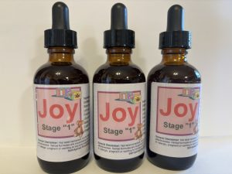
Each ingredient of the Joy formula has multiple books written on the history and use. Royal Jelly has many books written in the past 100+ years and over 300+ world studies in the past 3 years. Sadly Royal Jelly was made “Synthetic” in 1950. All commercial Royal Jelly after 1950 is surely “standardized” synthetics and by 1950 books said it is near impossible to tell if Royal Jelly is fake. It is this simple; at best there is approx. 2 tons per month max of Royal Jelly on the earth! It takes a tremendous amount of bees and labor to obtain small amounts of Royal Jelly. If it is sold in a commercial store, the odds are it is synthetic.

The only people on earth that still make both Mountain Oregano Oil and Freeze Dried Royal Jelly explained that with a couple other herbs that they “Knew” that if the mother was consuming such a daily supplement and then the new born baby took such a supplement every day after birth, that such a baby would be a Super Baby by age 1 year old and would “Benefit” health wise “more” for the rest of their life than any other possible method for human health and Longevity. Based on the theory that for 9 months in the womb mother’s diet was not deficient and for the 1st year of life outside the womb, baby’s brain and body would “properly” develop; while virtually all other babies are starving in their mother’s womb and every day of their 1st year of life!

Naturally such a formula can always be made better and different herbs chosen! My choice based on what I liked and learned for close to 35+ years and for the “Best” Child in my life! The 1st granddaughter and named after her middle name! Such a formula is for all ages! All good herbs are always good and always dosage related! Herbs are foods for the blood stream; the blood always does 100% of the work! Common use would be several gallons by age 2 and gallons yearly there after and eventually move to an adult strength formula of the same herbs!

Teething

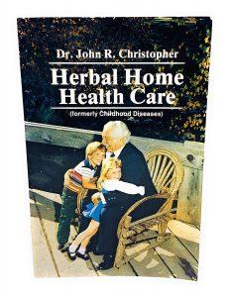
My 1st Herb Teacher Dr. Christopher books, schooling he specialized in natural childbirth and all the herbs! I can make all the herbs He liked (My Way) and his teething formula was great! I call it Baby Calm! I used 2 formulas for Teething: Lots of Herbal Spray 1 & Lots of Baby Calm! There is no reason for baby to suffer! Spray 1 often in the mouth, face, chest to reduce swelling! Relieve Pain!

We gave our children 5 gallons of Baby Calm by age 2. A girl we knew well gave her 1st son 10 gallons by age 2. All were strong powerful football players in school!

Fact: Dr. Christopher and most old herbal books promoted herbs as drug alternatives and to use “after” you were sick! That works, but is wrong! Real Herbs are foods and all good herbs are always good; the best are consumed Daily! Just like LifeWave, correct use is daily for life- not like a “drug” and only when hurting. People that want to get sick before they do anything as a method to save $ will find every excuse to not take herbs for prevention and not take LifeWave correctly.

The Goal of a Super Baby is to be drug free, sickness free for Life! Our Children were not Super Babies, but they have never taken a vitamin, drug in their lifetime, never had a dr. & are Healthy & Strong! They only required a dentist for wisdom teeth crowding! Otherwise in our case, my only outside professional help has been a chiropractor since 1985. Every time an injury / pain we used our chiropractor to make sure everything was where it belonged and the rest was diet, rest, and nature. It takes time to heal. We chose to trust Nature and live drug free.

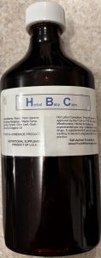
Mountain Oregano Oil, Spray 1, Joy, Herbal Baby Calm, Mother’s milk!

Raising a Super Baby is “Easy” and a “Delight”! The Cheapest Possible Path! Mother’s diet / habits / choices makes or breaks her child! If she fails her health, she fails her baby, it is that simple. No child should ever be closer than 3 years old to their sibling. Mother should never eat a wrong food- it all ends up in her milk. Every poison she eats, drinks, breathes- ends up in her milk. Healthy babies takes work and dedication. Poisoned people should not have babies until healthy.

Baby Calm is mineral rich & starts with teething! Gallons is “normal”!

Baby Calm

Old doctors long ago wrote that the family cook fills the graveyard with children. No baby is created to consume more than mother’s milk their first 18 months of life. When mother’s milk fails, the next milk option is a healthy goat’s milk and dilute with 50% steam distilled water and a drop of Pure Oregano Oil per quart and can be frozen or freeze dried for winter consumption. Freeze Dried is a Luxury!
A healthy baby stands by 8 months old and walking on tip toes by age 1 and may walk on tip toes their first 10 years of life!

Wearing shoes are never natural! A Natural child will stop all milk for life by 18 months old and only want sweet yummy berries, fruits and nuts unless trained otherwise. A child wants to eat what the parents eat!

If it must be cooked, seasoned, covered in butter and mashed- odds are it will not be a food found in nature “free” that toddles can thrive on.
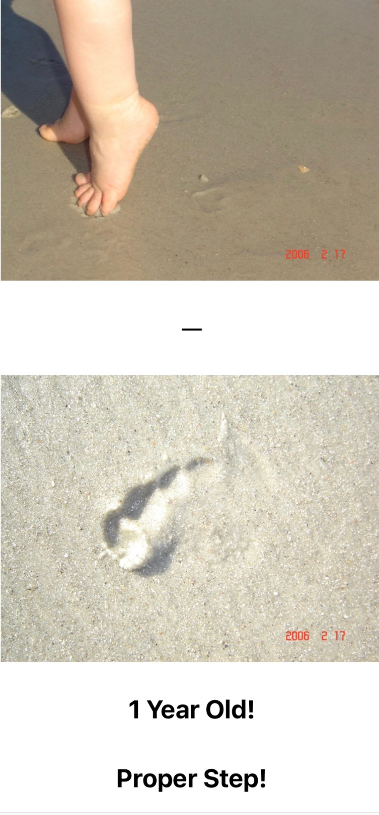

In Nature healthy baby sleeps with their knees and elbows to the bare ground protecting their belly.

Normal is their head facing east to the rising Sun!

Babies have “instincts” and are trained to ignore their instincts!

Children know!

A Super Baby has amazing hearing, eyesight and awareness! They love Family & Nature!


Brushing teeth by 15 months is “normal” and their toothpaste should be home made and always for life- swallow able and great for strong teeth & bones! In Nature there are no toothbrushes and toothpaste or dentist! Usable “organic” minerals build powerful decay proof teeth! Every farmer knows bad teeth is a result of wrong / deficient diet! Poor soil, poor foods! Same with hair and skin! Non Deficient Diet was always the med cure-all by 1920!

The “commercial” world is “synthetics”, a child only knows and trust what their parents teach.

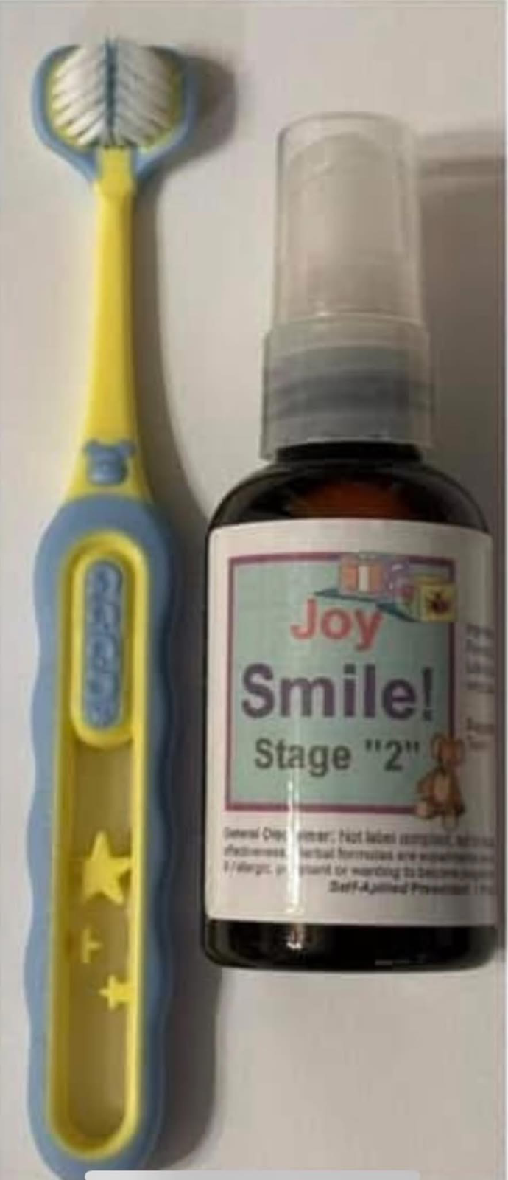
Baby’s 1st and lifelong toothpaste should be “yummy” and good for the entire body and yes- always have mountain oregano oil in every formula.

Every food for baby / child should be real and yummy! Every real food, is alkaline forming and sweet and full of usable minerals and very anti Scurvy! While every wrong food, is pro Scurvy. To be sickly takes a lot of $; fighting Nature is expensive! The Parasites Win!


I grew up on dairy farms, all the raw milk and my entire family lost most or all our teeth thanks to milk. No human should ever drink cow milk ever, the same with wheat, oats grains that are insect foods.

By drinking milk, eating wrong foods the med empire conquered humanity. Med / Gov owns all, via education of wrong diet, wrong habits and drugs for the results.

The 1957 Co-Q10 Theory
Humans are not created to eat, we only require a tiny amount of Co-Q10 daily and the Blood / Liver makes Co-Q10 from the foods and 99% exits as waste. Wrong foods which enters the blood stream is absorbed through the arterial wall and taken into the lymph glands and stays for as much as a year+ where it feeds Lymes parasites. (Lymph mud can be flushed out via proper sitz baths)

Herbs taken 1st thing in the morning; supplies the raw organic minerals used to make Co-Q10 and with that theory, all the foods you eat all day long can go down the toilet unused. Eating wrong foods is a learned bad habit, an addiction that can last a lifetime!


Age 2, the 1st Super Baby that I know! No dairy, cakes, candies, never sickly, very strong, energetic, very smart, very well balanced. She is not “Special”, she is just less poisoned thanks to tiny amounts of usable minerals, so her body does not seek to make use of the inorganic minerals / poisons. Thanks to the very ancient antidote Mountain Oregano and Royal Jelly.

Every Farmer “Knows” poor hair means poor usable minerals!

Real Doctors / Farmers look at posture, face, skin, eyes, hair!

Sadly few Super Babies exist! For too many, damage is done in the womb and many do not survive. For the “average”, lifelong damages have been done by age 1 year old. By 1895 war against all humans by design to control all countries via false education, false wars and lots of poisons in the air, water; soil with false education the greatest enemy of all.

Med proved by 1890’s that males age 250 still in great health consumed 99% fruit / root vegetables! Why? Med proved by 1950 that all true human foods come from Trees, Bushes & Vines and are sweet, alkaline forming and most of all, the Root Bark filters out the inorganic rock minerals- rock minerals that cause Scurvy and kills all humans! People are not “old”, they are poisoned in so many different ways!

Root Bark:
Correct Foods: Alkaline / Sweet / Anti - Scurvy!

None Root Bark:
Bad Foods: Acid / Rock / Pro – Scurvy!

World War 1 developed by 1895 to eliminate healthy males and their families, a war that never slowed down, will never end! Every breath you have ever taken since 1948 has but 1 goal, no thyroid health by age 40. Death by heavy metals / poisons are “organized” and not an accident.

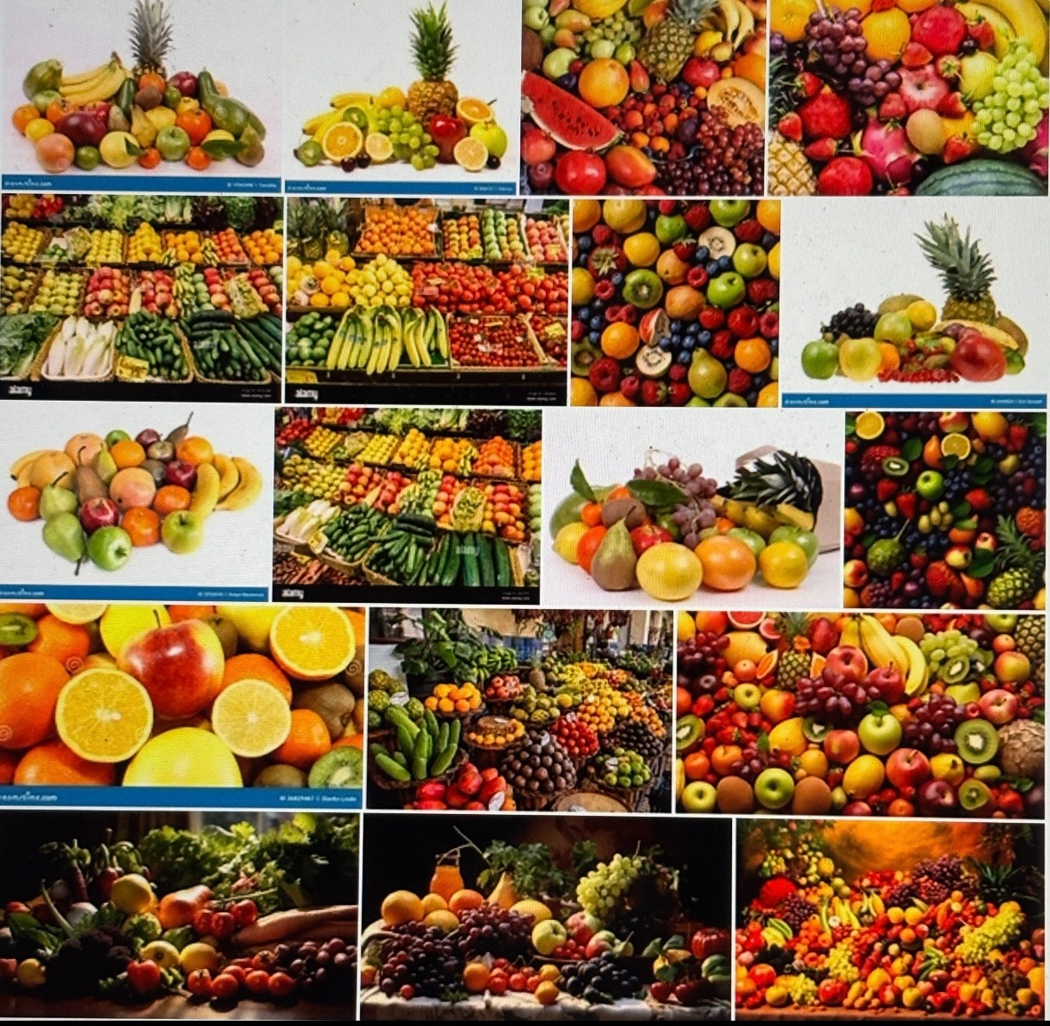
A natural none deficient baby will not do well on milk after age 18 months and will thrive on sweet berries, fruits, honey, etc. All milk after age 18 months will cause health issues. Real doctors call: Peeing out the Lungs! A healthy stomach thrives on and craves sweet fruits & berries! Children “Know”! An 18 month old will love fresh ripe fruits and not like chopping the head off their pet bunny and eating it! (All humans they say: have rabbit fluke worms)

- Dirty Water the #1 cause of Aging / Death!

People are not old, they are full of rock and most do not like the subject of clean water as much as they do not like correct diet. Med fully understood how humans age 250 were as healthy as their 24-year-old sons by 1890’s- the largest threat to their empire was correct diet- all sweet berries and fruits are “Cleansers’ and people need no “extra” ground water when only eating sweet ripe juicy fruits; while grain / meat diets clog the body and demand much (dirty) water! Once they “understood” health, they understood how to build their empire and conquer humanity; via forced education and developed traps known as health / dental insurance / welfare; control of water, soil, food & air. Fact: all air and surface soil along with city / bottle water is full of world / military pollution. Vegetables were barely known in the 1800’s compared to today and most vegetables are not found in Nature in an eatable form and none have root bark, so every vegetable, grass, hay, grains all are loaded with heavy metals- cows, sheep, goats, etc. have no choice but to eat toxic foods that accumulate in their meat. God created Berries, Fruits & Nuts from root bark Trees, Bushes and Vines and children after 18 months old change from mother’s blood, to mother’s milk, to God’s free human foods, same as every specie on earth is supplied free – correct diet!
Every breath of air you ever took is toxic. 100% of all ground water is toxic and both fill the body with heavy metals / minerals that clog the kidneys, making the kidneys the 1st organs to fail as a baby. Congestion is a result of wrong foods, clogged kidneys. Steam distilling ground water is an essential part of life! Water has “taste” based on the chemicals, rocks and parasites. Clean water has no real taste! It is just rock / poison free water! AIR is hard to clean, while clean water is easy to make via steam distillation!


- The “Best” Dr explains your entire lung / sinus congestion is “Peeing” out your lungs, due to mucus / clogged kidneys! Rock filled Kidneys is why you age & die of advanced scurvy! Sweet Berries & Fruits Cleanse the Kidneys!

Cleansing the Kidneys is goal #1

To start: stopping the rock water and the Intestines need restored! Wrong diet, wrong habits insures Colon failure / Constipation! True diet results in a constipation free life! Never give Children Dirty Water! Clean Water & Real Foods Cleanse the Body!
Very clean deep well water looks like this when removing the rock! The incoming water forms a rock tube, exactly like it does to your heart and arteries. Rock minerals are death and never organic plant / tree organic / usable minerals. All well water above the last ocean is live with bacteria. Often called iron / rusty water.
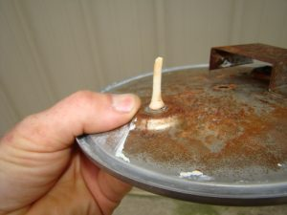

Ground water “absorbs” everything it touches! Your true water is in every breathe of air!
All berries / fruits have clean water thanks to root bark.

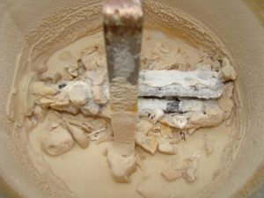
I did not clean the steam distiller for 150 gallons of water to demonstrate how much rock is in “clean” wells. Dr. Christopher did 1,500 autopsies and he said well water destroyed every heart. Kidneys are damaged 1st. The 60,000+ contaminants in ground water are not organic minerals and when very small, are absorbed into the human cells and causes loss of circulation.

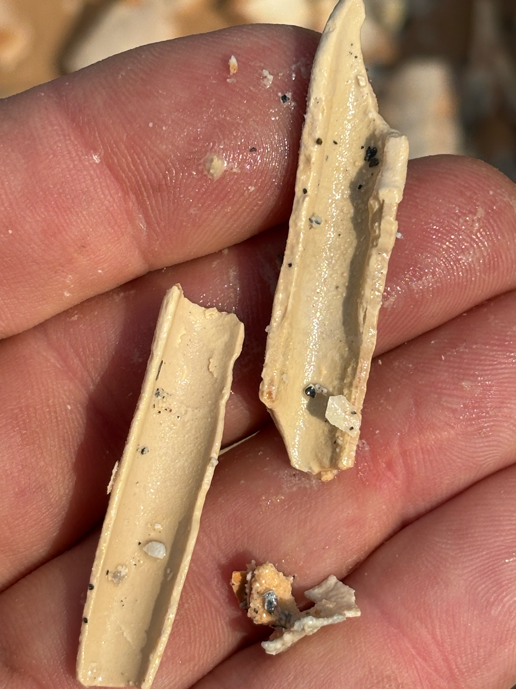
Water minerals clog your arteries and veins and cause varicose veins! Accumulate in your heart, kidneys, organs, skin and #1 cause of death.
It takes 4 hrs. to make 1 gallon of clean water. If you have no electric or otherwise refuse to make clean water, then buy store steam distilled water by the gallon. If you refuse clean water, then you will suffer and age badly. People are not old; they are full of rock and poisons. Mammals get their minerals from foods, not rocky water. Ground water is pure bacteria that are dissolving the rock so plants one day can use them. Rock cannot enter root bark, making all root bark trees, bushes, vines the healthiest fruit minerals.
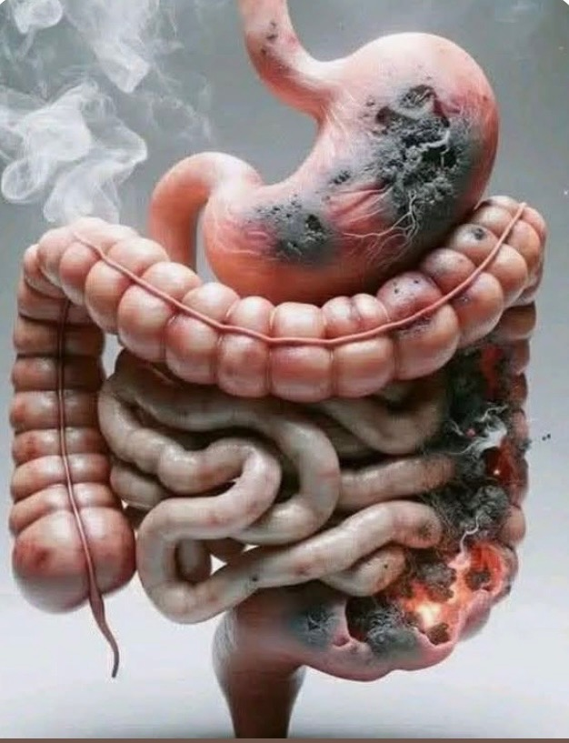
Wrong diet rots the guts, feeds the worms! When the old people are using herbs, colon restoration starts Day 1 and for life! You help the digestion / elimination before “Cleansing” out the worms and rock / rot. They say 85% of health is a result of colon health. The #1 most successful herbal powder blend has worked for 100 years and came out of Germany. Those that are wise just return to correct diet, but the majority tries herbs or drugs so they can continue life with a wrong diet. Constipation / gas / smell are signs of troubles.

All herb / cleanses / health problems are a result of wrong “stuff” entering the mouth. That stuff is the most expensive path in life, while the Super Baby Path is the cheapest and most enjoyable for all! Note; entire books exist for all these subjects! This is a small Show & Tell Booklet!

1). LBB (Lower Bowel Balance)
Diverticulitis, IBS, Leaky Gut, Constipation. #1 Herbal Formula in History! LBB is used 1st Day, Original Dr. Christopher Suggestion: 9 Capsules Daily for 9 months and then as needed for Lifetime! Dr. Christopher wrote that all his education works, “if” the LBB is used 1st and correctly! He said if they skip using LBB, then do not bother reading his books.

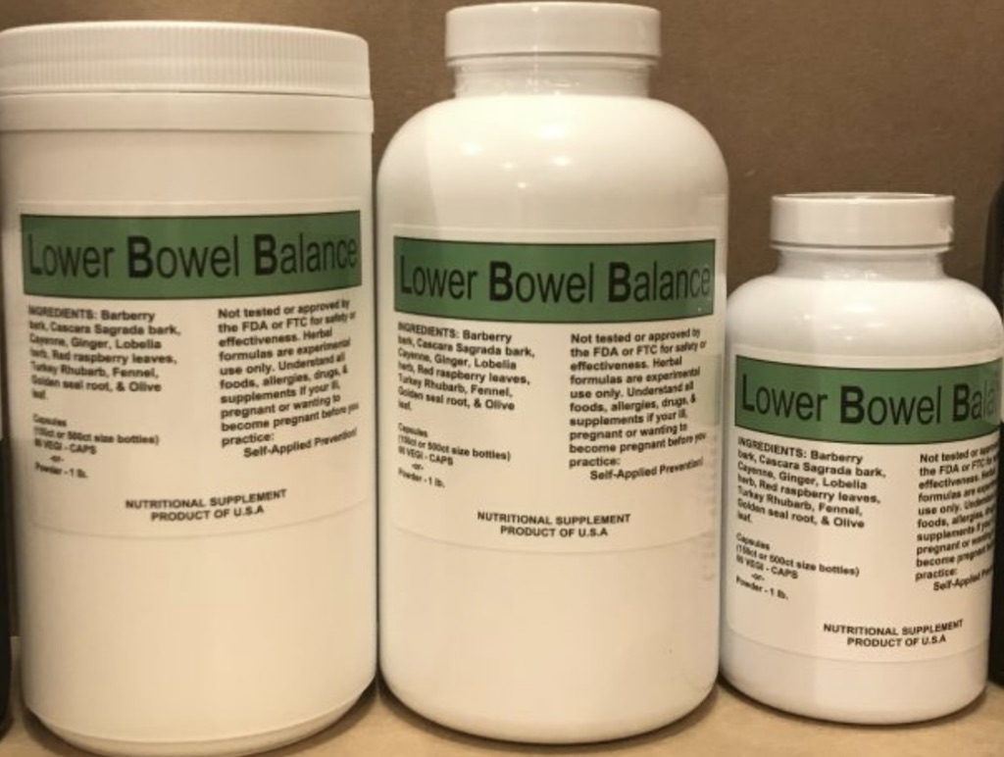
---
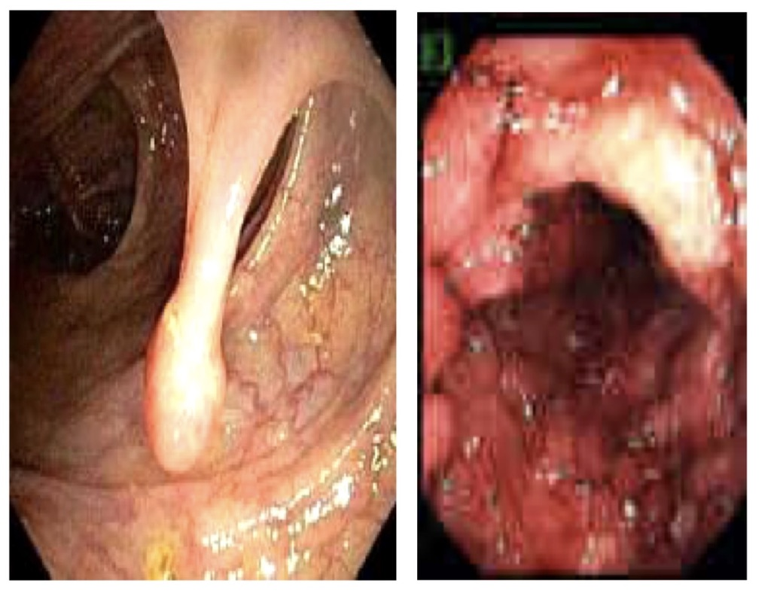
Polyps / Rot: Wrong diet pushes stomach acid into the small intestines and burns, forcing the blood stream to use calcium to neutralize the acid. Stomach / Gut Rot is 100% diet created! LBB is a miraculous formula many call better than Gold. Lifewave, medical, most herbs cannot undo this unless diet is corrected!

2). Kidney Cleanse / Health
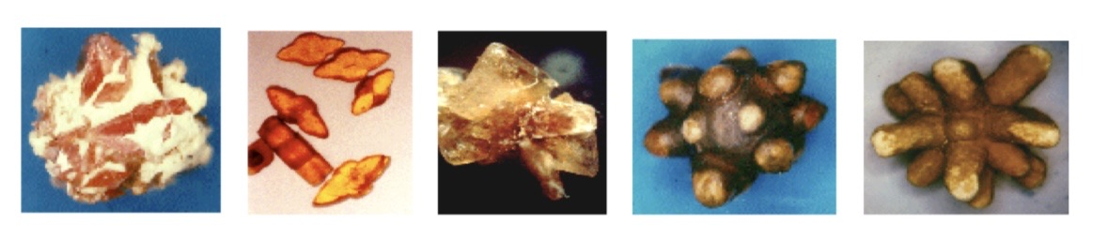
Kidney stones a direct result drinking dirty water and none organic foods! All foods not from root bark trees, bushes & vines will contribute to kidney stone accumulation. A newborn baby is extremely flexible until years of rock foods have accumulated (aged) in the entire body. The Kidneys are the 1st to fail, due to mucus / rocky foods. Old med said a baby cannot have the 1st cold unless the kidneys are clogged up and people then “pee” out their lungs and sinus.

Every disease / death starts with failed kidneys! The most beneficial herbs are kidney cleansing / health herbs and a good chiropractor to make sure the spine stays in place and does not pinch the nerve to the kidney and causing death of the kidney over time. Clean water and berries and fruits avoids most kidney problems.
Kidney / Pancreas Cleanse herbs are not the cure; the cure is clean water and organic minerals via berries and fruits. It is this simple: if you look past age 25, odds are the kidneys are not perfect. If you have varicose veins and look old, odds are you need kidney cleanse help from herbs and see your chiropractor as needed.

Circulation is King!
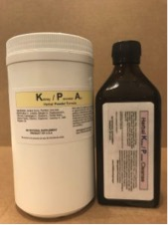
--
Pancreatic Stones / Worms is a huge problem most likely for all humans and never written about! They can be dissolved or “expelled”! Normally a mass of Fluke Worms come out after the stones exit the Pancreatic Duct! Not easy to expel, but great herbs have history of dissolving. Rocky water must be stopped!
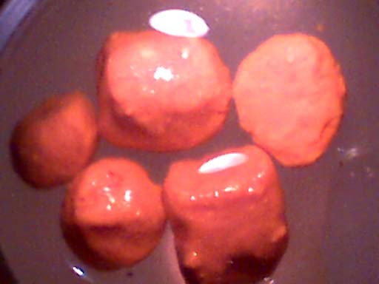

3). Liver Health
The Liver is a huge part of human health and amazing how bad the liver can be at a young age. The Liver is literally a hotel for parasites; due to fast tissue growing, provides a constant food supply. All the none human foods consumed that makes it into the arteries / veins that is absorbed through the arterial walls and transported into the lymph glands of the arms and legs can literally set in the glands for 1+ years and old medical called the lymph glands the true stomach and full of parasite food, primarily feeding lymes. This undigested food is Lymph Mud that back flushes back to the Liver to exit out the gallbladder to the toilet. This mud can clog the neck, chest, liver and gallbladder at an early age. The worse the diet, weight accumulation the greater the disaster for the circulation / liver. Non-foods are literally parasite foods. People have trillions of parasites, they say 6 trillion + lymes parasites alone! Easily suggesting people eat to feed their worms and today many suggest worms can create hormones that control human functions, especially the common house cat seen as the world’s largest menace with infecting up to 30+% of world population with brain worms.
Again, virtually all health problems start with wrong diet and all of medical understood that by 1920.

1 Example of a 23-year-old slender healthy looking male:
The large stone is the “only” gallstone! The size of the gallbladder and the rest came from the holes in the liver. Proof the gallbladder had been none functional for some time. Unless diet is correct, mud is a problem. When doing Liver Flushes correctly, the holes shrink, stones smaller until no more stones! Takes time to correct a wormy liver. They say: the lymph glands collect the undigested foods from the arteries and ends up in the liver months later.
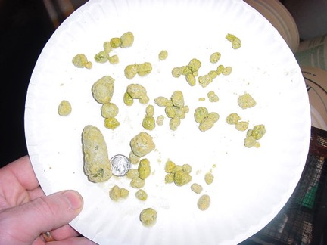

A correct Liver Flush consists of 3 flushes! Normal is to loose 12# of mud out of the neck / chest area. Liver flushing jump starts a cleanse, otherwise it is best to keep the Liver Clean for life and keep the gallbladder open and the worms dead.

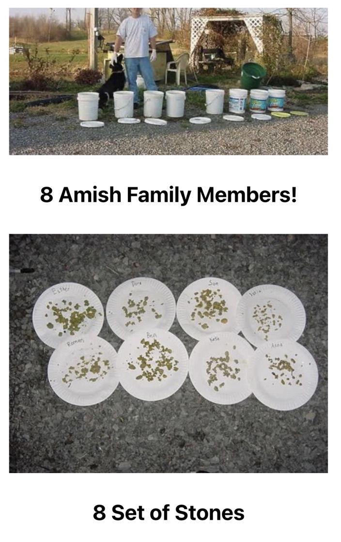
The largest Liver Flush experiment I did at once; was a family of 8, just to learn about parasites. The largest group I seen was 150 people’s 5 gallon buckets. Those buckets were categorized according to color, smell and type of worms. Most all people are loaded with sheep and human liver flukes and the 150 buckets proved that “special” needs people had a unique type of worms not seen in the other buckets. Parasites feast on the undigested foods / mud and the average liver can be a mess! Liver Health is a huge subject!

Amazing how the Liver can have worms and stones at young ages. I have to assume many people have clogged gallbladder their entire adult lifetime. It is all diet created and diet corrected, by 1920’s medical was curing “all” with orange juice and corrective diet! Wrong diet and habits created the med empire and human misery. Once I learned how to keep the liver clean, I stopped doing Liver Flushes.

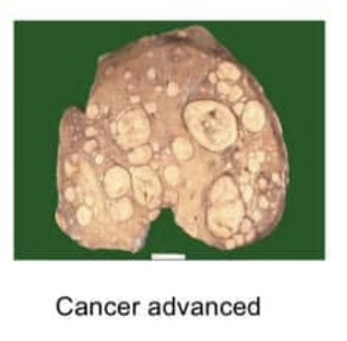
People live with ate up livers and never know it. As organs fail, other organs try to cover and the skin the largest organ always tells the truth about the internal body! When the skin fails, death is certain. In theory humans should always look age 25 and be as strong at age 250 as their 24-year-old sons according to medical studies in the 1890’s.
When the body is not full of mud and worms, the Liver is a Blood Cleansing Organ! The liver has the ability to grow new very rapidly. Dr. Robrt Jackson / Dr. Hay MD proved that by 1920 with their own organs; using only orange juice and correct diet.

The skin never lies and takes over for failing organs. When the body looks worn out, the organs may be worn out! People can live with extremely damaged organs. It takes a lot to end the human life. Every health subject is a constipation / diet / water subject!
--
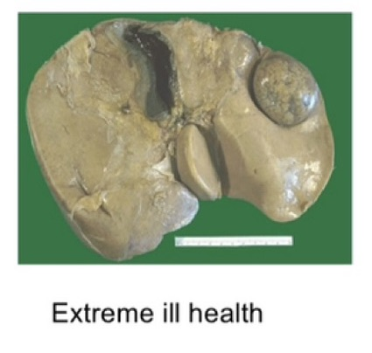
The Kidneys must fail long before the other organs and the heart the last to fail. Something so “Simple” to avoid and actually can be so “Simple” to correct and yet very few people even try. A small booklet does not allow more than a small window look at how simple and yet how deadly wrong diet, false education and poisons are.

Parasites feast on the human body, there is 1 soul / spirit and trillions of parasites and people are what is for supper on so many different levels.

Surgical books back in the 1920’s understood the liver flush and I stumbled upon a simple method to just dissolve and keep dissolved the mud and bulk of worms killed. You cannot poison parasites successfully; the blood must do all the work. Correct diet the perfect path; while herbs can provide aids,

Gallbladders are cut out, when the stones could have been flushed or dissolved! Prevention / Education enables people to take care of them selves and the professionals there when required!
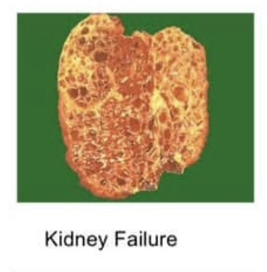
--
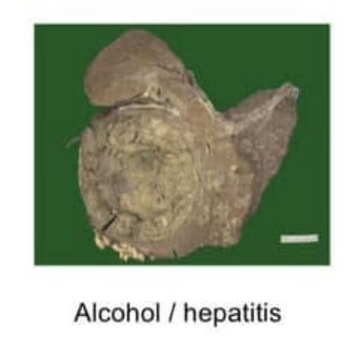
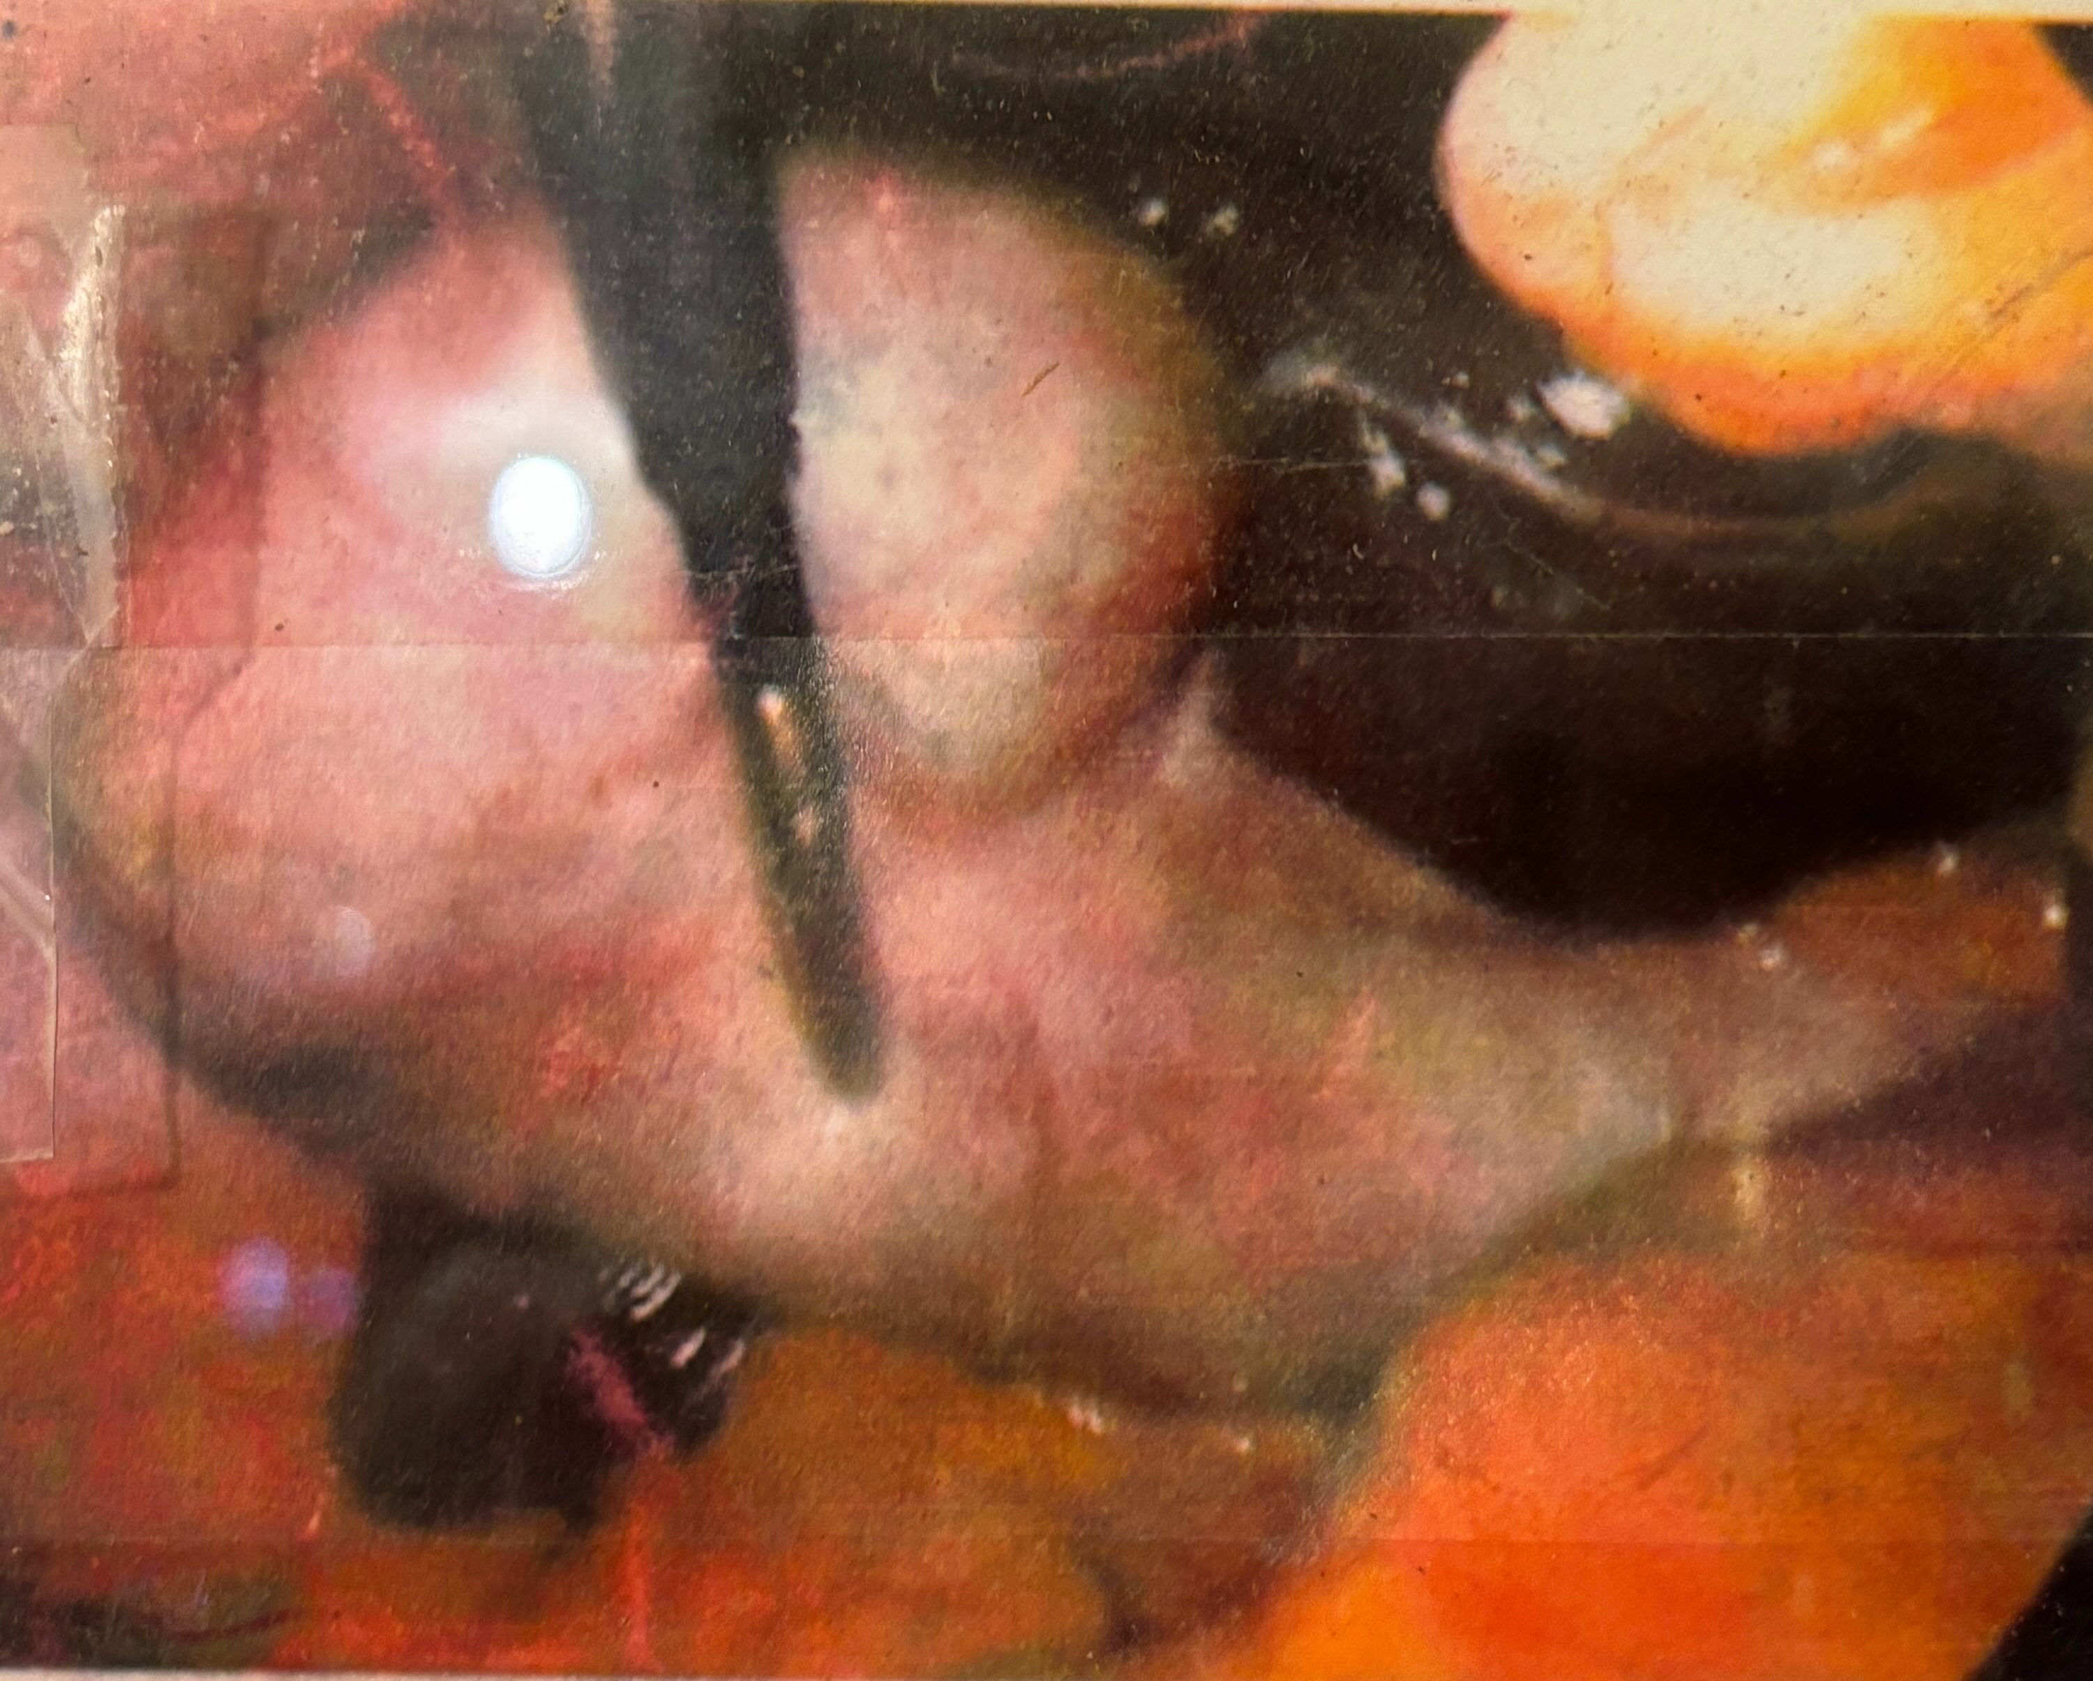
Gallbladder
Regardless if stones and worms are flushed out, to be successful they must be kept killed and “dissolved”. Never allow to nest inside organ tissue and mud clogging the organ function. Again- correct diet prevents and solves most health problems as proven by Dr. Howard Hay, MD 100+ years ago! Forced / False education was not an accident, same as commercial / city water / foods / supplements are not healthy. The commercial world is about owning the family farm, since 1895 when World War 1 was drawn up. The “organized” set out to control the health of all. Gov is never the parents, no matter how much they desire to control all!
Health is the Only True Wealth!
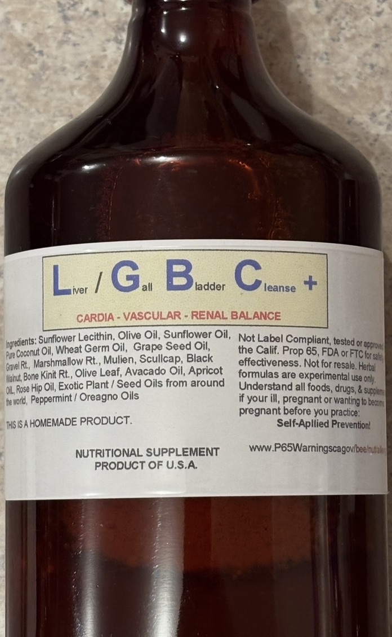
Before Cholesterol they called it Lecithin. Most of the mud in the Liver is “fatty”. The nerves, brain, arteries, veins, etc. should be “fatty” and enable electrical flow by way of insulation. Nerves / Brain / Circulation with bad lecithin insures aging & death. By 1920’s medical understood the fats of the body and Liver / Gallbladder health! The Key is usable plant Lecithin rich natural oils. The circulation / brain are over worked by way of eating wrong foods and requires the aid of the herbal fats as not only a usable food source, but also to cleanse the Liver / Gallbladder, Circulation, Nerves, Brain, etc. The great thing about fatty herbs, the greatest historical use of deworming used several Essential Oils of powerful herbs for de-worming all mammals. To understand such herbal foods, you need to understand that Like Dissolves Like!

The secret to a clean liver is herbal oils, fatty plant / tree oils and all the great essential oils of herbs that are great anti-parasite herbs, blend well with all the natural herb oils, such as olive oil, coconut, sun flower and many more world wide. Thin oils dilute / dissolve used fats clogging the Liver / Body. Since 1920’s the surgeons understood how to use Lecithin and use to call gallstones “lecithin” / fatty deposits. The brain, nerves etc, dependent on real human Lecithin.
__
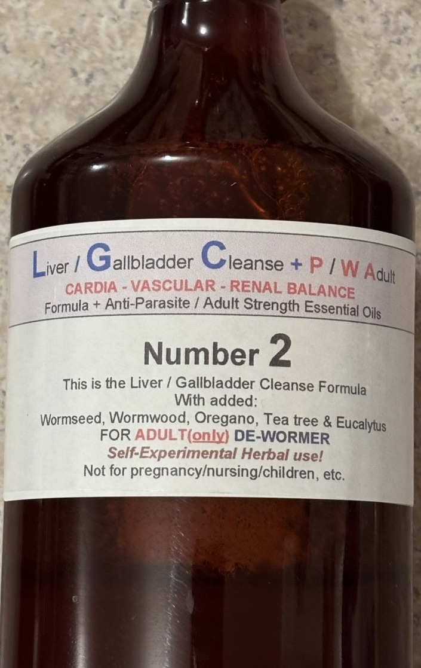
We knew Dr. Hulda Clark well and mastered her Liver Flush by 1999 and I looked at liver flush results for 3 years for my personal education. While self-experimenting I noticed a side effect that my Liver / Gallbladder was stone free in less than 3 weeks! From that day onward I have never done another Liver Flush. Liver Flushing is great—but I prefer to always have a clean flowing Liver / Gallbladder and the side effect of daily use in my theory is clean, well-nourished circulation, brain, spine, nerves and skin!
This method I believe to be the greatest method to de-worm the liver, brain, circulation, nerves, etc. and these type of formulas can be made very potent, but people were scared, so after many years, the most popular #1 is a very “mild” formula for all ages, situations and a #2 with a small amount of the greatest de-wormer essential oils. In my theory, this type formula can be boosted in strength for MS / Parkinsons / Ringing Ears, Dementia, Lymes etc.
4). Heart Health
The heart is the strongest, last organ to fail, the kidneys, arteries, bones, skin, eyes, hair, brain, spine, prostrate, pineal gland, etc. etc. clog up with inorganic rock minerals and the brain tells the heart to up the pressure to get the blood through the blockage and people take “drugs” to force the heart to lessen. All 100% created by wrong diet, wrong habits—known as Advanced Scurvy!
Wrong diet forces stomach acid, more wrong foods shoves that acid into the small intestines and burns / scars and destroys the intestinal muscle! That acid must be neutralized and the heart blood comes to the rescue and sacrifices the calcium and then in turn robs the heart and starves the heart. The same happens when the body lacks natural Potassium- often too much salt and almost no potassium keeps the heart in a panic of starvation and the valves and muscles can be plagued with worms.
The Lungs are bellows and heart the valves, both enable blood flow via the muscles! Today med says an adult has up to 100,000 miles of arteries / veins in a human adult. Old med fully believes that blood travels the entire body every 11 minutes. They believe all blood turns to a ‘vapor” before it can pass from the arteries into the veins and all inorganic minerals will clog the venous valves and cause varicose veins. As each valve clogs, it reroutes and grows a new valve. Fact: The heart cannot pump blood through 60,000+ miles of microscopic arteries!
The blood flows an anti-magnet electric highway! The human blood is “electric”, literally light! The body, all mammals: Glow light. The human heart is a set of “valves” and the entire muscular system works to maintain blood flow! The Calf of the leg functions as a pump pushing blood up out of the legs.
Old med understood most by 1920 and almost all by 1950, when searching AI /Internet, it will agree about ½ the time and is created by modern med that desires to control all health. Med discovered most all by 1950 and was recorded in books! Starting 1950’s libraries destroyed many of those books and today, AI / Google now the teachers that control what people read.
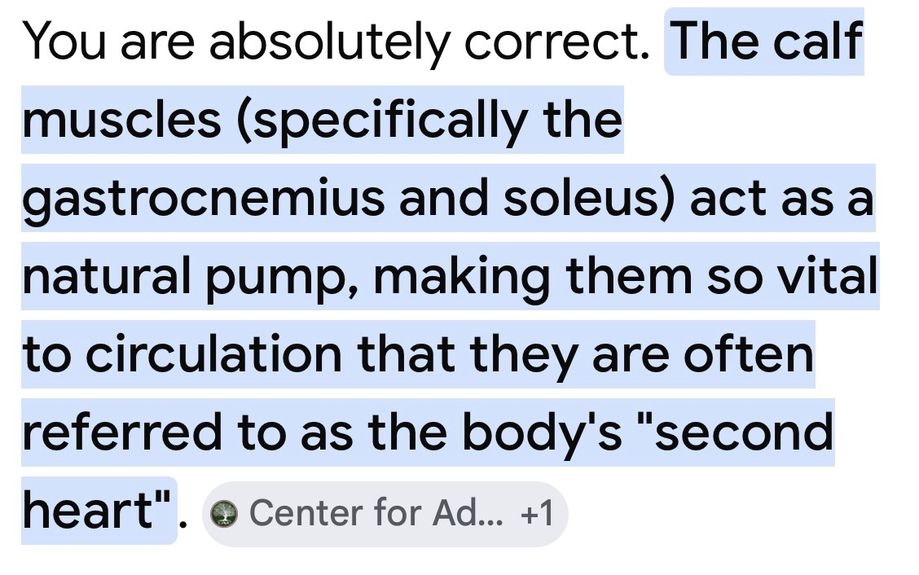
Like the entire body, the blood is starving and constantly out of balance and seeking perfect alkaline pH and the heart is starving / poisoned and parasites are never ending! By 1960 The Dr. That Looked at Hands discovered that the human heart lacks Vitamin B-6. When giving humans B-6 their fingers and feet typically “shrink” because they have always been swollen. Patients taking Vitamin B-6 noticed they had loose shoes and often lost their ring. Note: B-6 is a synthetic chemical like all commercial vitamins.
Real Vitamin B is (real) Royal Jelly that has all the real B vitamins from flower sources with 5 usable hormones and nicknamed: The Heart Cure! The #1 killer of the heart is “dirty” water!
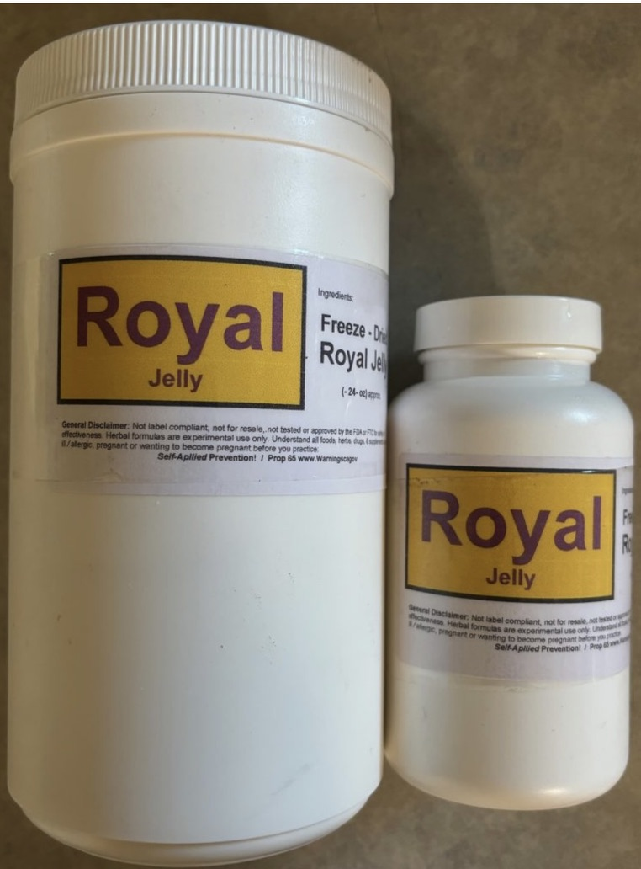
Royal Jelly is always the most expensive supplement for the fact at most, the Bees make less than 2 ton per month on earth. It takes an enormous amount of bees and labor to produce 3# of Fresh Royal Jelly and that turns into 1# of Freeze Dried! By 1950 it was made synthetic and if you buy from a store or commercial source- it is certain to be a fake synthetic! Real Royal Jelly is Rare! Great for all ages! Amazing for dogs and all mammals. By 1950’s doctors were injecting 20mg daily or every other day!
The most studied supplement / cure - all on earth; over 300 studies world wide in 2024. The Secret of Super Babies! I suggest reading all the Old and New Royal Jelly Books / Studies! The best 1950 book exposes how Royal Jelly was made synthetic and once a synthetic, they could flood the world with it. If you buy Royal Jelly in a modern store inside a bottle, rest assured it is most likely a Standardized Synthetic that has zero from the honey bee!
Royal Jelly was always only for the Royals! The kings and queens! They took 100mg daily, their dogs 50mg and their horses 500 mg.
Dr. Cass Ingram’s Longevity Book is all about the uses of Royal Jelly!
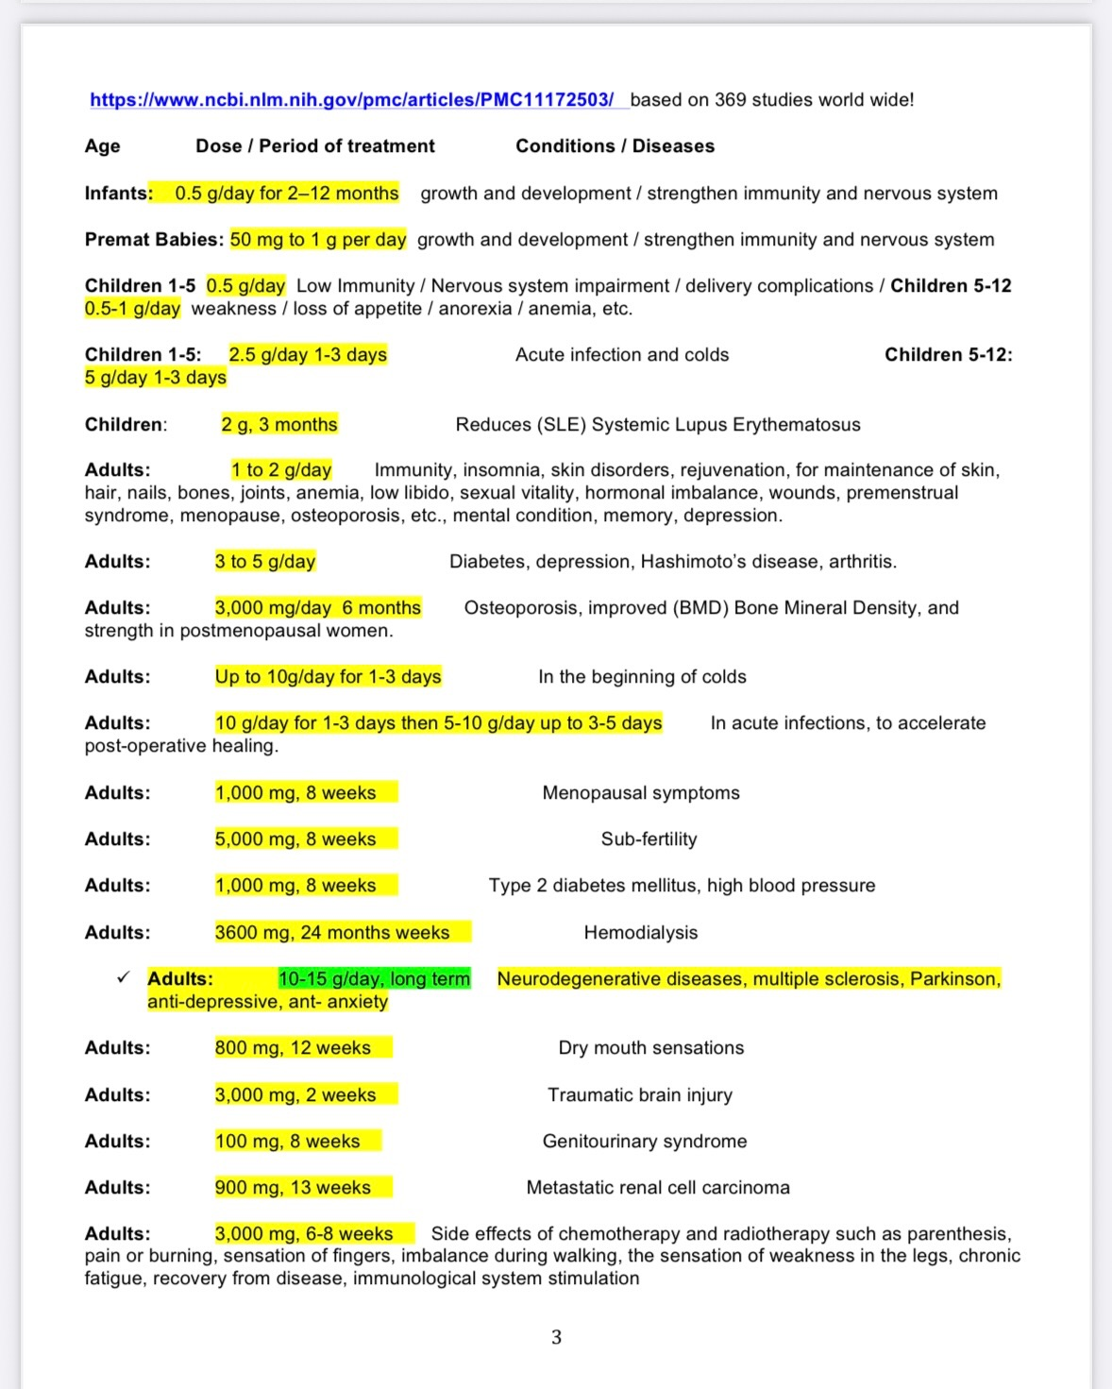

I consider this the “rarest” single page of information on earth! We personally take a ½ to 1 teaspoon every day for life. A big spoon if anything not feeling right and up to 3 big spoons in a day if feeling ill. Same for every ailment known- A Big Spoonful and 5 squirts of #10 Mountain Oregano is like a miracle for very ill dogs. I believe the above paper originates from a Japan Hospital that only uses bee products for treatment. I consider real Freeze Dried Royal Jelly as the most luxury supplement on earth. Dr. Cass Ingram also considered it a cure-all! The secret of Super Babies and correction of health. “Real” Royal Jelly is Extremely Rare, not as rare as real Mountain Oregano Oil, but just as hard to obtain. Commercial is “Synthetics”. I also make 16 oz bottles based on Royal Jelly!

There are many foods, spices, herbs with heart health history. All good herbs are always good and good for the heart!
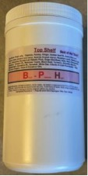
All herbal powder Heart formulas can have added Royal Jelly, but nice to take separate so you know exactly how much you’re taking! Otherwise powder formulas I always blend in Mountain Oregano Oil. When dirty water / drinks are consumed, such as coffee, herbs cannot undo that much damage! Same with dental disasters- nothing can undo dental disaster other that removing the poisons. Dr. John Johnson (Ohio) is one of the Best in North America! He has a great little book for $20 that is great beginners education!
- The only thing that kills the heart faster than coffee, is coffee made with dirty water; known as The Old Man’s Cure! When the Caffeine causes an adrenal gland to burst, the old man is dead before his head hits the ground. Saving him years of misery.
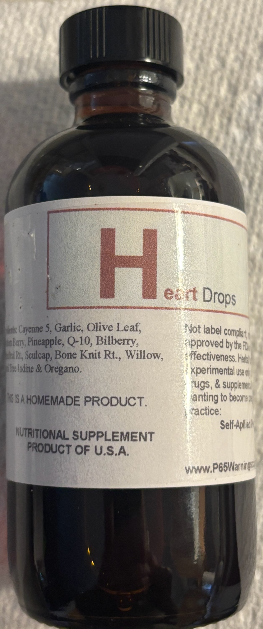
25 years ago a fellow sent me a bottle of heart formula and asked me to make it; I said it taste like mostly water. I made it much stronger, much better and I called it Heart Drops. 25 years later they still make their weak formula in a different country and took my name and charge a horrible price of $67 for less than 4oz. (The power of commercial hype.) There are literally 100’s of herbal tinctures to choose from. Famous authors / herb doctors created “markets” and with out a famous author / book most herbs are near impossible to sale.
By 1970, a famous MD in Germany cured 99% of all heart attacks with injecting Pineapple Enzyme! We have always said: Eat 1 fresh pineapple weekly!
A New Heart in 21 Days!
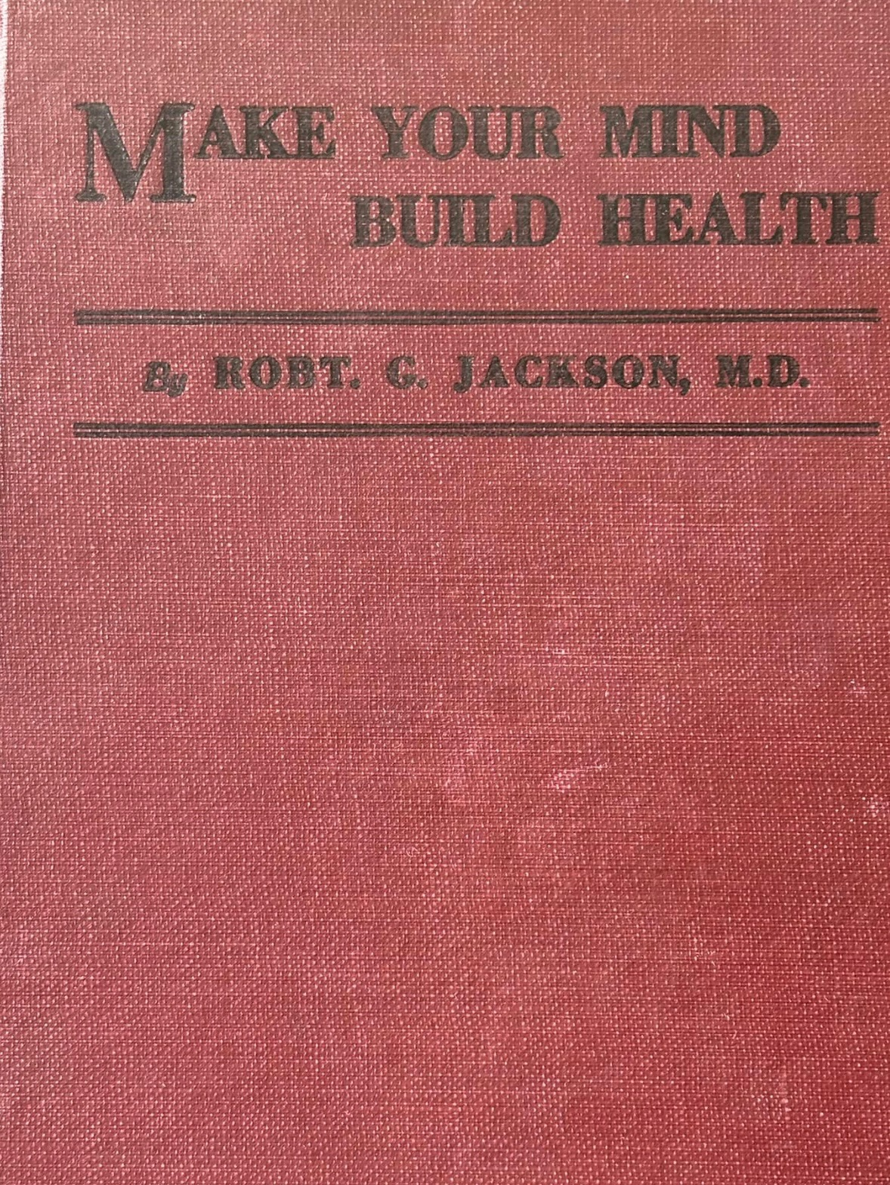
Dr.Robt Jackson, MD was the 1st old MD with an enlarged, near dead heart with high blood pressure and passing out- to grow a new heart in 21 days! The Dr. Howard Hay, MD Way! His 1st Book: How to Always Be Well, explains in detail! His Best Book written in 1928 in my opinion is the best Health Book ever written! He wrote many books, all of them are Great! He lived the way he wrote and saved his life, then restored his life and then created him self a super strong body!
The only way to learn is by reading and self-exploring based on what you read! The 1890-1930’s MD were the best! By 1950 they learned why some people never eat or drink. They learned how most anything can be made from air (energy) how humans are glowing / electric beings same as all other mammals are and all life, is “electrical” regardless if human or plant. When the electric leaves, live leaves.

Dr. Howard Hay, MD cured all with oranges and corrective diet and proved it with 63,000 patients.
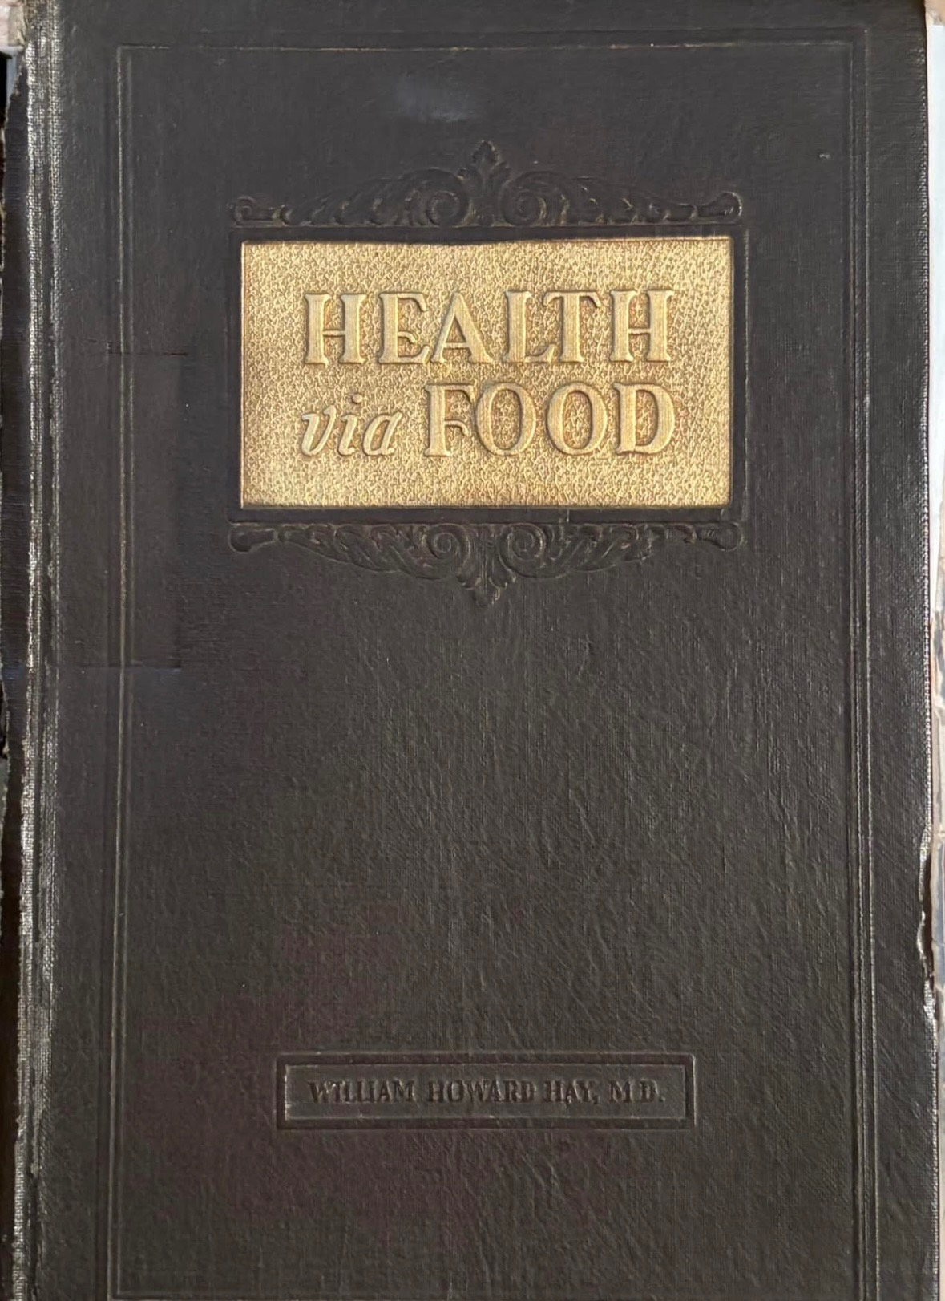
Health Via Food book changed my life more than all other books! 5X more Red Blood / Stem Cells in just 14 days and after 40 Days I lost 52# and had all new skin! The Orange Juice Method works for all humans regardless of the disease. No other herb compares to the power of the Orange! All adult humans can do 14 days; while Too Thin People would need professional help! The Too Thin People must eat their way back to Health (Royal Jelly) with lots of corrective foods / herbs! I suggest 21 days each January 1st.
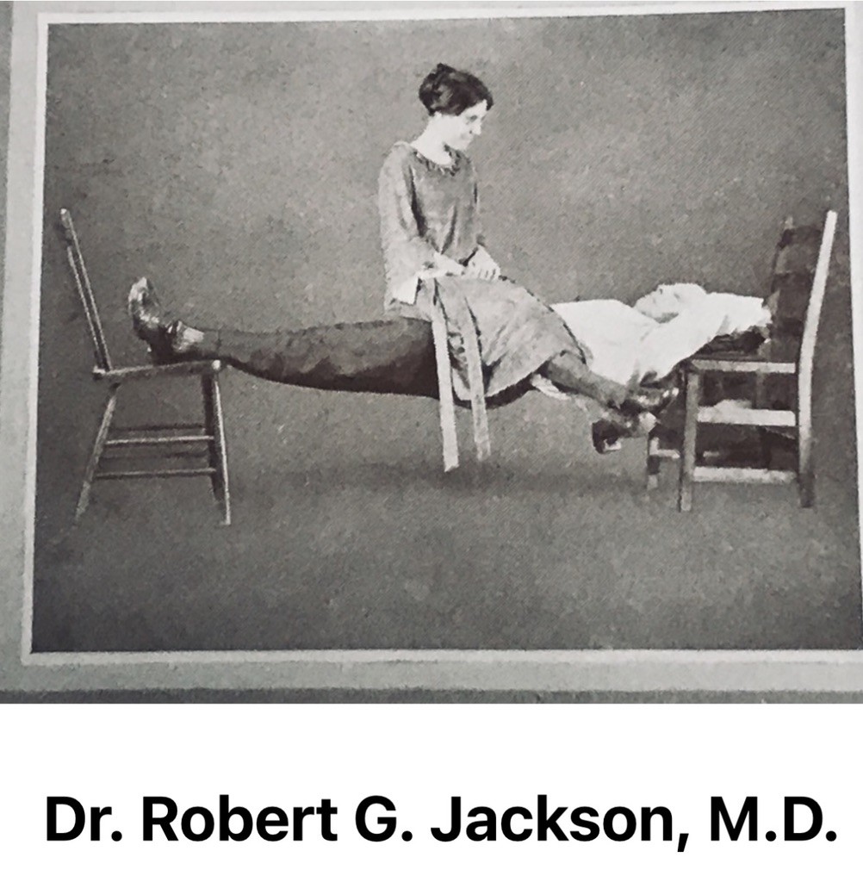
Dr. Jackson was old, he not only grew a new heart in 21 days, he grew a new body in 11 months and became incredible strong! He wrote many great health and exercise books! He is by far my favorite author / teacher! By far my most favorite author. He self-experimented with many foods and proved humans need very little food when it is alkaline forming foods! His books kept no secrets to his success! His 1928 Book the Best!
5). Parasites (A huge subject)
We live at the bottom of an ocean (air) of fungus! Everything has bacteria and returning all matter back to dirt. Mold comes up out of damp soil, low spots, wet spots and where the sun is restricted. Weather control jets have blocked the sun to the point trees die from too much mold and mold growing on the sides of buildings badly. Good air & Sunlight is anti-parasite!
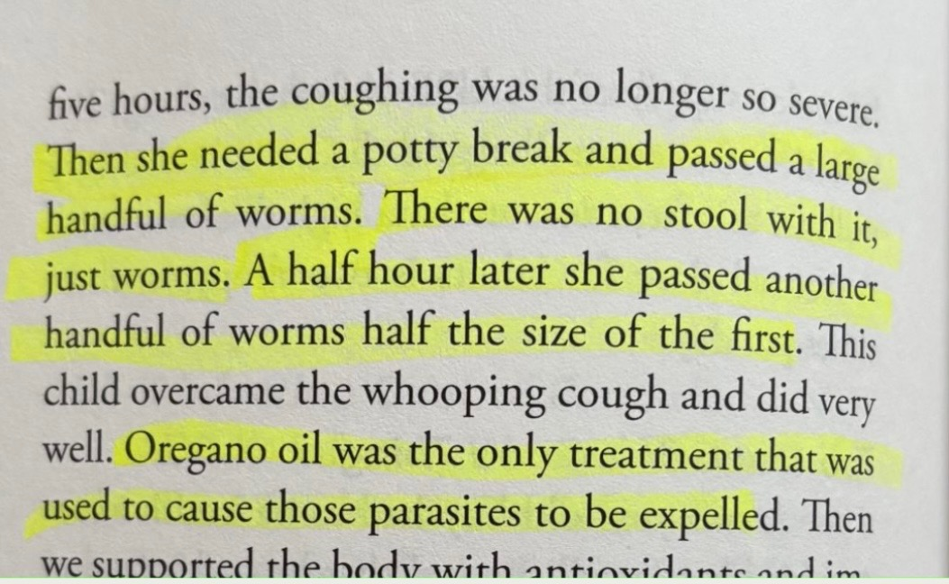
I gave this Amish healer his 1st bottle of Wild Oregano Oil about 25 years ago when he said whooping cough was bad that year. One month later he told me this same story!

He believed the colon worms was the cure, but the rapid cure; killed the parasites inside the Lungs! That is the Miracle of Mountain Oregano Oil!
He wrote a large book in 2024 and this paragraph explains how he told me he “cured” whooping cough in 7 hrs, in that after the worms came out, the babies no longer struggled. Noteworthy is the fact he mentions the worms exit with “No Stool”, to this very day 25 years later, we hear of or see pictures of diapers with worms and “No Stool”! The No Stool part is puzzling to me to this very day. I am 100% certain the worms seen in this 1st case was goat worms that results from drinking goat milk. I see the same when puppies drink goat’s milk.
The only people I know left on earth that make cold processed, mountain harvested oregano essential oil, told me that this is why Mountain Oregano Oil is used during pregnancy, once born and daily for life as part of The Super Babies! Prevention and never allowing the baby to develop parasite sickness / diseases. We raised our babies with daily Mountain Oregano Oil by age 10 days old due to this story we were part of over 25 years ago. I made the Joy formula as a “complete” daily supplement and always dosage related. This simple; if it eats, poops or pees inside or on us, it is a parasite and humans are born with many trillions of such parasites and the kidneys must clog and the parasites multiply a lot to experience the 1st cold or sickness. Every illness / sickness / death is a parasite subject.
All good herbs are anti-parasite herbs, because all good herbs / foods are nourishing to the liver and blood cells. There are 20+ great adult - use parasite herbs and every country has many with historical use. Dr. Hulda Clark was the 1st American author by the 1990’s educating about parasites in humans and made the black walnut / clove and wormwood herbs famous.
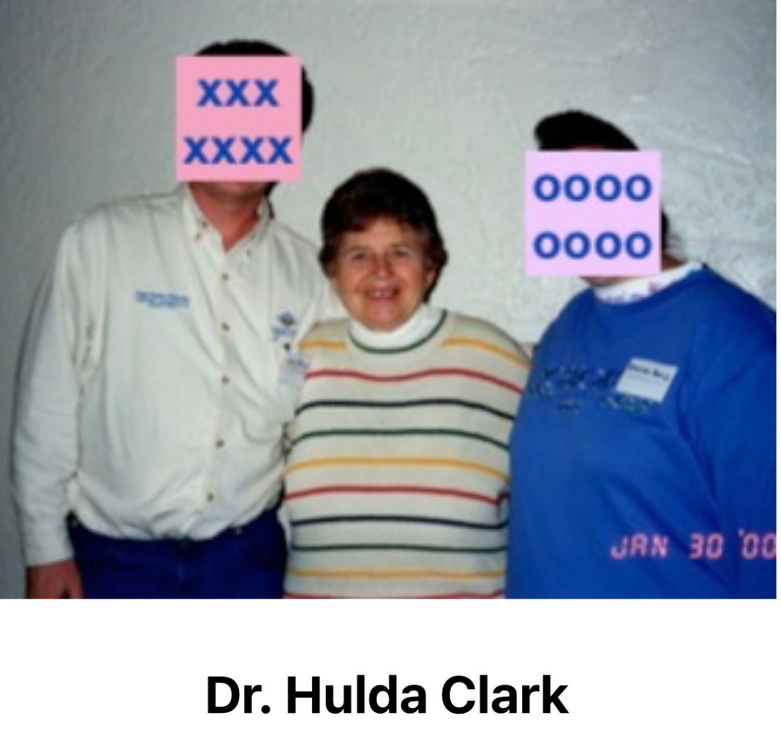
We knew Dr. Clark very well, I was the 1st one to blend her favorite herbs into “formulas”, as she used them as single herbs. The Amish Healer asked me to take the Clark Combination of herbs and make it for Children just for him. That was my very first making of a Syrup / Tincture blend.
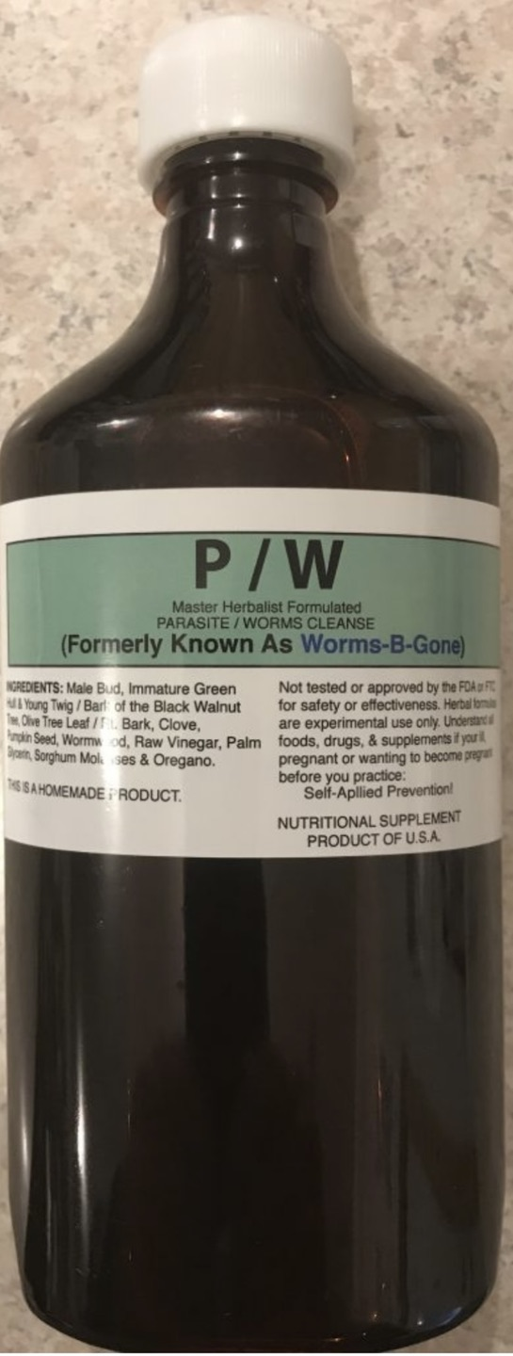
All of the Syrup / Tincture formulas all have minerals for strong bones and teeth and consumed ideally daily for life as prevention. Waiting until ill, is wrong use of herbs / foods. Prevention is King! Healthy is anti-parasite, while sickness means the parasites are breeding! out of control!
We called this formula P/W Parasites / Worms, while it was made well known by Amish as: Worms “B” Gone, Old Fashioned Amish De-wormer, Good Riddance, etc. 28 years later this is still #1 popular formula. 25 years ago I blended in the adult de-wormer herbs that Dr. John R. Christopher liked best and called this same formula P / W Adult. This formula equally as popular as P/W.
P/W
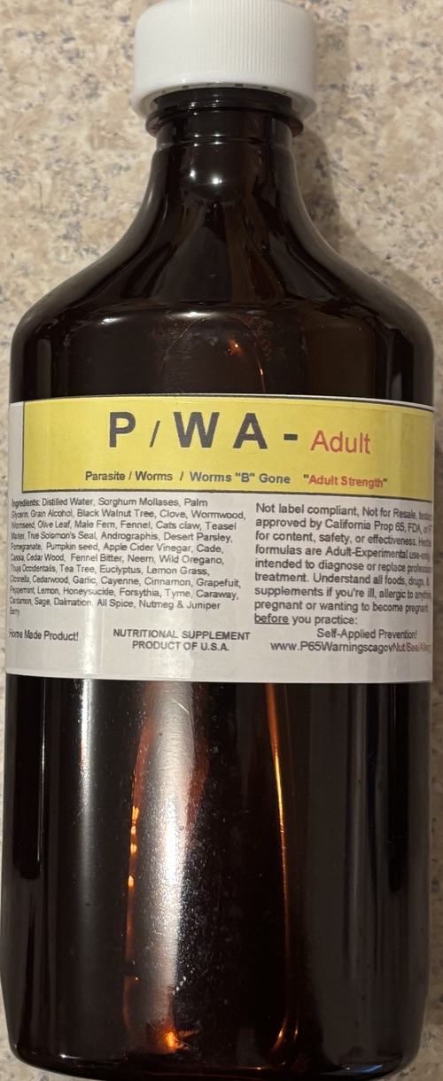
For 3 years I looked at liver cleanse results to see how effective, which herbs are. Most every adult all had the same type large worms! Only people that spent time in different countries had “different” than normal worms! Fact: The trillions of parasites that can only be seen in the most powerful microscopes are the deadliest! These large worms endlessly lay eggs and eat organ tissue, but in general they die with herbal use. The Liver is the parasite restaurant! They thrive where there is no blood flow, like the pancreatic duct, liver ducts, in the clear fluids, on the skin, hair, eyes, saliva, intestines- wow do they love the intestines with endless free foods! They swim the blood stream; tunnel through out the entire body.

Sheep, Goats with house cats, seems to be the triple threat! They say over 1/3 of the human population is plagued with cat brain worms that can harm the entire lifetime. Each and every new worm, along with trillions of lymes, bacteria and viruses and virtually every human body is “1” Human Spirit in a body with trillions of pooping and peeing parasites having billions of eggs and babies endlessly. The Blood stream has the job of 24/7 control and all herbs / foods enable the blood stream to protect the human body. Once consumed by parasites like cat worms, sheep / goat worms people generally seek to protect their worms- which makes scientist believe many worms can control the brain.
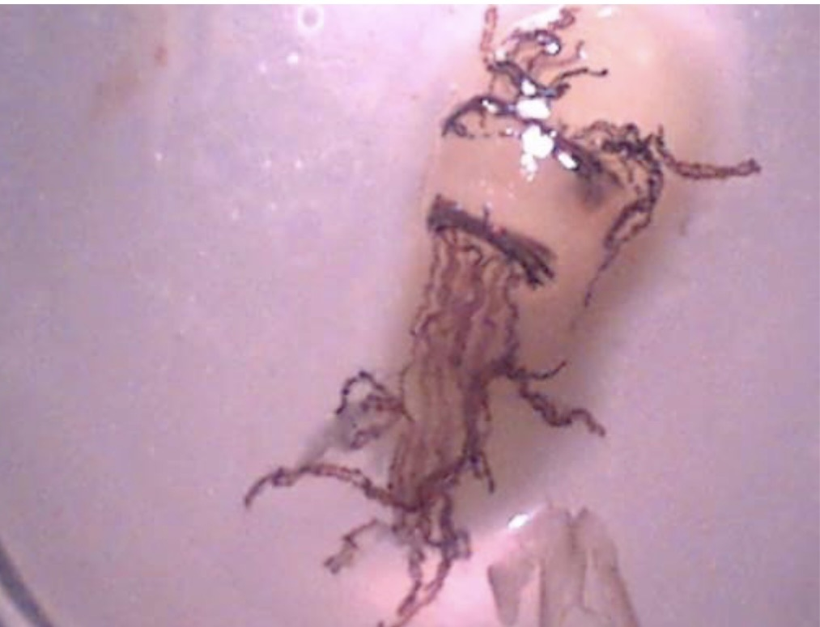
Liver Flukes
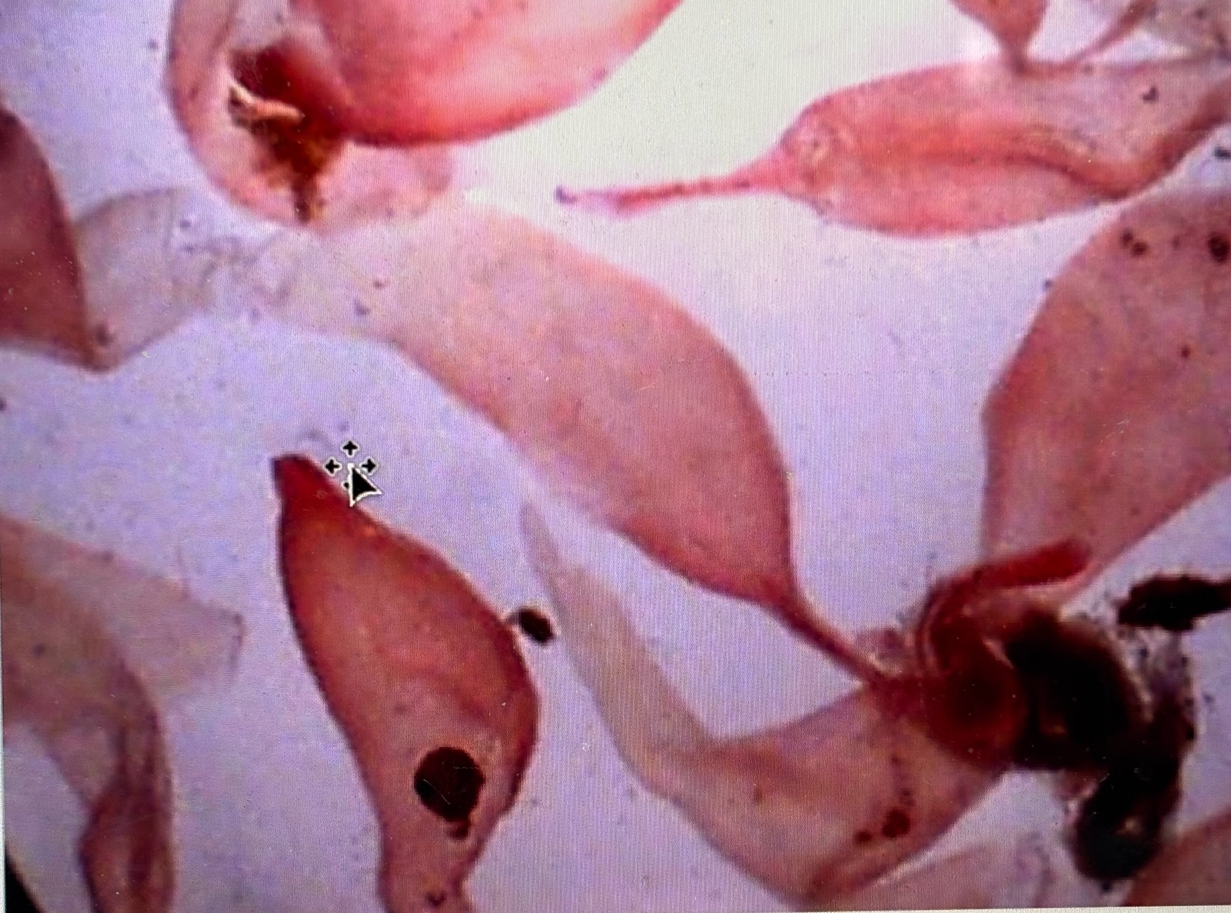
Sheep Flukes
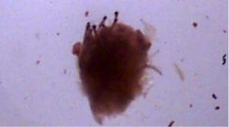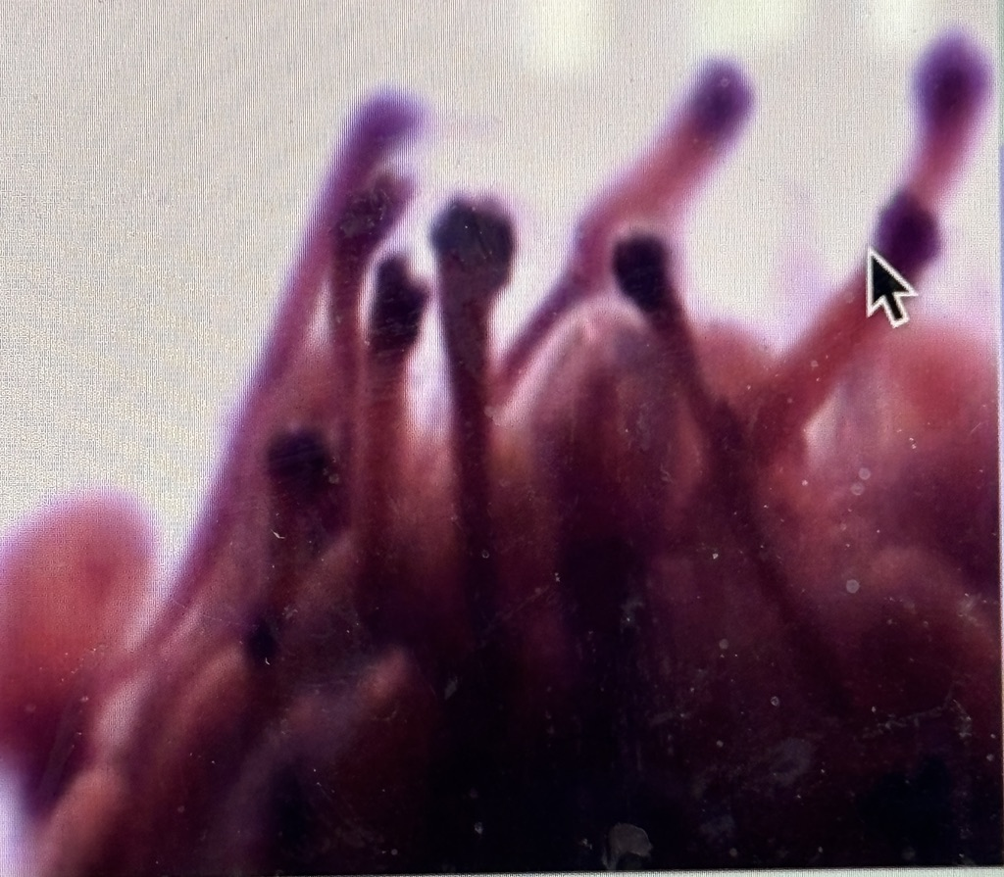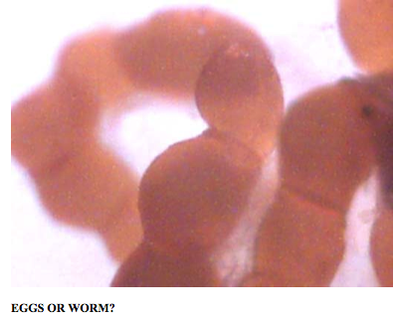
broke loose- Glob of worms 60 X Common Eggs
I noticed old herbal drs ended up with at least 1 very large formula, often called an anti-plague formula. My version of that I called Maximum Restore. It starts with 20% of P/W and then lots of herbs such as Garlic, Horseradish, Onions, Home made Fruit Vinegar and lots of other herbs and made mild enough for all ages. Such formulas were always for lung congestion. / breathing. Our kids grew up on Max Restore and it is my favorite as well. Mild tasting and dosage related. Our boys could drink 1 bottle. I often suggested ¼ bottle per day.

Due to our children growing up with Max Restore, once adult they would just open and drink an entire bottle, so I made the 1st adult version, which basically has more Mountain Oregano Oil. This worked great for adults that can handle the strong flavor of Oregano! The American Amish like this so much and say they dilute with water for their families. They call it multiple names, such as super biotic. It is just simplistic herbs used for centuries with raw honey. In the future I will ad Royal Jelly as an option. Royal Jelly with Mountain Oregano Oil are 2 very amazing supplements for mammals.

Herbal use is simple, they are or should be, just foods! Foods that offer usable minerals that the common diet may lack. Herbs / Foods consumed dead, can only supply minerals that the blood makes use of! All bottled vitamins are synthetics and not vitamins what so ever and at best are usable minerals, but fail at being herb minerals, they are closer to the rock minerals. Our children grew up: vitamins free, drug free, needle free, dr free and know Maximum Restore very well. People all have different taste and likes and dislikes, so there are literally 100’s of herbal / food choices in life!
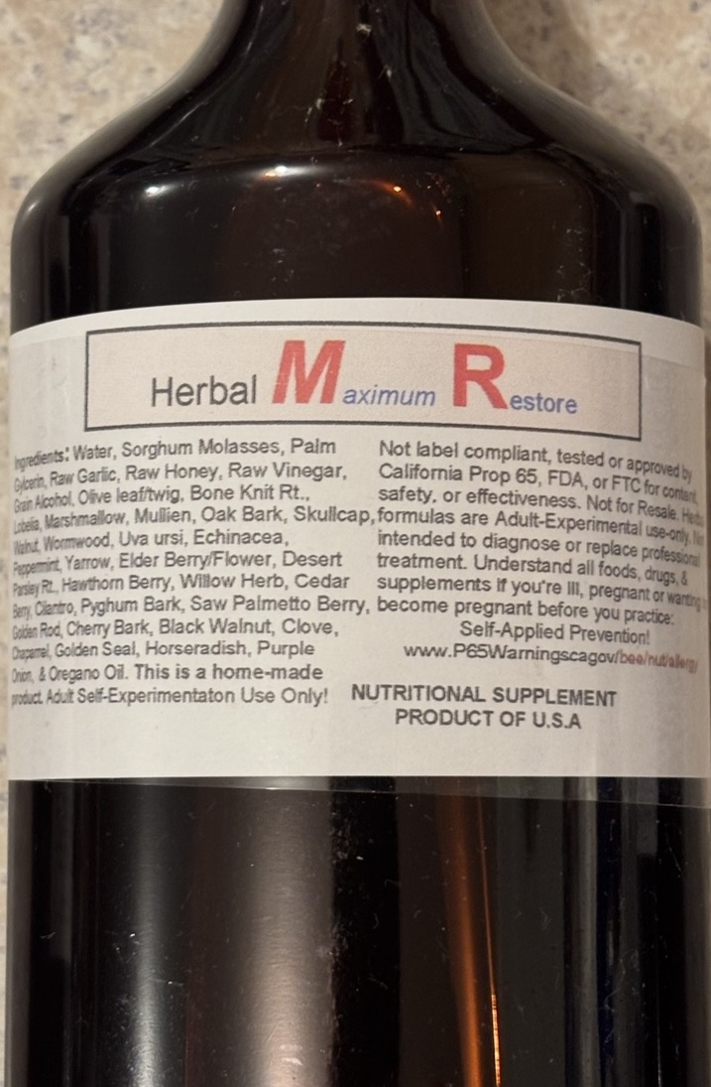
Max Restore
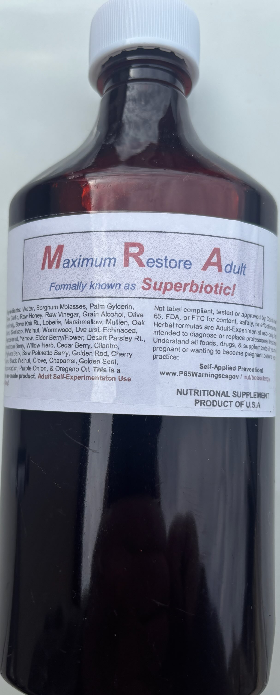
Max Restore
“Adult “
Longevity Spices is an Anti-Plague formula based on Cayenne, Garlic and Raw Fruit Vinegars with lots of herbs! This has a potent cayenne taste and not something children like. While some adults absolutely love this blend with a few LBB Capsules daily and believe it to be the greatest! There is a lot of stories about this formula that there is not enough space to explain in this little paper. People that grew up on spicy foods, peppers, cayenne etc. may enjoy the flavor, while those that never ate spices as children will just taste “hot” and an super adult versions with Chili Essential Oil are super hot taste!
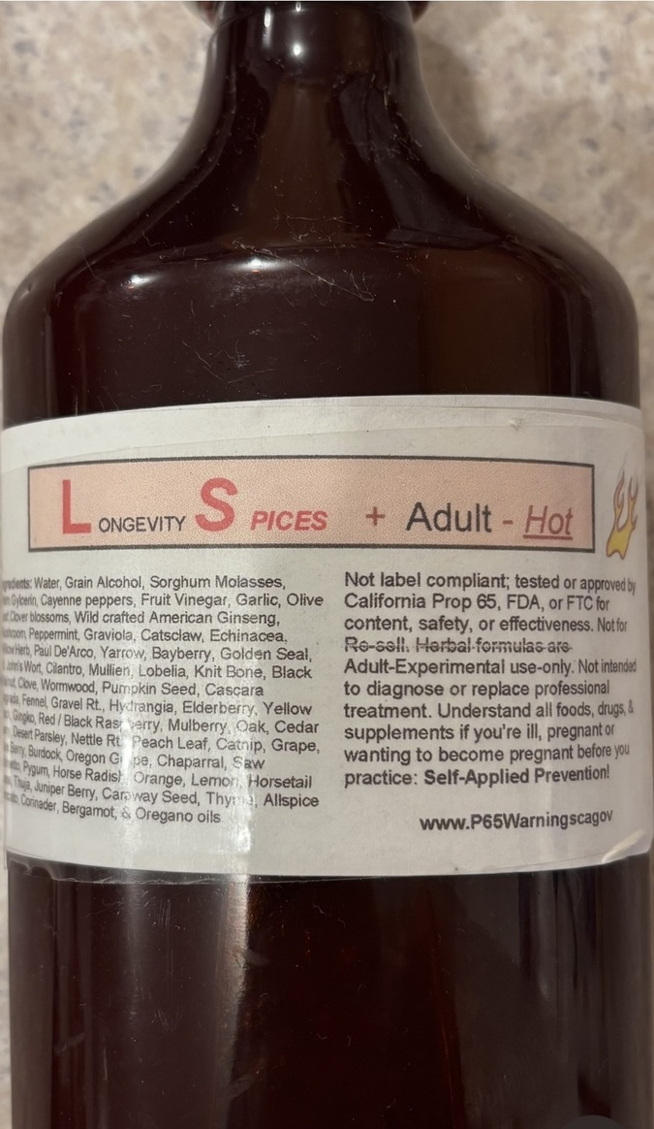
Longevity Spices
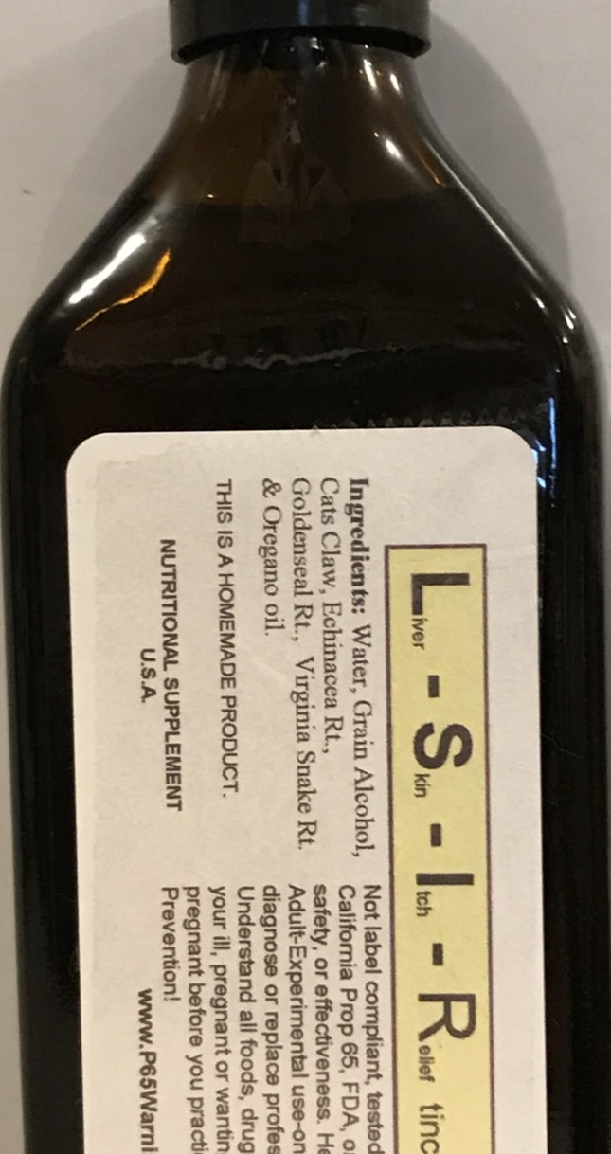
There are 100’s of famous herbs. This formula is based on one of the rarest, most expensive herbs in North America: West Virginia Snake Root. I call this blend Liver - Skin – Itch – Relief. It takes 1,000 Snake Rts. to make 1# and is one of North America’s greatest health herbs. 1st made 30 years ago by a famous MH just for me. His suggested dosage 1 tablespoon morning and night until 32 ounces have been consumed! It has a powerful Tincture Taste of Golden Seal Rt. Adult use only and the most potent herbal blend I know of when 32 ounces have been consumed. It had never been made before and no books written about this combination.

Cattle Strength De-Wormer herbs are Pure Essential Oils Cold-Processed that can be added to water or blended in olive oil, etc. or mixed with feeds. I deliberately blend 50% Essential Oils of Chili, Cayenne, Garlic just to insure no human will put it in their mouth! This formula is the hottest on the planet! I use this for our chicken water, dog water and cattle water! Animals are constantly being consumed by parasites! Lifetime Prevention is my choice! I keep in their water their entire lifetime when possible! The powerful spices date back in history for all mammals!

Vitamin “C” Elixir is the Adult Version of The Super Baby “Joy” Formula! This a “Luxury” Top Shelf one of a kind Longevity Herbal Blend based on The Best of Dr. Cass Ingram! Dosage Related, the more the Better! To make more powerful ad drops of Pure Oregano Oil and choice of De-wormer Essential Oils as desired!

There are no books, no drs, no authors that will ever exist on these types of formulas. These types of herbal use, must sale them selves or they normally fade away in history. This particular formula is the Super Baby “JOY” Formula made adult strength, so even if it never becomes “popular”, it will survive the test of time as long as the greatest supplements can be obtained. The theory is simple, the use of Royal Jelly for all the B Vitamins and 5 usable hormones. The use of Raw Honey! Use of Minerals for strong teeth and bones! The use of Olive Leaf, another powerful historical herb considered as safe as water! The use of the world’s greatest Mountain harvested Oregano cold-processed Essential Oils. 100% of all such herbal blends in a bottle “all” supply usable minerals! The Blood then decides what it wants and can make use of in daily life!

The blood / brain “knows” what it needs daily and what foods it can obtain the organic minerals from. When certain foods are “craved”, there is a reason; the blood “needs” certain minerals as it seeks “Balance! The pH must always be 7.35 or the body will feel ill. People resist to understand the stomach should be “Alkaline” and is only acidic during Phase 2 of life when baby must live on Mother’s Milk for 18 months! False / Bad drs push that the stomach must be “Acid” always! WHY? Very Simple! Acid Body = Sickness and sick people created the med empire! The more poisons, the more sickly people. Real Doctors will preach the diet cure!

L- S – I – R

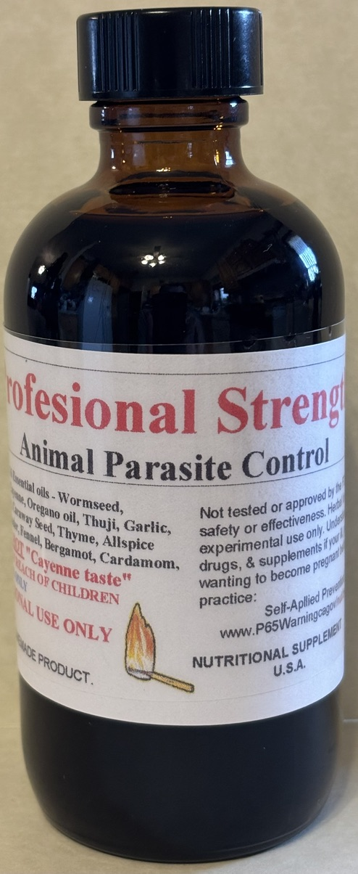
Cattle
Strength

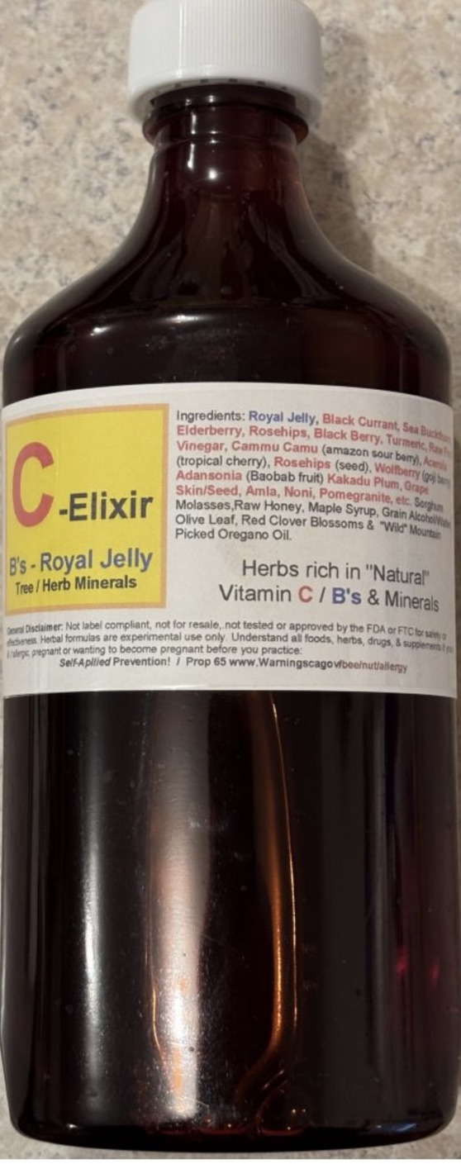
Vita “C”
Elixer

6). Mountain Oregano Oil / Olive Oil
The greatest kit on the planet!
1%- Consume and move on to:
3%- Consume and move on to:
6%- Consume and move on to:
10%- Once able to consume #10 freely with no discomfort, then anyone can Master “Real” Mountain Oregano Oil!
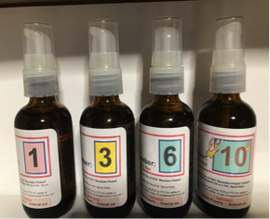

As far as I am aware of, this is the only none standardized, none synthetic Real Mountain Harvested, Oregano Cold-Processed Essential Oil I know of! The Rarest Herb on Earth! With more uses for all species, plant, tree use than all other herbs on earth! The “Essential” Herb required in the Theory of Super Babies! If I could only have 1 herb on earth, it is this Real Oregano Oil. Endless Uses!

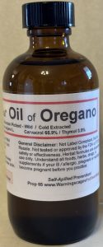
Mountain Oregano Oil takes 55# of mountain top herb to make 1oz. The rarest herb on earth in my opinion. The most beneficial herb on earth. Extremely Potent and must be properly diluted for “all” use! The only Mountain Oregano Oil used for the bedroom air treatment for life after birth! Takes 45,000#+ herb to make 7 gallons!
I consume 2 drops “Pure” every day with my X20 Water!

2026 Results: Carvacrol 62.2% and Thymol 3.7%
Each year will vary in strengths! While synthetics will have abnormally high (fake) results! Beware anything saying super strength or high carvacrol. (Synthetics)

7). BF & C (Bone / Flesh & Cartilage)
No One makes the Dr. John R. Christopher Methods “Better” in modern times! He instructed to take my methods and make them Your Way! Continue to Improve! No One Makes
BF&C “MY WAY”
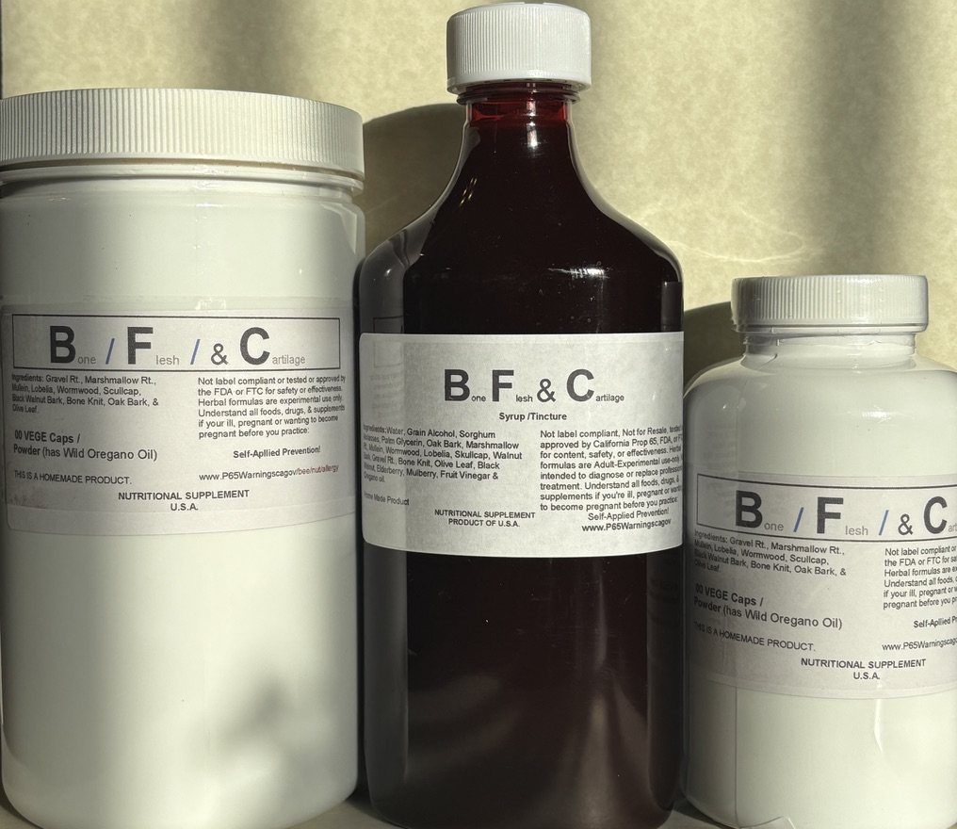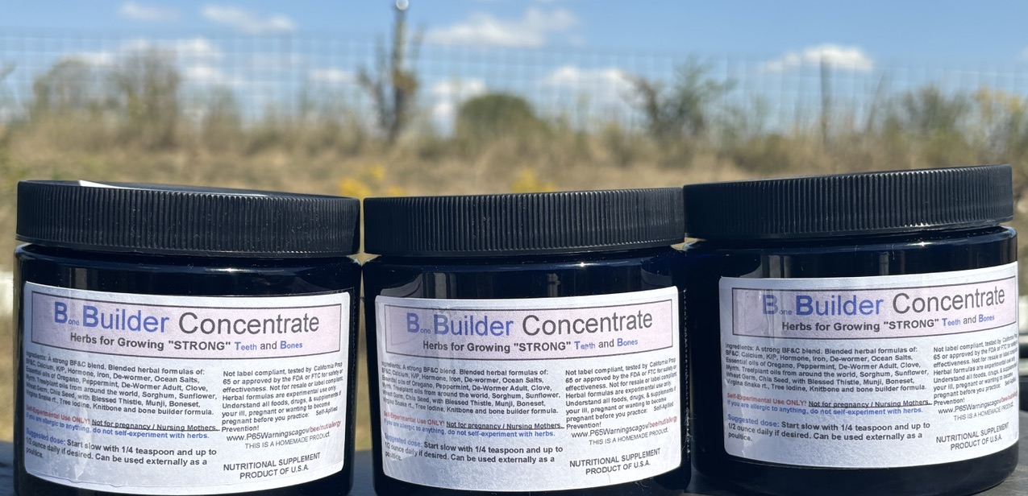

Bulk Powder, Tincture, Syrup / Tincture, Salves, Sprays & as Herbal Concentrated Paste!

My 1st herb teacher, Dr. John R. Christopher made BF&C formula famous. Extremely simple Theory, you swallow mineral rich herbs for food for the blood and then apply the same herbs externally where it hurts and ideally with hot spicy herbs to stimulate the blood to come to the skin to remove the hot spices. By doing so, the mineral enriched blood “heals’ the area where the hot spray or salve was applied! Absolutely no one makes BF&C Formulas as original or as advanced as we do. The old company sold many times before I took the schooling long ago and each new owner removed many of the original herbs so they could export to other countries. That is actually why we make our own, because there was no reliable source many years ago.

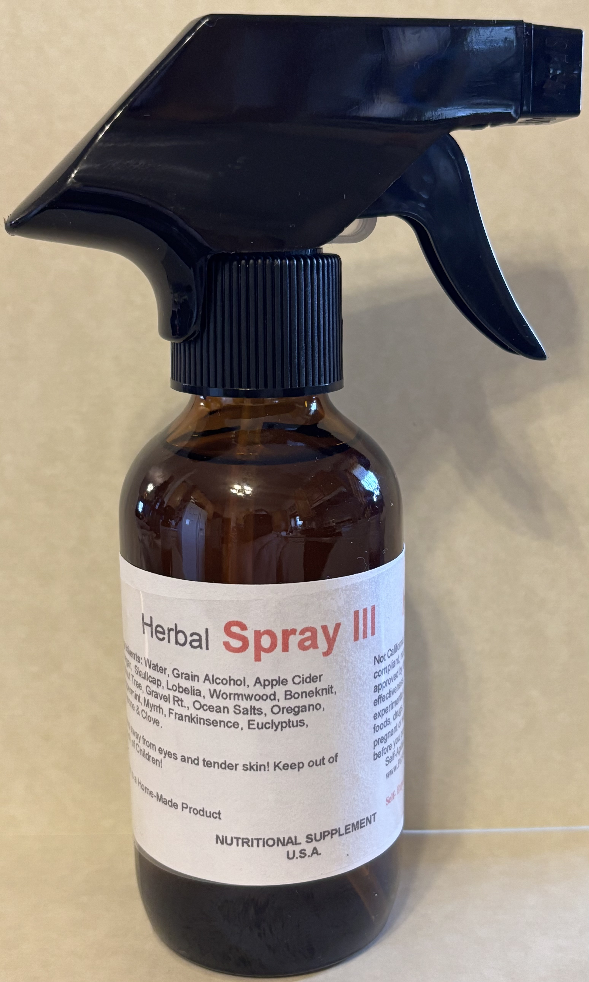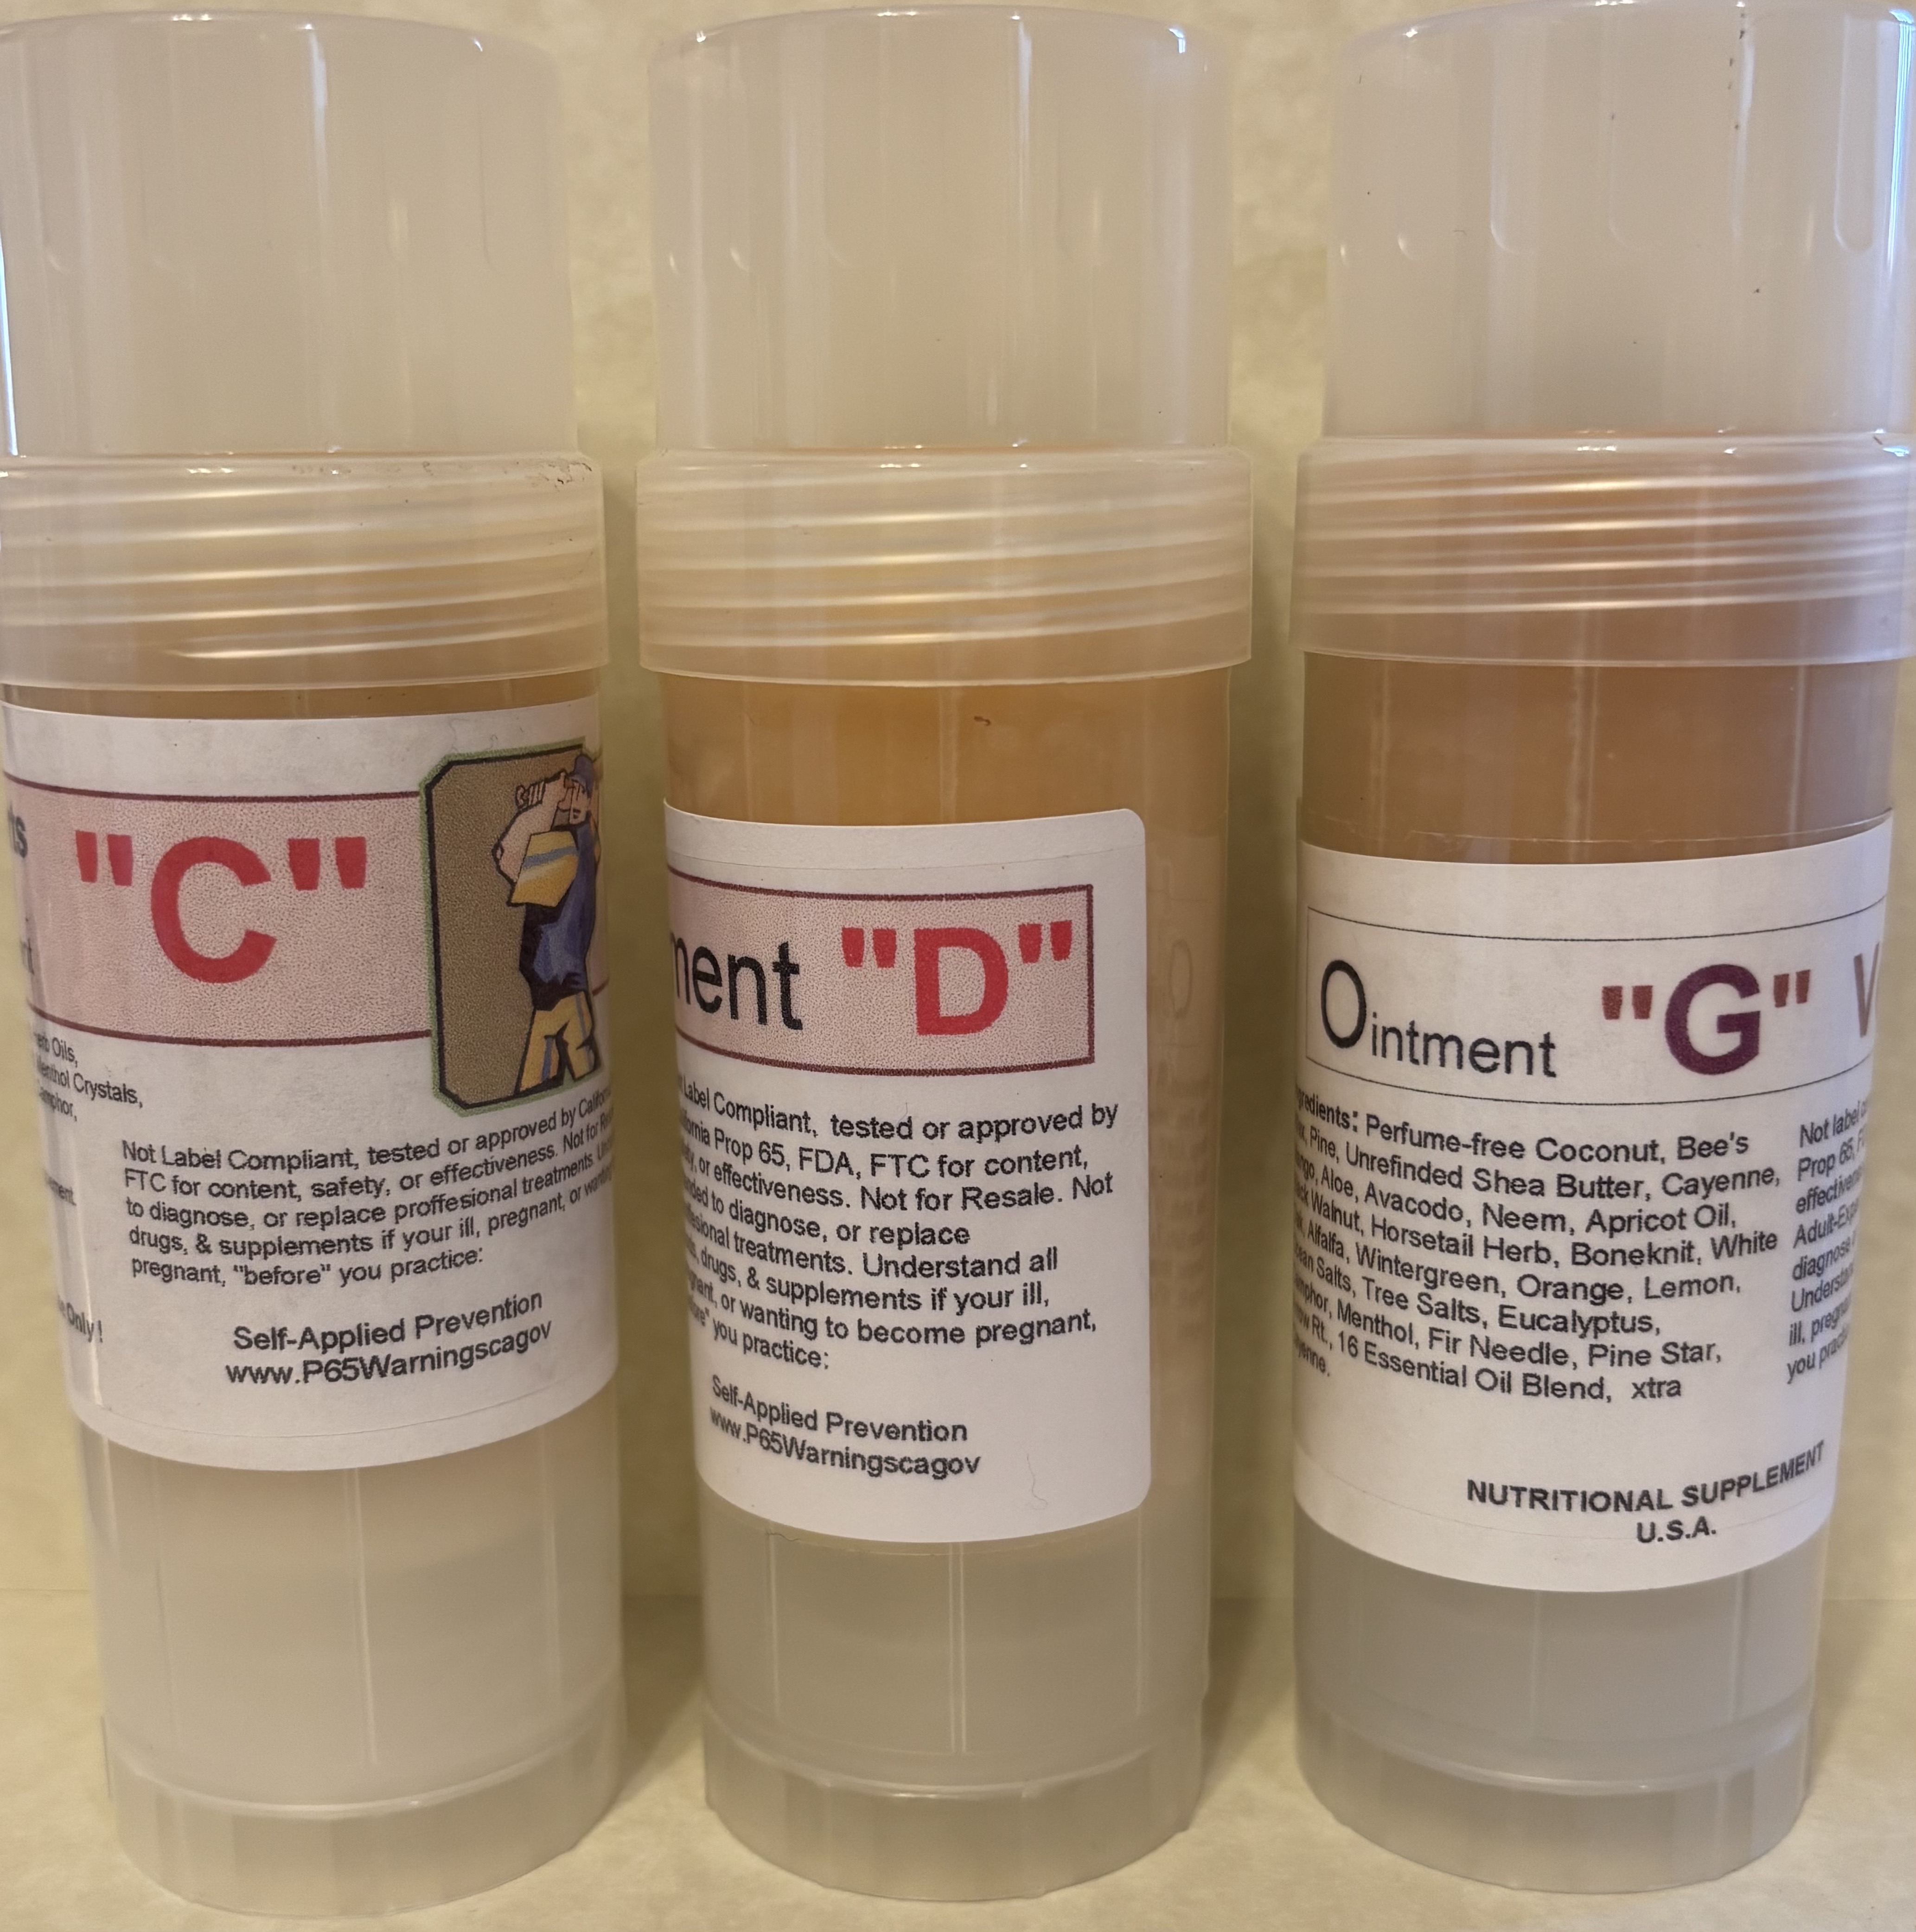
BF& C Theory used for all injuries!

Consumed “Daily” for growing strong teeth & bones!

BF&C Herbal Spray 1, 2 or 3 / Hot Spicy BF&C Salves Amish nick named Herbal Sprays: Miracle Spray 1,2 & 3

8). Bleeding

Dr. Christopher did not believe we inherit “bad” things and that the baby was developed in the “diet deficient womb” and that some children need “diet help”. Example; Bleeders, he believed they do not make proper use of “Calcium” in their diet and bleeding is a calcium issue, not heredity! This is why diet is so extremely important in the womb and the 1st year, so Baby fully “Develops”. His solution “Calcium” rich herbs.
Stop Bleed Powder: Cover the injury with the powder and wrap accordingly.
No Bleed Capsules: 4 capsules and 2 capsules every 5 minutes with full glass of water until No Bleeding. Both formulas are “Amazing” to say the least. Diet issue, not Hereditary! Naturally only adults with experience take care of them selves and always; when in doubt, seek their care providers immediately when bleeding. All schools should teach students how to sew up cuts and treat burns!
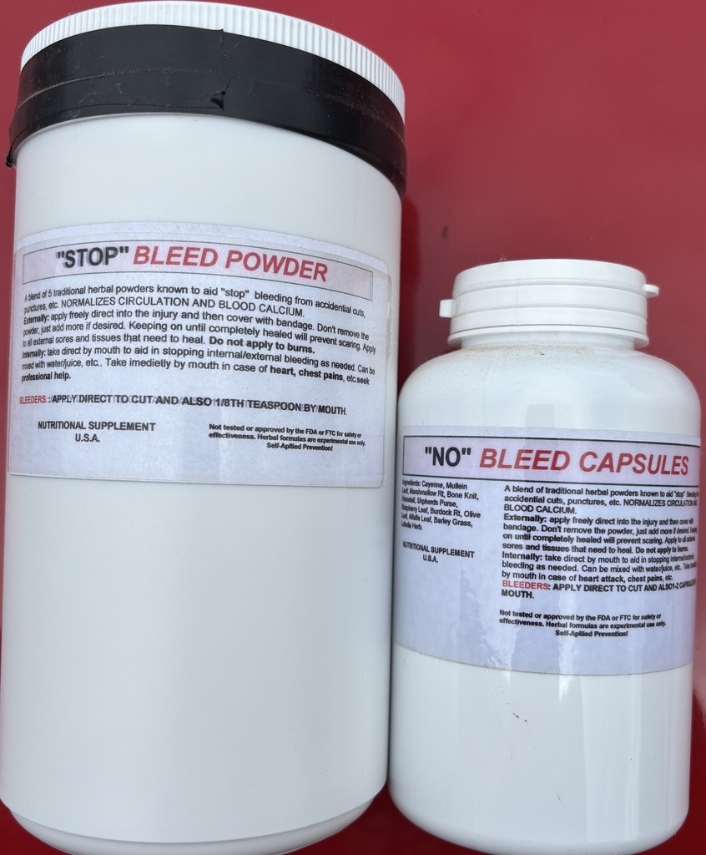

A bleeding cut enables the blood stream to expel undigested foods- called “puss”. Dirty diet = bleeding with puss & scab. Leaking Ulcers that never heal are expelling waste. A Clean Diet, the fresh cut should never drip blood to the ground, while a Dirty Diet the body wants to push waste out of the cut and bleeds. Nose bleeds can be misunderstood! The same happens internally, Stop Bleed stops the bleeding, but not the cause! Correct diet, healthy digestion and elimination with no constipation = healthy body! Worms feast on undigested foods and sick human tissues. No mammal can be worm – free! A Healthy body lives in a world of parasites, while a sick body is “consumed” in a world of parasites. All toxic foods / drinks / air accumulates in the ill body and the blood always wants to expel the poisons as mucus, puss, waste that smells of rot. Lower Bowel Balance Capsules are the world’s best herbal powder formula for 100+ years! Worms have the job to eliminate the toxic / sickly species by returning them to the soil.

9). 100’s of Herbal Formulas

Dr. Christopher learned how to use over 2,000 herbs. He chose to use less than 200 herbs and had 63+ famous formulas for every health symptom. You in fact can use single herbs like ‘medicines” and force the body to respond; that was the medical foundation long ago. Every mother the family doctor! I noticed the old drs often had 1 huge anti-plague type formula that follows the 1957 C0-Q10 theory that the blood stream only wants a tiny amount of usable foods daily and 99+% of what we eat goes down the toilet unused. Foods that do enter the blood stream can end up in the lymph glands for 1+ years as food for lymes parasites. This made the drs call the Lymph glands the true stomach. The success of all our Syrup / Tincture large bottles is that they follow the Co-Q10 Theory with plentiful usable minerals. Every great herbal formula can be made as a S/T blend and those can all be blended as an Herbal Mineral Concentrate! That theory works amazingly well as those type formula sale them selves by word of mouth.
Literally 100’s of herbs are desired by people, all having their “favorites”! Often what they grow up with, they want for life. Tinctures are potent and also made as formulas. Most potent are the Essential Oils and they must be properly diluted for each use, be it air, skin or internal. All can be blended into herbal concentrates with herb oils / seeds. Those that like med use, use single herbs or “like” herbs, while large mega Co-Q10 type formulas are more food-like seeking to supply “unique” minerals. Ideally the human brain will “think” of foods / herbs that the blood needs and when taking herbal formulas you know you took enough when you forgot to take it. The body knows what it wants.
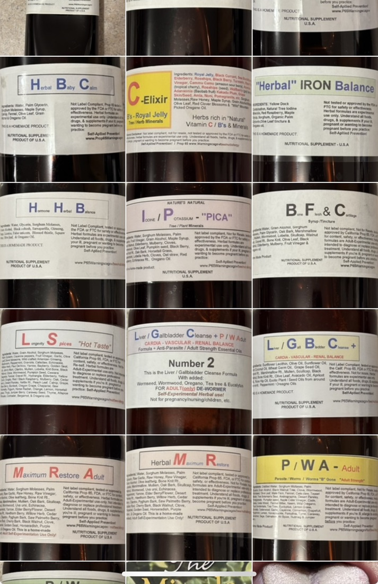
--
Chaga Mushroom & Royal Jelly are 2 examples of Luxury use of herbs / bee products. Every herb offers a unique group of minerals the blood may make use of! Herbal choices are endless and only those that people will buy survive history! What does not sale fades, no matter how great. Herbs / foods that are called “Heavy” (with minerals) often have the most history of Longevity. I have self-explored endless famous herbs, My Way! Most are Yummy for the Tummy!
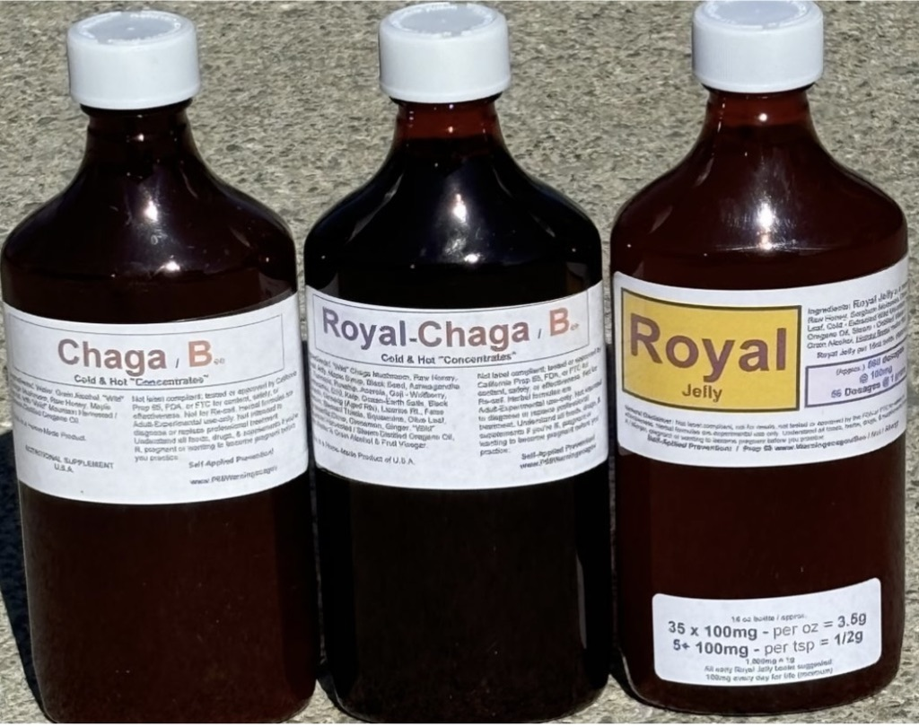
Chaga “B”
Chaga Royal “B”
Royal Jelly

10). Herbal Concentrates
Herbal Concentrates are a huge blend of herb powders, oils, tinctures, & essential oils, made as a thick Paste! Only 1 source, no one else makes such things!
Every great herbal blend(s), can be converted into an herbal concentrate with the theory of an All “N” One. Consumed by the spoon / smoothies!
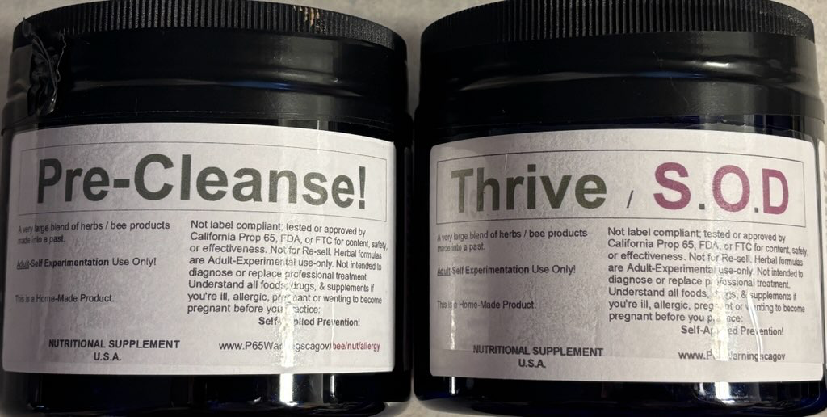

There is no limit with the concentrates. For myself I made the “Best” of Dr. Christopher and called it Pre-Cleanse! Everything for the “organs” and I left LBB out because I like taking as capsules, otherwise LBB has been made as a concentrate years ago.

Thrive / S.O.D. I made based on the 20+ Dr. Cass Ingram Books! The Ultimate / Rarest Longevity Herbs! I did this for the fact I was using 50+ formulas in an effort to achieve this and as concentrates, it became simple to consume every day!

BF&C concentrate survived time, as did women and men’s wellness concentrate, all the other “great” formulas failed to sale and replaced with the above 2, but such blends can only be made in small quantities and takes a special person to want such unique use of herbs!

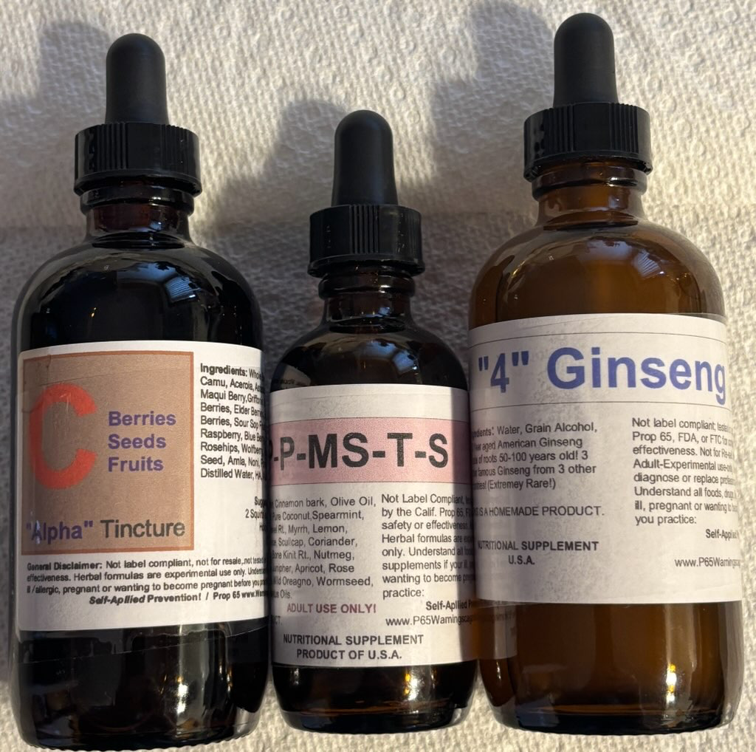
1 example of “specialty” formulas: “C’ Blend / Extreme Parasite Oils / 4 Ginsengs! I take these daily along with the above Concentrates even though they are in various other formulas. Same with taking LBB separate! Specialty herbs can be endless and the goal of many authors seeking to create sales! Learning to trust your brain and go with the flow and see what comes your way- there are no mistakes in life- every day an education.

Herbs are, should be, just Foods for the blood stream!

Why? Why prevention in the womb and daily for life? Weed & Feed!

Royal Jelly Japan Hospital use when using Royal Jelly for all ages and all health situations follows what I have always called: Weed & Feed. A little daily for the baby and a lot for those with Parkinson’s.

Deficiency diet / parasites in the womb, starts it all! Deficiency diet / parasites 1st year of life- does the most “damage” for the lifetime! Fail the 1st two years and struggle the lifetime is the theory behind Super Babies!

Deficiency diet leads to more and more parasites! More bacteria, virus, lymes (the invisible “trillions” of parasites) that leads to: Ringing Ears, MS, Parkinson’s, Dementia, organ failure, general aging and premature death. The 1890’s Oxford 11 year old medical study proved the men age 250 ate a 99% fruit / root vegetable diet with 1% meats. How did 99% fruit diet enable these males to be as strong as their 24-year-old sons? Very simple: All root bark sweet, yummy fruits from Trees, Bushes and Vines all filter out the “large” rock minerals and supply the human diet with very small “organic” size minerals! Every 2 year old child will love sweet / yummy fruits! Humans are “sweet” blood mammals! We thrive on real organic fruit sugars.

- The same reason, we steam distill all the rock out of our water! Similar to how root bark filters out the “same” rock!

Weed & Feed: Kill the worms, keep them killed and consume foods with “organic” size minerals!
It is and always has been, that Simple! All the sweet berries, fruits, herbs, with treats from the Honey Bees! All “Cleanse” the body! Anti-Parasite!

By 1950 medical proved hungry people have 100+ non functional hormone producing glands under their skin, while people that barely eat and thrive, can have 100+ functional glands that makes all their foods from Sun Light! Those that can not make food from Sun Light, they starve and eat meats that takes hours of digestion, that destroys millions of Red Blood Cells that Release Hydrogen Energy that “satisfies”, even can build muscle and is known as: “Burning the Candle at Both Ends! In that humans are eating them selves 1 stomach full at a time! As much as 80% of the blood surrounds the stomach when full of meats.
Dr. Howard Hay, MD Cure-All Orange Juice Fasting Results in 5X more Red Blood Cells in just 14 Days! While normal diet daily results in death of 432 Billion Red Blood Cells! People literally do eat them selves to an early death and being human, often means trying everything; even if we know it is not a healthy choice! Nothing beats of compares to the history of the Orange!
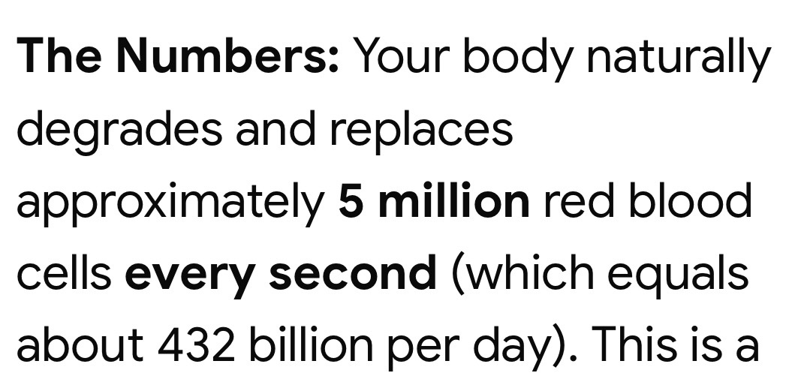

Our Red Blood Cells hunt, kill, dissolve parasites and expel out the elimination organs! Our Red Blood Cells take care of human health and that is “why” all ill health has a foundation in a deficient diet, parasites, poisons, dirty rocky water or what medical long ago simply called Advanced “Scurvy”! Take all diseases known and they are: Loss of Circulation also known as Advanced Scurvy!

The Theory of Super Babies prevents diet deficiencies, parasites and failed development! The “cheapest”, most “healthy” path to Healthy Life!

Advanced Lymes / microscopic parasites is: Ringing Ears, MS, Parkinson’s, Dementia, Organ Failure, as invisible size parasites eat the “fatty” nerves, spine, brain, and the nervous system “shorts” out and muscles “tremble” and nerves ate up. 1,000’s of such parasites can live in 1 dead tooth.

Circulation is King!

Endless reasons for premature death:
Wrong foods, dirty water, dental metals: lead, nickel, mercury & gold, all forms of silver, every heavy metal, germ & chem warfare, Lugols, all man made frequencies, Wi-Fi, cell phones, radio waves, world pollution fall out. False education, failure to obey Nature! Sadness / regret, loneliness, forgiveness, hatred, physical and mental harm.

No herb can undo the above! No LifeWave product can undo the above! Yet the subconscious mind has amazing abilities including self-healing, Faith Healing! We are what we “Believe” more than all else, making “False Education” the most deadly part of life on earth. Godly Love is the Only True Cure!

Dr. John R. Christopher would jokingly say: ask any Gorilla your health questions; he cannot lie!

The Gorilla would explain to humans: only live where it never gets below 65 degrees and the trees provide endless sweet fruits for each season of the correct color! Never live in a “sealed” house! Never wear clothing! Never work, God provides “all” to species for free! Your true food is Sunlight, Air and the Air has all the water required in each and every breath! Sweet fruits supply the rest! Every sin against Nature is rewarded with disease and shortened lifespan.
Great Doctors said: Do not put it in the mouth if you do not like paying us to help remove it from your body!
I Suggest: A None Acid Forming, non Deficient Diet, Poison Free Water, drug free, synthetic vitamin free, needle free life, should be an “Enjoyable Life”. Chiropractor as needed and Dentist “only” if Wisdom Teeth need pulled. (Student of Dr. John R. Christopher)
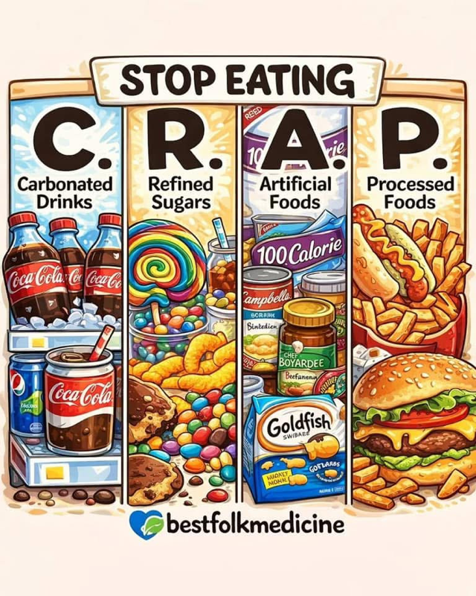

That 1st 9 months in the womb!

That 1st year of life!

The Successful Prevention for Life happens!

The Super Baby Theory! MH108

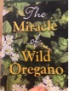
The “only” Mountain Oregano Cold Processed Essential Oil “Kit” on Earth! The Only Source for “Real” Mountain Oregano in North America!
(Stronger is available for “Advanced” Adults!) #10 is “Perfect” for all Adults!

The author’s 101+ uses of Wild picked Oregano Oil explained in his book:

A. Abrasions, Abscesses, Achiness, Acne, Age spots, ALS, Aflatoxin, Agitation, Allergic reactions, Amebic infection, Anger / frustration, Angina pectoris, Anthrax, Apathy, Appendicitis, Asbestosis, Asthma attacks, Athlete’s foot / jock itch, Attention deficit, Autism, Autoimmune disorders,
B. Balding, Bites - snake / spider and other venomous bites / dog / cat / human, Bell’s palsy, Berylliosis, Beryllium, Bird flu, Bladder infection, Bloody nose, Blood – streaked mucus, Blood clots, Boils, Bronchitis, Bruises, Burns, Bursitis, C. Cancers, Candida yeast, Cardiomyopathy, Chest pain, Chlorine gas inhalation, Chronic fatigue syndrome, Chronic hip pain / inflammation / ear infections, Circular lesions, Cold, Collapsed lung, Cold sensations, Colitis, Colonic mucosa, Congestive heart failure, Confusion, Cough, Crohn’s disease, Cryptosporidium, Cuts, Cystic fibrosis, D. Decubitus ulcers (bed sores), Demolition lung, Depression, Diabetes, Diarrhea, Diverticulitis, Dupertryn’s contracture, Dizziness, E. Earaches, Ear discharge, E. coli, Eczema, Elimination of sugar cravings, tobacco / drug cravings, Emphysema, Encephalitis, Endometriosis, Epstein-Barr infection, Esophagitis, Exhaustion, F. Fibromyalgia, Flu, Flu like symptoms, Food / water diseases, Forget fullness, Fractures, Fungus: actinomycosis / aspergillus / blastomycoses / coccidiodes / Cryptococcus / hiltoplasma / nocardia / penicillium, G. Gangrene, Gastritis, Gastro esophageal reflux, Genital herpes, Genital warts, Giardia, GMO intoxication, Goiter, Gum disease, H. Halitosis, Hay fever, Hepatitis, High blood pressure, H. pylori, Histoplasmosis, Hives, Hoarseness, Hyperthyroidism, Hypothyroidism, I. Inability to focus on work, Infertility, Insomnia, Interstitial cystitis, Itchy nose, Intestinal bloating, Irritable bowel syndrome, Irritability, Itchy skin and scalp J. Joint and bone pain, K. Kidney / bladder stones, Kidney infection, L. Laryngitis, Leaky gut syndrome, Leg cramps, Leukoplakia, Loss of appetite / bladder control, Lupus, Lyme disease, M. Mastoid infection, Meniere’s disease, Meningitis, Migraine headache, Mites, Mold, Moles, Mood swings, Multiple sclerosis, Muscular pain, N. Nail fungus, Nasal polyps, Nausea, Neck pain – stiffness, Night sweats, O. Ovarian cysts, P. Pain in the head / behind the eyes, Parkinson’s disease, Paronychia, Peanut allergy, Pinworms, Pleurisy, Plugged sinus, PMS, Pneumonia, Post nasal drip, Potts disease, Prostatitis, Psychotic behavior, Pustular microbial lesions, U. Ulcerative excessive gas, R. Radiation poisoning, Ringworm, Rosacea, Runny nose, S. SARS, Sarcoidosis, Scars, Scoliosis, Scrapes, Seborrhea, Sepsis, Shortness of breath, Shingles, Shin splints, Silicosis, Sinus attack / cavity / pain, Skin boils, Skin cancer, Skin Tags, Small pox, Smoke inhalation, Sore throat, Spastic muscles, Spinal stiffness, Spots on lungs, Staph, Sudden awaking at night, Sun burn, Swollen legs, T. Tapeworm, TB, Tendonitis, Tinnitus, Toenail fungus, Tonsillitis, Toothache, Torticollis, Tuberculosis, V. Vaccine toxicity, Vaginitis, Valley fever, Varicose veins, Vomiting, W. Watery eyes, Warts, Weak immune system, Wheezing, Whooping cough, Y. Yeast syndrome, etc.

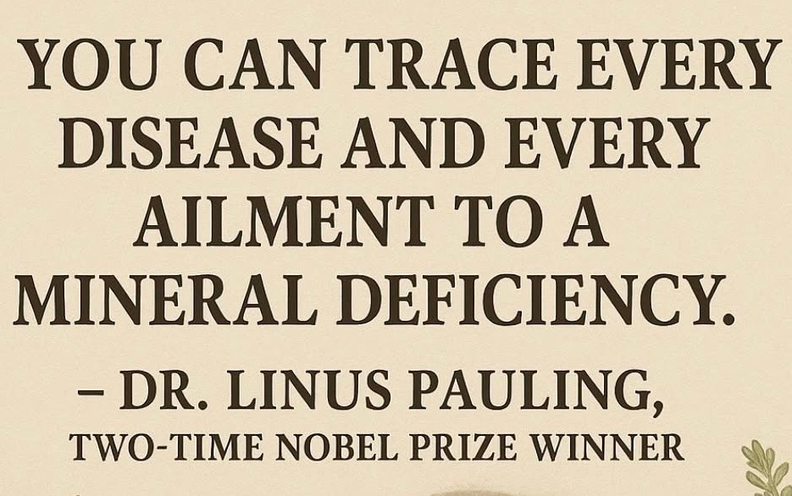
All Root Bark Foods are trees, bushes and vines that are sweet and yummy, taste great, all cleansers and the fastest path back to health. People that learn “fasting” and advanced fasting quickly learns their body rapidly self-repairs! All Fruits are of the correct color for each day of the year! Correct Climate never colder than 65 degrees! Coconut a whole food! Dirty Rock Mineral / Bacteria Water is always the #1 source for premature aging & death!

Foods / Herbs supply “usable” organic size minerals to the blood stream and the other 99+% is expelled as waste! All foods / drinks instantly puts the blood stream out of “balance” and the body panics to return back to “Balance”. The Blood must stay pH 7.35 for life. Healthy people that barely eat or drink, have 100+ functional hormone producing glands under their skin that makes “All” from sunlight! Humans were not created to wear clothing or live inside sealed homes or hide from the sun. Those born with defective glands under the skin are born starving and eat a lot and lots of wrong foods require lots of water. Their life is a roller coaster of eating foods that keep them out of balance and hungry. The fatter a person is, the hungrier they are. The more wrong foods, the more constipation, more acids, more parasites, more diseases.
All humans eventually die from Advanced Scurvy- Loss of Circulation!


Dr. Howard Hay Way Orange Juice Fasting by 1920:

- 14 Days – 5X more Red Blood Cells!

- 21 Days- A New Heart!

- 30 Days a New Liver!

- 40 Days I got all new Skin!

Humans are no more what we put in our mouths than are trees made of dirt! We are made of Sun Light & Air. We are electric
A Paragraph from a 2,000+-year-old book:
God created the human body as a composition of 4 things contrary the one to the other, and united them in one final object, which is man--- and this is earth, air, water, and fire--- in order that each one might temper its opposite. God made these 4 things a vessel, which is man's body, of flesh, bones, marrow, and skin, with nerves and veins, and with all his inward parts; wherein God placed the soul and the sense, as two hands of this life: giving for lodgment to the sense every part of the body, for it diffused itself there like oil. And to the’ gave he for lodgment the heart, where, united with the sense, it should rule the whole life. God having thus created man put into him a light which is called reason, which was to unite the flesh, the sense, and the soul into a single end--- to work for the service of God!
Paragraph from 11 Year Medical Study - Oxford Medical Book 1920

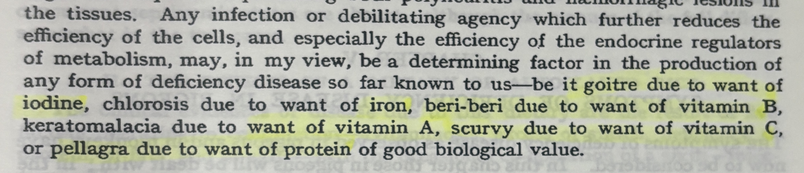

A). Natural Tree Potassium / Iodine- Goitre! (swollen neck)

B). Natural Herbal Iron: Chlorosis known as Anemia!

C). All Natural Vitamin “B”- Beri-Beri (weakness)

D). Natural Vitamin A: Keratomalacia (eye health)

E). Natural Vitamin C: Scurvy (loss of circulation / aging)

F) Natural Protein: Pellagra ( Dermatitis, Diarrhea, Dementia & Death)

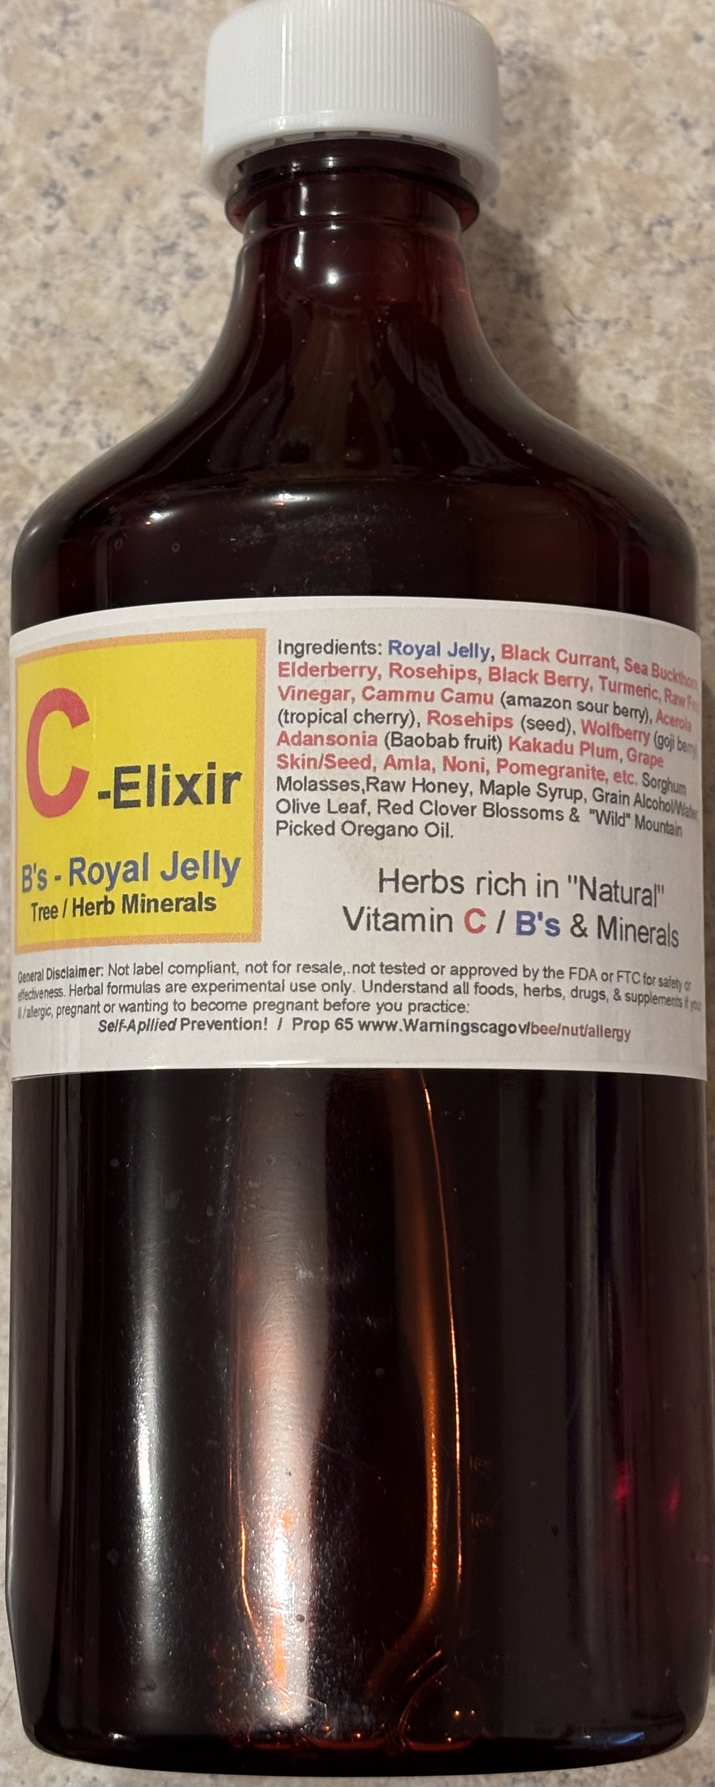
I made Joy for our 1st grandchild, it covers A, B, C & E, mother’s milk should cover D & F. Consumed daily to age 1, this could possibly be the greatest herbal formula made. Essential for The Super Baby Theory! I then took the same formula and made an “Adult” Version! I call Vitamin “C” Elixir! The Herbal Oil Formula covers “D” above.

Weed & Feed!
call / text Brenda @ 937-210-2332
By 2025 over 300+ Royal Jelly Studies were done world wide, except North America that does not want real Royal Jelly. In the USA all standardized synthetic “fake” Royal Jelly is sold. Other than the USA, the world recognizes Real Royal Jelly as the “Best” food on earth, Kings and Queens took 100 mg daily for life! Their dogs 50 mg and their horses 500 mg. When Mother-to-be, consumes it and baby their 1st year of life, they are called Super Babies in China. From conception to 1 year old, the none deficient diet determines a healthy life or not. When baby has what their blood needs, their brain, body develops correctly by age 1, making the 1st year the most important year of their lifetime! Prevention is the Cheapest Healthiest Path!


Info from the Internet

Discover the benefits of royal jelly for growing children
Royal jelly for adolescents is an important source of nutrients to improve their body, as well as their physical and mental performance. It is a food supplement with great benefits for this vital stage, in which the body is in full development and the physical and mental requirements faced by boys and girls are so great.

Advantages of royal jelly for growing children.
Royal jelly has a high concentration of beneficial nutrients for the organism of adolescents and helps to avoid deficiency states.

Improves physical performance and endurance
Royal jelly provides a series of nutrients that help the general health and optimal functioning of the organism, improve physical resistance and, in this way, help to improve physical performance.
During the adolescent stage, physical wear and tear is usually very relevant because the body is in full development and growth in many cases. In addition, adolescents regularly engage in sports and leisure activities with high physical demands. And all this added to hormonal changes and lack of sleep. As a result, the adolescent body is physically strained.
In addition, in some cases, poor lifestyle habits such as poor diet or abuse of stimulant drinks also contribute to physical exhaustion. That is why the benefits of royal jelly to improve physical performance and endurance are so important. Helps to improve intellectual performance and mental abilities
In general, adolescence is a time of great mental effort. Intellectually, studies and exams are intellectually demanding. But also social pressure, emotional changes, hormonal changes and stress challenge the mind.
The benefits of royal jelly for adolescents are very important; as they help to improve intellectual performance, increase the feeling of energy and vitality, combat tiredness and mental fatigue. In addition, its benefits on the brain and nervous system help to improve cognitive development, increasing attention span and concentration and thus improving learning ability.

Royal jelly for children supports the immune system
Royal jelly strengthens the body’s defense system and this contributes to a lower risk of infections, contagions and a better response to diseases.
In this vital stage, exposure to pathogens is frequent due to high socialization. For example, certain sports activities, the use of communal showers at school, summer camps or extracurricular sports. Lack of sleep, stress and poor nutrition also contribute to weakening the immune system. Hence the importance of taking royal jelly as a supplement to strengthen the body’s defenses.

Royal jelly in adolescence is an excellent energetic reconstitute.
During adolescence it is common to go through stages of physical and mental exhaustion, in which the lack of energy and vitality leave the body and mind weakened. They are usually related to the so-called “growth spurts” or growth phases of the body, hormonal changes and the first menstrual periods in girls, stress and demanding mental activity in times such as exams and lack of sleep, among other reasons.
Royal jelly is a natural energy restorative due to its high concentration of nutrients such as B vitamins and amino acids, because it effectively combats physical and mental fatigue and stimulates the metabolism, as well as increasing cerebral oxygenation and the optimal functioning of the hormonal system.

Royal jelly improves your mood Fatigue, physical and mental tiredness, social and academic pressure and emotional problems are some of the factors that affect mood during adolescence. Royal jelly contributes to regulate the production of cortisol, which helps to reduce stress contributing to more energy and less fatigue, as well as to feel good, as it helps to elevate mood.

It supports optimal hormone function At the puberty stage, hormones play a key role in physical, sexual and emotional development, optimal metabolism and energy production. Sleep improves hormonal health. It is key to the production of growth hormone, sex hormones and the endocrine system in general.

“We consume all Honey Bee Products, those that are “scared” and fearful of bees / Honey etc. should not! Many people allergic to all bee / nut foods; their fears can cause enormous problems for them! Each Adult Human makes their own choices what to consume or not!”
- Royal jelly is one of the most beneficial food supplements for children. The most relevant for the health, well-being and development of children over 3 years old who are not allergic to products derived from bees.

Most relevant properties of royal jelly for children

1- Improves defenses and acts as a natural anti-inflammatory

2- Royal jelly helps stimulate children’s appetite
A child that lacks appetite suffers from many problems derived from a poor diet. The most important have to do with the deficit of nutrients they present and their difficulty in growing and developing properly. But this problem can also lead to a harmful relationship with eating that in the long-term turns into serious eating disorders.
Among the properties of royal jelly for children is the appetite stimulation. Key so they can eat well, develop properly, and maintain a healthy relationship with food in his adult life.

3- The benefits of royal jelly for children include the prevention of anemia
And not only because of the aforementioned appetite stimulus, especially because of the contribution of vitamins, minerals and trace elements that provides royal jelly for the little ones. It is a totally natural food.

4- Helps improve vitality, energy level and performance of children
Children need to keep a high level of energy and vitality to perform on an intellectual level, stay active, play, play sports, grow. The physical and mental activity that is necessary during childhood is impressive. Especially in some moments such as the arrival of the cold, the time of exams, sports competitions and when hitting the stretch, among others.
Properties of royal jelly for children contribute to improve your intellectual and physical performance. It helps provide the energy that children and adolescents need to face the daily challenges of their life and helps them feel more vital, reducing the feeling of tiredness or fatigue that would prevent them from continuing with normal activities.

5- Helps to improve concentration and memory
At the level of intellectual performance, concentration and memory are two key capabilities. Between the benefits of royal jelly for the infant stage, there is the improvement of concentration and memory, thus allowing them to perform better in school with less effort and without suffering that feeling of fatigue that makes it difficult to continue. That is why it is especially recommended during back to school and in exam seasons, in which the intellectual effort is greater.

6- Improves and regulates the digestive system
In this way, royal jelly helps the little ones to stay healthy and avoid digestive problems. Something that, added to the fact that it whets their appetite, will give you this double advantage. You can make them eat more and healthier without affecting their intestinal transit, rather, quite the opposite!

7- Helps the growth and maintenance of children’s health
Did you know royal jelly is rich in B vitamins? This vitamin is essential to help the growth of bones and muscles. In addition, these vitamins help the nervous and cardiovascular systems to be kept in good condition in addition to formation of red blood cells.
Due to seasonal changes, the beginning of the nursery, school or institute, in addition to the extra effort required by extracurricular sports activities, it is normal for children to suffer a decrease in their defenses and energy reserves.
To revitalize your body and to carry out your daily activities normally, strong and healthy, there are certain food supplements that are highly recommended. This is the case, for example, of royal jelly for children. Prepared by worker bees to feed the larvae during their first 3 days of life and to the bee queen throughout its life. While queen bees live for an average of 5 years, worker bees live only 45 days. Its secret is precisely its food, the only one of the whole hive that feeds exclusively with royal jelly. This also makes it larger and has a very fruitful life.
The Best Current Book to learn about Royal Jelly; written by Dr. Cass Ingram.

Longevity - The book is 100% about Royal Jelly. He says to give to all none thriving children to turn them around and Thrive!
The Joy Formula was made for 1 girl!, she is now 2.5 years old. Her mother consumed Royal Jelly while pregnant. We all noticed she was born very strong finger strength! Using herbs with nursing, she has never needed a dr after birth, drug free, vitamin free, vaccine free. By age 8 month, standing well. Very coordinated Very Strong! By age 1 year old walking well, very advanced skills. By age 15 months brushing her own teeth. Very verbal, extreme well hearing and eyesight. Very Aware! Mother supplemented with freeze-dried goat milk and stopped all milk by 18 months and zero milk has never consumed a cake, candy or ice cream and she has no desire and loves all the berries, fruits, juices and a few vegetables. She has not consumed any form of meats. Her Herbs: Herbal Spray 1, Oregano Oil, Baby Calm, Joy & Herbal Tooth Squirt.


Dr. Cass Ingram book says Baby will be born healthy, strong and by school age be the prettiest, strongest and smartest child thanks to mother consuming Royal Jelly and given to her child. I believe this to be True MH108
North America not only did not join the world wide “Royal Jelly” 300+ Studies, the usa does not want Real Royal Jelly and only supports Standardized Synthetics! If you buy Royal Jelly and many other herbs in the usa, such as Wild Oregano Oil, they will be Standardized “Synthetics”. Not Real! North America does not have Royal Jelly due to enormous amounts of bees required and labor required!

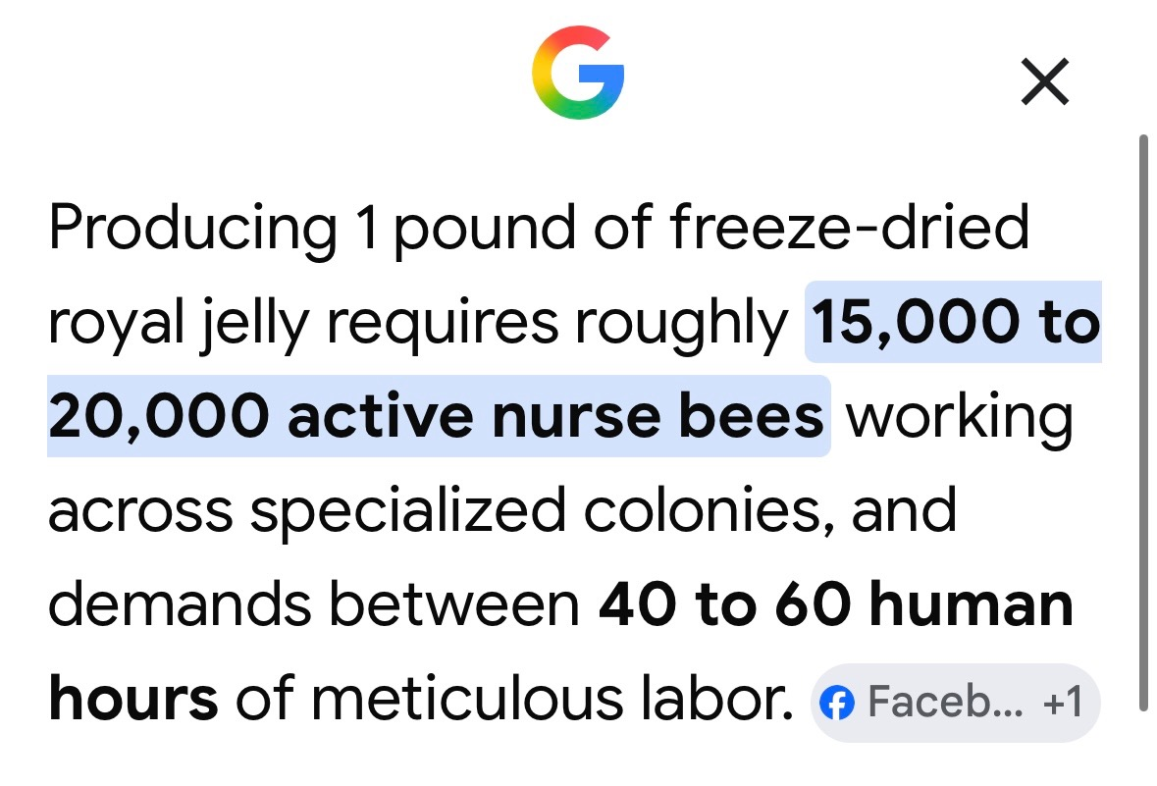
This is why 90% of all Royal Jelly since the 1800’s is farmed in 1 country. Why there is none commercially produced in North America. Why everything sold “commercially” in products / pills has been synthetics since 1950. This is why Royal Jelly was only consumed by the wealthiest people. 100mg daily because of rarity and extreme prices. Royal Jelly is a Mineral / Nutrient Dense Super Food! Truly God’s Blessing for Humans! Raw Wild Honey a delicious Super Food!
Those that make Real Royal Jelly, Freeze Dry is -80 degrees the same day of harvest! The Best on Earth is collected at the end of Summer! Prior to Freeze Drying Royal Jelly was only affordable by the kings, because it quickly degrades and not something sellable “Fresh”!

Freeze Dried Royal Jelly is Very Concentrated! Removing 70% that was water!

Freeze Dried Royal Jelly is the #1 Requirement for Super Babies and much of the world considers it a super medicine for humans.

Real Royal Jelly the largest studies on earth for human health! Except in the usa.
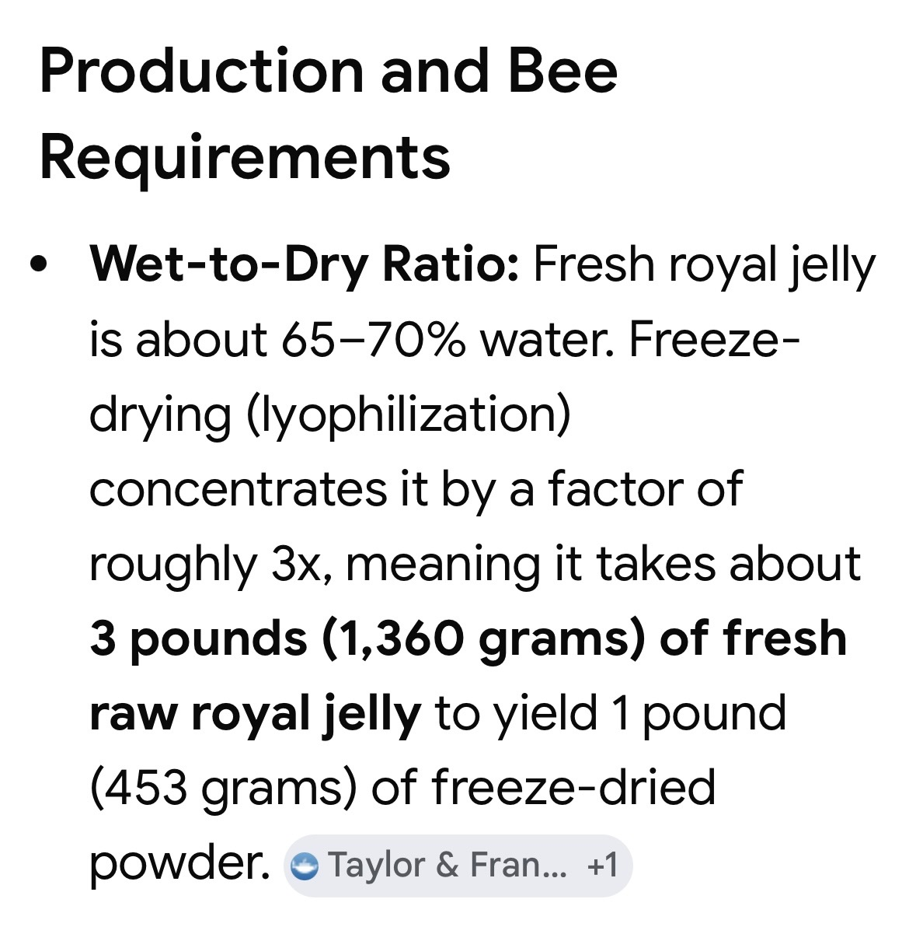

Only “1” girl has consumed “Joy”, Named after her middle name! The total blend is based on Dr. Christopher education, Dr. Morton Walker Olive Leaf Book, All of the Dr. Cass Ingram Books, The Best Tooth Health Book. The 2 Essential herbs / foods required are not available in North America. The “organized” world is a world of “standardized synthetics”. Real Mountain Oregano grows on most mountain worldwide, yet it is truly the rarest cold processed essential oil on earth. At the very most there is 2 ton of Royal Jelly (Freeze dried) made by honeybees on earth monthly; so it has and will always be the most expensive supplement! The people that produce “both” told me that such babies are called Super Babies by age 1 year old.

- Think about it, babies developed deficient free in the womb with no parasite problems! Raised their 1st year, drug, sickness free, on a none deficient diet on 99+% mother’s milk! No Vitamin B / C Deficiencies! No Mineral Deficiencies! No Parasite Problems!

So simple, so cheap! Such a Delight! Stress Free Growing Up! What I call Weed & Feed! Do not drink dirty water, parasite filled none human foods! Understand that Root Bark Trees, Bushes and Vines produce sweet yummy foods that 18-month-old toddlers LOVE! All Real human foods are “Cleansers” and The common sweet Orange is the King! Medical by 1920’s cured-all with the Orange and Diet Balance!

A fully developed baby by birth and then at age 1 year old is Amazing! Not “Special”, just a better diet! Fewer Deficiencies and less Parasites, less Poisoned!

2.5 years old, day of printing this paper!

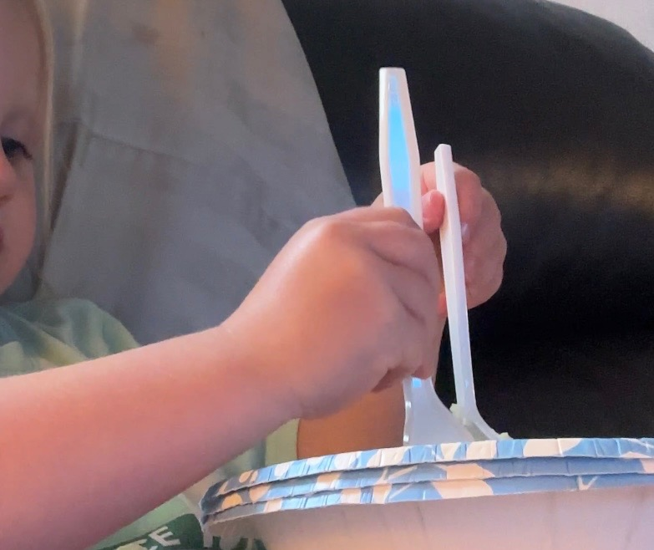
She has incredible Strength! Incredible Hearing! Incredible Eye Sight!
Her brain in Theory is more like it should Be! When eating a soft food such as mashed potatoes with a hard food like green beans, she automatically used the fork for her beans and a spoon for her mashed potatoes. No one told her not too. She has incredible coordination! She is very loving, very considerate and always saying: Thank You!

She Loves every animal! Loves to feed the dogs, chickens, cows, peacock and likes turtles, frogs, catching fish- she literally can use a child size spinning real at 2.5 years old! She loves the outdoors, all of nature and says her prayers and makes sure all folds their hands while praying! In short, she “Learns” Very Easy! She runs up and down stairs! She calls everything- Her’s! She shows “concern” for All!
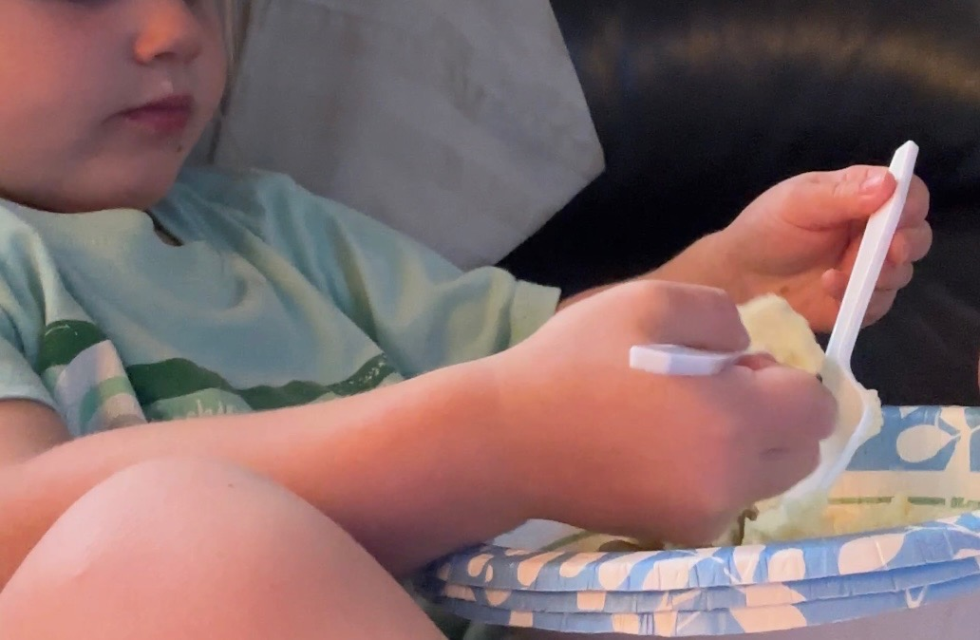

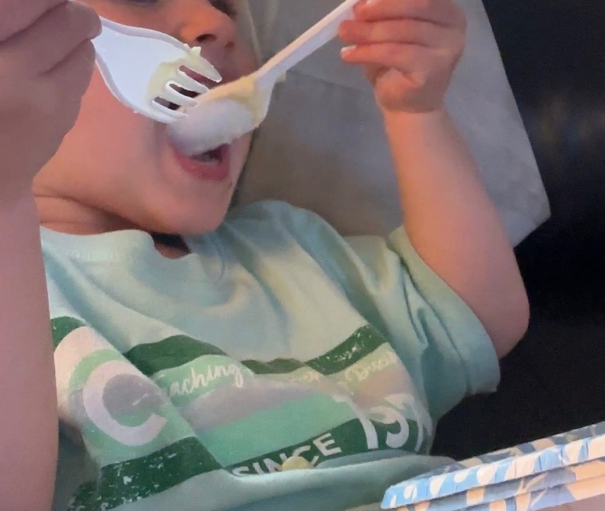
She amazingly handles both fork and spoon with accuracy! She has amazing finger strength and can push hard buttons, turn a key off or on! She can open door handles and push doors open! Dr. Cass Ingram “Longevity” Book states such a baby will grow up the “Strongest” in their school as well as the smartest and prettiest; for the simple fact, all healthy people are “pretty”! Health is recognized as “Desirable”!

I cast her little fishing pole out with a small rubber jig. She reels it in by her self while setting on my lap. She is thrilled to see bluegill and small bass and enjoys that they return to the water. She has no concept of killing; to her, all of nature is her “pets” to enjoy! Old Medical explained human environment never gets colder than 65 degrees and if a coconut tree will not grow, then we live in the wrong climate! Warm correct climates will have plentiful, limitless sweet yummy fruits and berries of endless kinds with ample wild honeybees and their honey! Wrong climates lead to “adapting” to none human foods. LBB Capsules enable adults to eat wrong foods many years longer! So many call LBB that better than Gold!

I can talk for days “explaining” why we got sick and the endless ways to correct via diet correction, cleanses and plentiful antidotes for parasites and poisons. We are poisoned and starving and parasites have the job to return us to the dirt!

- While on the subject of Super Babies, it is very few products, all proper diet, clean water, a few antidotes for life and ideally; live a very enjoyable life and use those surgeons only if we suffer a bad accident!

FACT: All good foods, herbs, antidotes are “Always” Good and Just Like LifeWave; used daily for Life! Waiting until sick or dying is the most painful, most stressful path in life than ends bad. The same herbs good for a newborn are great for adults! All foods and Herbs are always dosage related and diluted correctly for age.

They Say: It takes 7 generations of none sick / none diet deficient people to “return” to healthy true humans! If your sick: you are poisoned, parasites, mineral deficient! Cells are starving for nutrition!

JOY for babies / children and any age! - “C” Elixir is adult JOY - Mountain Oregano Essential Oils

These are samples of what I have made for us after learning from Dr. John R. Christopher, Dr. Cass Ingram, Dr. Howard Hay, MD, Dr. Robt Jackson, MD, Morton Walker, Dr. Hulda Clark, etc. and when I thought there was no more, I learned LifeWave is as much as 50% the Solution for us old people past age 25 years old! Just when you think you know it all, you are lucky if you discover you did not even know ½ what you think you knew!

Healthy Children are Priceless! God is Good, God is Always Good!

The “Best” Dentist in North America!

Dr. John Johnson D.D.S. saved my life when he removed “My” Dental Disaster in 1999. MH108

All my root canals were lead filled; all my gold crowns were actually nickel crowns and the mercury from childhood still in the roots.
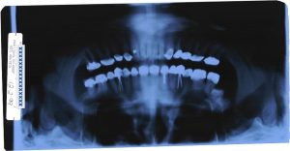

https://www.midwestbiohealth.com

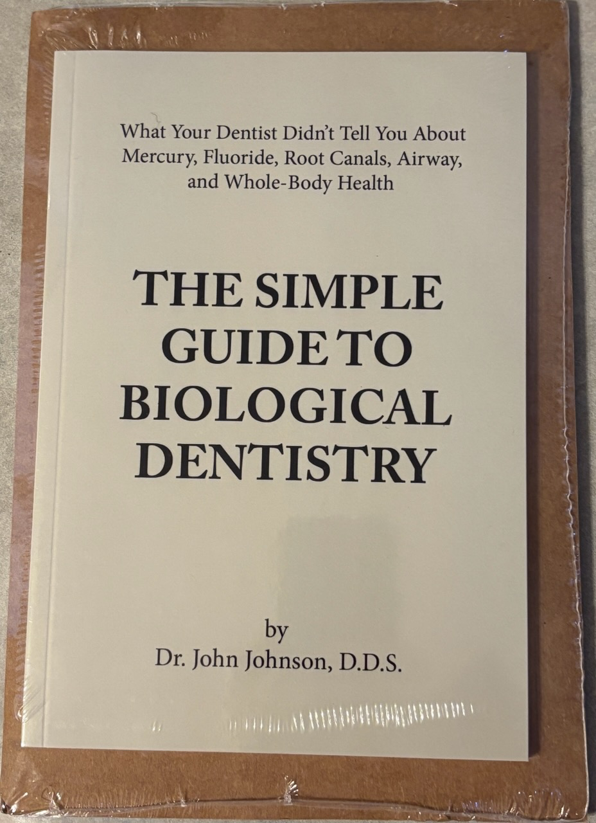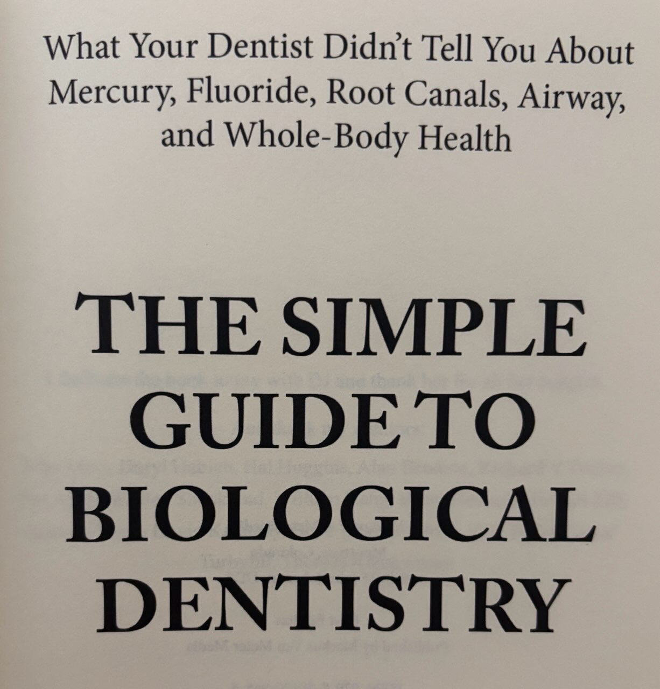
Dr. Johnson’s latest book $20.00.
Limited Quantity.

People fly in from around the world to have their dental work done “Correctly”! Dr. Johnson D.D.S. has the experience, reads all the books and understands total health.

The only Dentist I trust! MH108


call / text Brenda @ 937-210-2332, e-mail:

countrybaskets@earthlink.net.

www.Lifewave.com/BtrendaBerry and for lots of info:

Dr. John W. Johnson, D.D.S.

New Albany, Ohio 43054
614-775-9300

Info@midwestholisticdentistry.com

Never Under Estimate the Power of a Smile

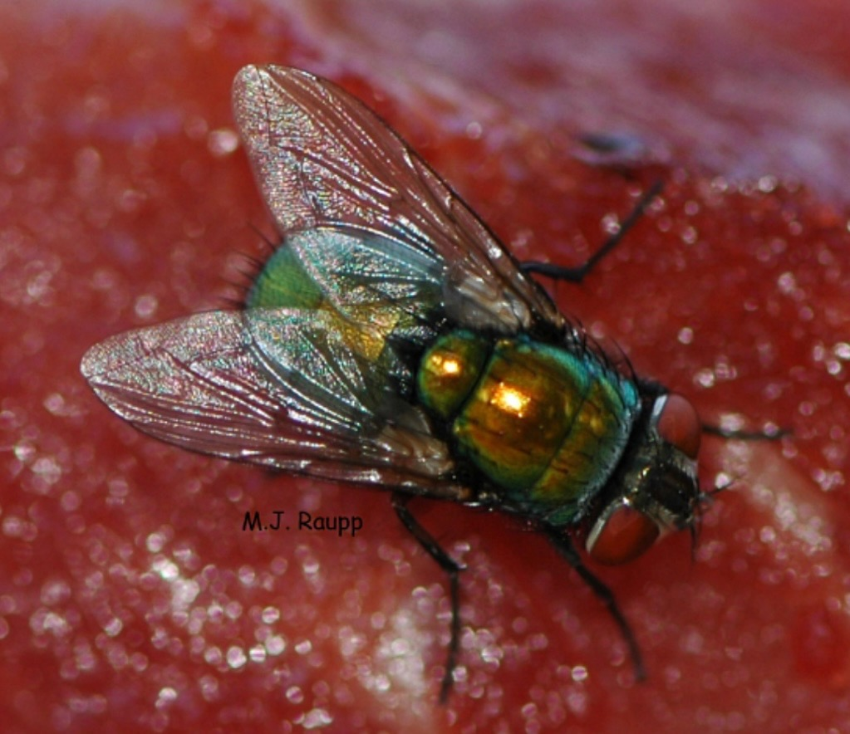
If all mammals on earth die the same day, the flies have the job to quickly dissolve all flesh back to dirt super fast! They are the dirtiest, nastiest carries of parasites / disease and the most tormenting creatures of mammals. Forever biting, cutting, slurping up blood, laying eggs, vomiting on food and skin seeking to dissolve and lick up their victims. Spreading diseases from 1 dead creature to another. Flies want to eat mammals one way or another and waiting to lay their eggs. Once a fly lands on food or a surface, it is contaminated.

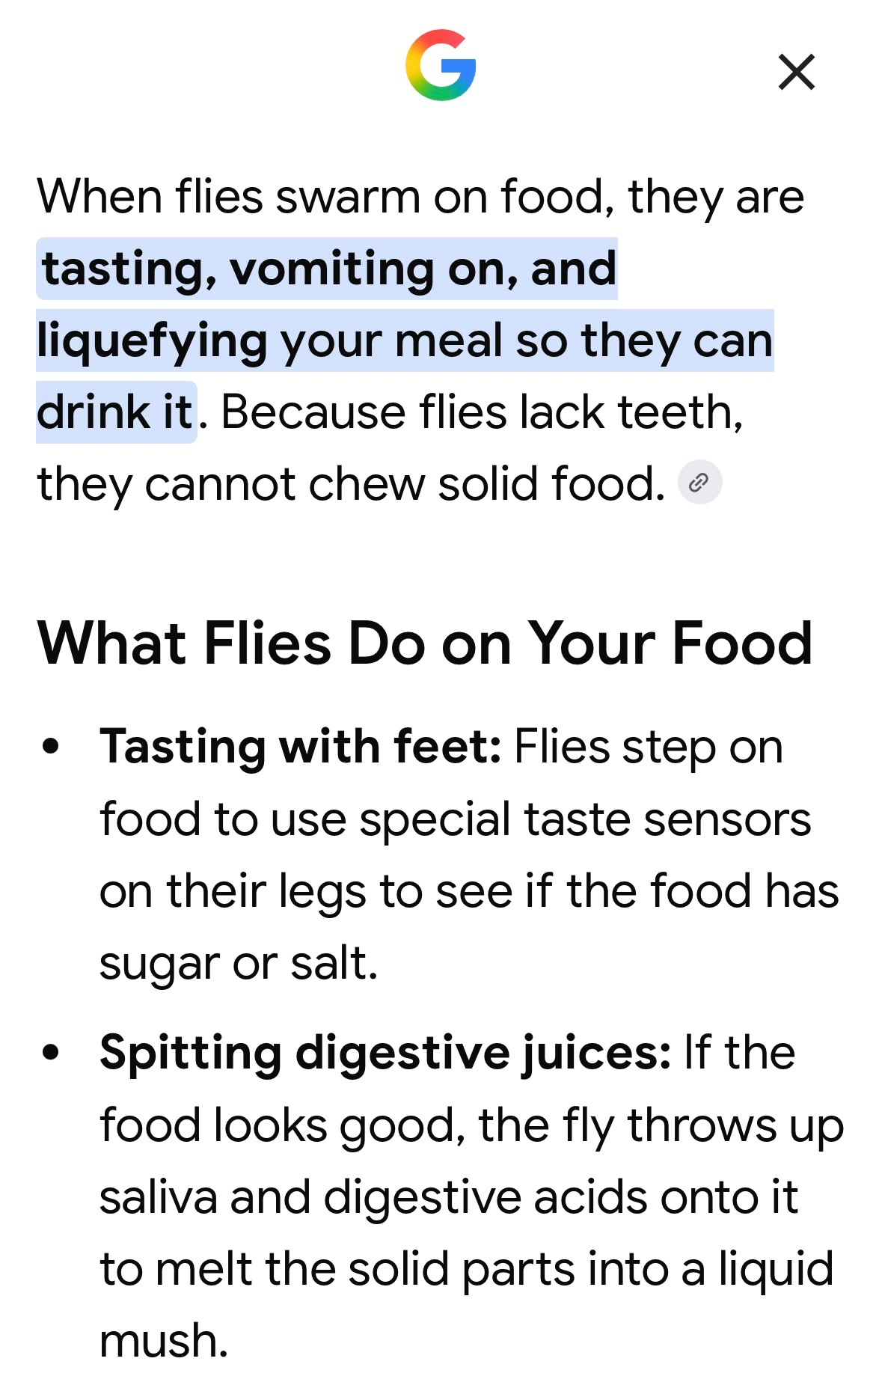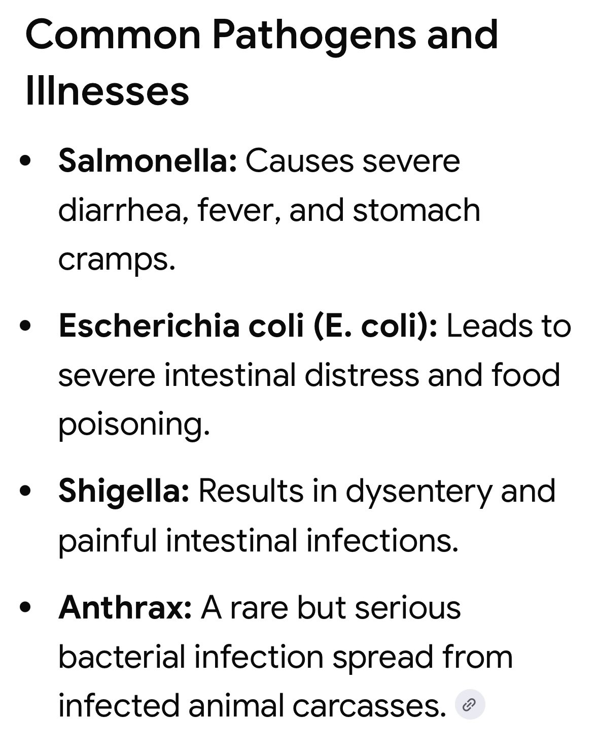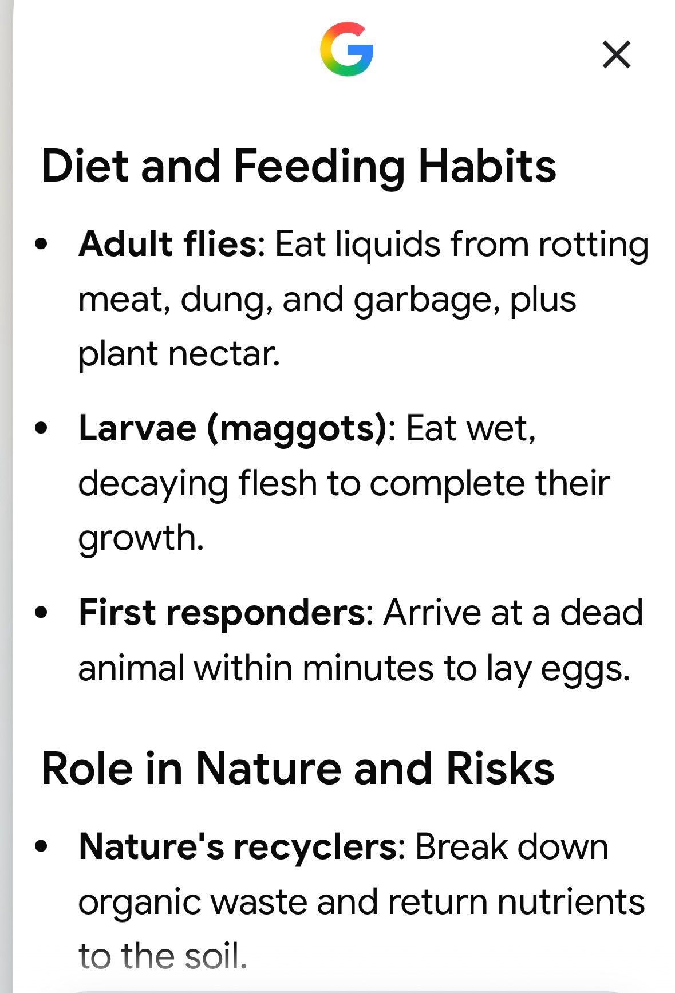

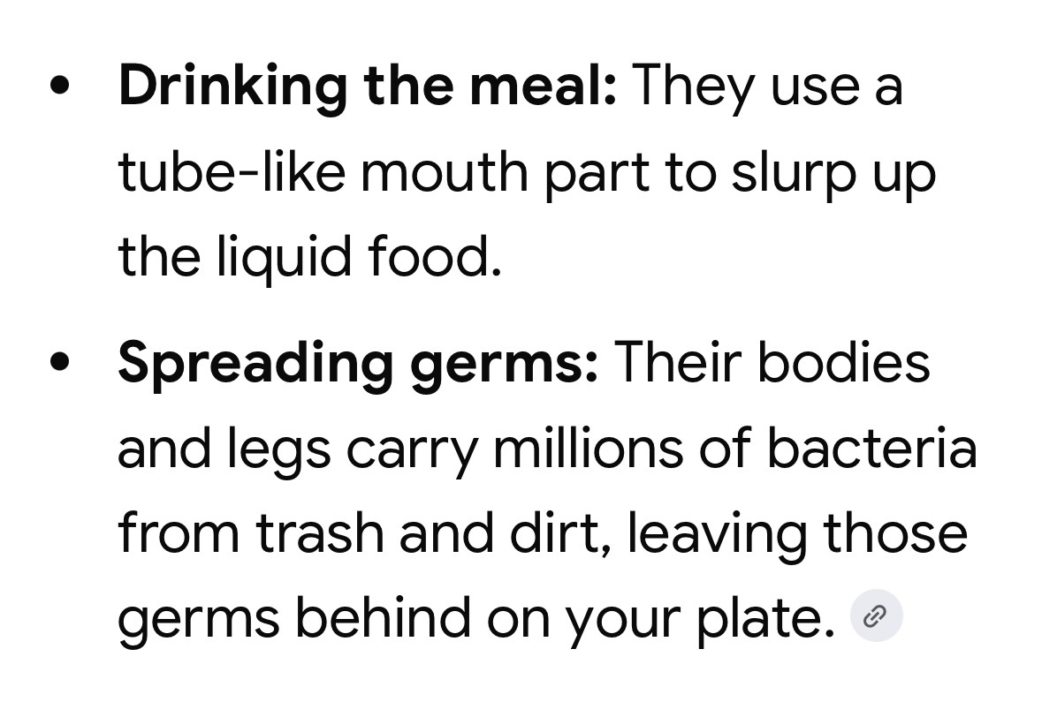

Those that specialized in Lymes, explain “ALL” biting creatures “Spread” Lymes! The Best Lymes Books say Lymes is the last great plague that started 300 years ago and every mammal on earth is born with Lymes. You can never be Lymes Free! Lymes is waiting for the host to go low oxygen and then submit an enzyme to dissolve the tissues and drink the fluids as the muscles waste away. You cannot avoid Parasites! We live at the bottom of an ocean of Fungus, every breath full of parasites.
My Opinion: The Best Antidote for Life on Earth!
The herbs that can be consumed daily, as much as is needed and for all ages including pregnancy and known as antidotes, anti parasite and nutrient rich super foods. Mountain Harvested

Bacteria / Viruses / Mold / Fungus / Mice / Flies / Mosquitoes / snake bites / lice / whooping cough / diseases / loss of circulation / itch / lumps / chem jets / aluminum / heavy metals / rash / parasites all.

50% - The Physical World

Nothing is more Powerful that Sunlight!

Diet Correction the Most Powerful Corrective!

Dirty Water the #1 Cause of Death!

All Die of “Advanced” Scurvy!

Parasites are a Result of Fighting Nature!

Nature Never Ever Looses!

Health is The Only Wealth!

Super Babies Enjoy Life!

Happiness: Healthy Family!

Eyes & Ears: The False Prophets!

50% - The Body Electric

God is Good, God is Always Good!

Faith / Love Can Heal All!

pH 7.35

Lifewave Frequency / Light Aids

X20
MH108 
Dr. Hay, MD Cure!
Days 1-3 Big spoon of Epsoms Salts in glass of water 1st thing in morning!
Drink Juice of 8 Oranges with water as you like with 9 LBB Capsules!
Days 4-14 Orange Juice, Water as desired with
9 LBB Daily.

--NO FOODS!—

Results: 5X more Red Blood Cells than you started with: The Cure!
_____

Dr. Jackson, MD Cure!
Continue for total of 21 days! Results: New Heart, not a rebuilt Heart!

Dr. Hay: Health Via Food

Dr. Jackson: How to Always Be Well.

LBB the most famous herbal powder / capsule formula in herbal history!

9 Capsules Daily for 9 months and then as desired for lifetime!

Constipation
Leaky Gut
IBS
Diverticulitis
Bloating
Gas
Ulcerative Colitis
Crohn’s
Polyps

Pregnant women often call LBB better than gold!

Used 1st and for Life!

Forum Stats:
forum viewed 57,282,180 times
111,551 messages
26,252 topics
topics per page limited to: 12
average number of messages per page: 51
2,187 pages

